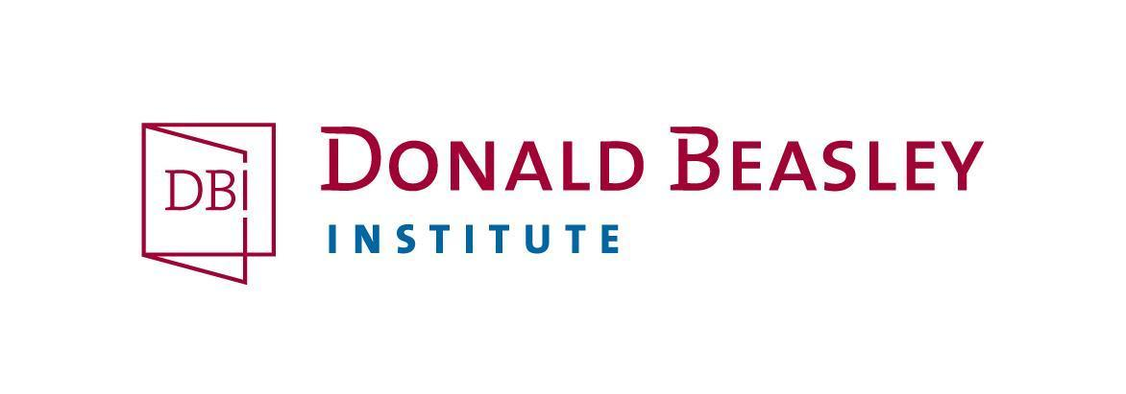
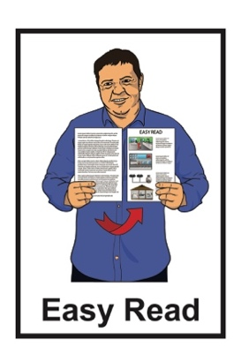

Participant Interest Form:

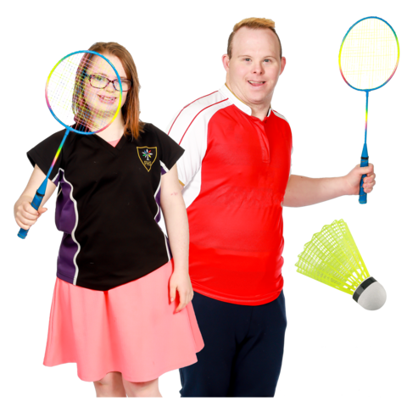
Young adults with a learning disability’s ideas about sport and activity

Taking part in a research project
Published: May 2023

What is this form about?

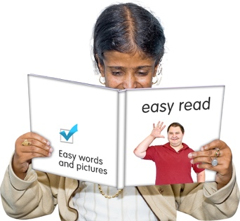
This Easy Read form is for people to say they want to take part in a research project.

Research is when we:
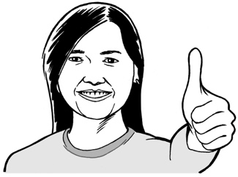
- look at what things have happened
- find ways to do things better.

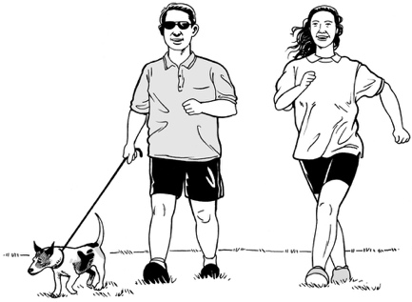
The research project is called:
Being active, feeling good:
Young adults with a learning disability’s ideas about sport and activity
The research is being done by the Donald Beasley Institute.

The Donald Beasley Institute does
research with disabled people about their lives

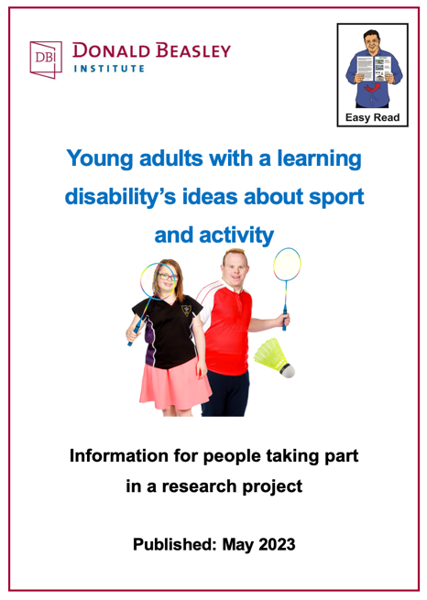
You can find out more about the research project in the Easy Read document:

Young adults with a learning disability’s ideas about sport and activity
Information for people taking part in a research project

You should fill out this form if you want to take part in the research.

You can send this form back to us by sending it by email to Paul Milner at:
nottheotherpaulmilners@gmail.com
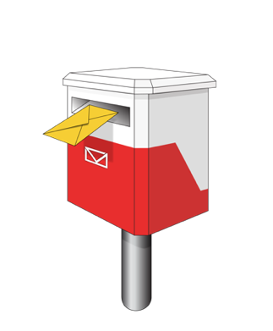

You can also send the form back to us by post when you have filled it in.

There is an envelope with our address on it with the form.

It will not cost you any money to send this back to us.

You can also fill out a Participant Interest Form on our website at:

https://corexmss43gf6x5cw7qm.qualtrics.com/jfe/form/SV_6WE218CM604ECd8

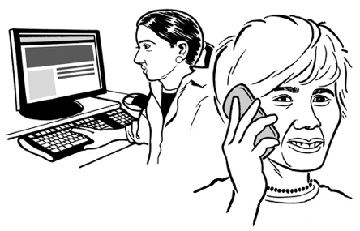
If you need someone to support you to fill out the form you can:
- contact us for support
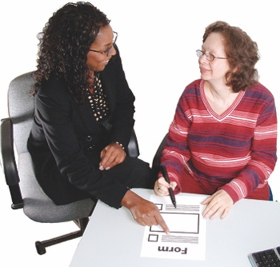
- ask someone else to support you like a friend / someone in your family.

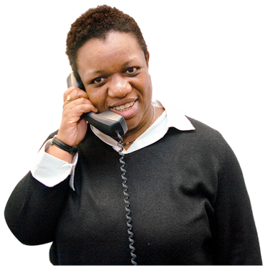
You can also call the Donald Beasley Institute for support on:
0800 878 839

Participant interest form

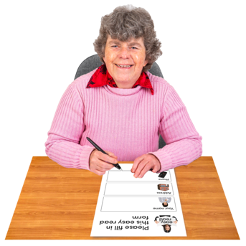
Please answer the questions on pages 6 to 11 of this form.

We will not use the information you give us in this form as part of the research.
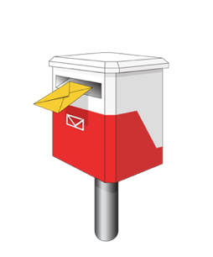

Send this form back to us when you have filled it out.

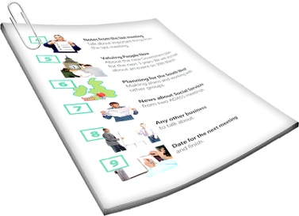
Our contact details are on page 3 of this form.

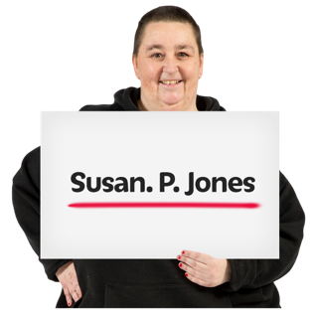
Write your answers on the lines.

My full name is:

My telephone number is:

My email address is:

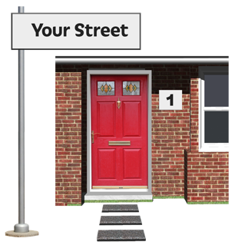
The address I live at is:

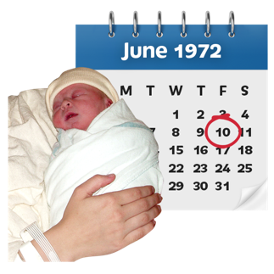

I was born on:

Tick 1 box that is right for you.

I am:

a man

a woman
another gender – please let us know by writing on the line below

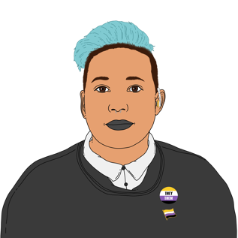

I would prefer not to say

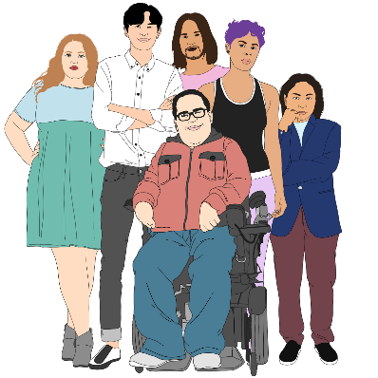
Gender is if you are:
- a man / male
- a woman / female
- another gender like nonbinary.

Tick the box that is right for you.

I am:

NZ European / Pākehā
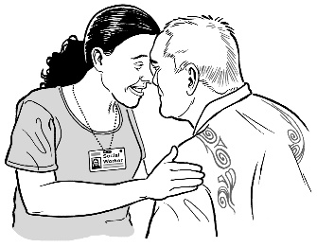
Māori

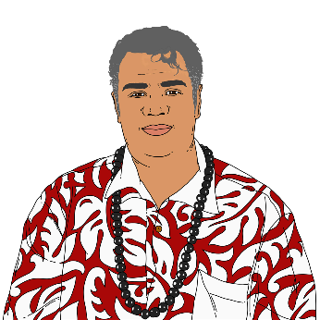
Pacific Person

Indian

Chinese
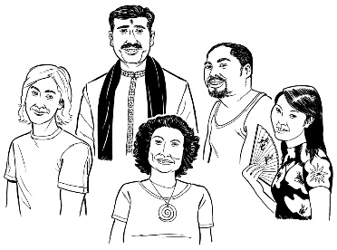
something else – please let us know by writing on the lines below

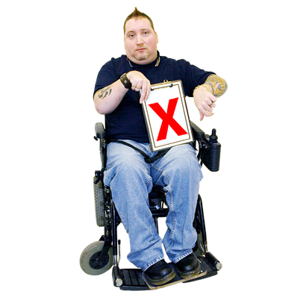
............................................................

............................................................

I would prefer not to say

Tick 1 box that is right for you.

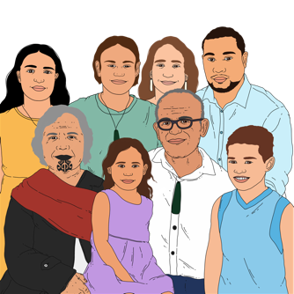
At the moment I live:

with my family / whānau / aiga

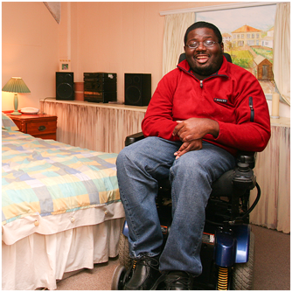
by myself

with other people who are not part of my family
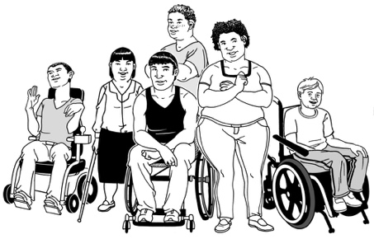
something else – please let us know by writing on the lines below
............................................................

............................................................

Tick 1 box that is right for you.

Are you involved with Special Olympics New Zealand at the moment?
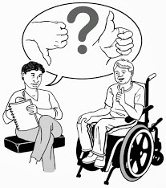

yes

no

Tick 1 box that is right for you.

Would you like a support person with you when you take part in the research?

yes

no
This section is about your support person if you want one.
You do not have to fill this in if you do not want a support person.
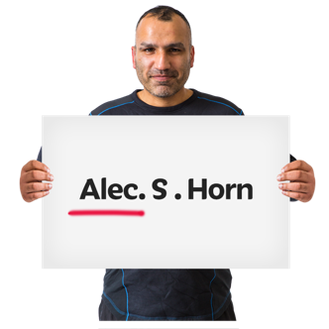

The full name of my support person is:

The telephone number of my support person is:

The email address of my support person is:

This information has been written by the Donald Beasley Institute.

It has been translated into Easy Read by the Make it Easy Kia Māmā Mai service of People First New Zealand Ngā Tāngata Tuatahi.

The ideas in this document are not the ideas of People First New Zealand Ngā Tāngata Tuatahi.

Make it Easy uses images from:

- Changepeople.org

- Photosymbols.com

- SGC Image Works

- Huriana Kopeke-Te Aho.
All images used in this Easy Read document are subject to copyright rules and cannot be used without permission.

