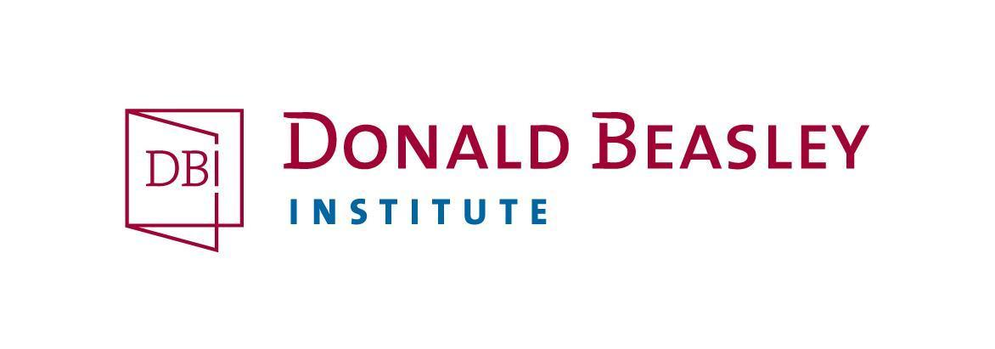
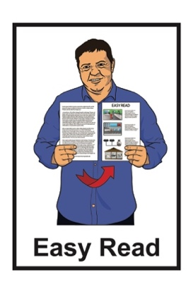

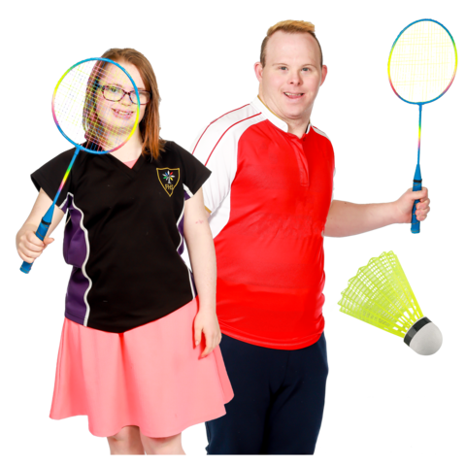
Young adults with a learning disability’s ideas about sport and activity

Information for people taking part
in a research project
Published: May 2023

What you will find in here

Page number:
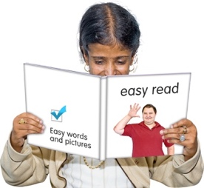

What is this invitation about? 3
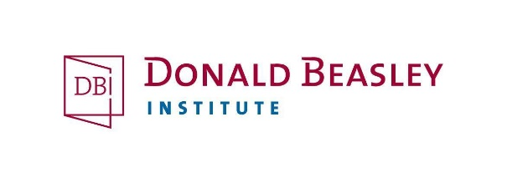

Who will be doing the research? 7

What is the research about? 9
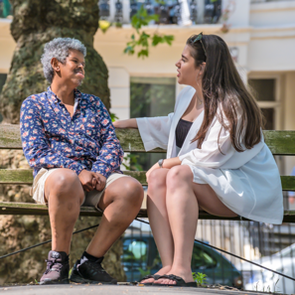

Why is this research important? 13

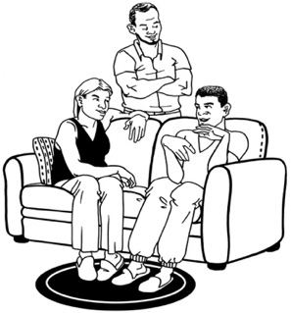
Who do we want to talk to? 16

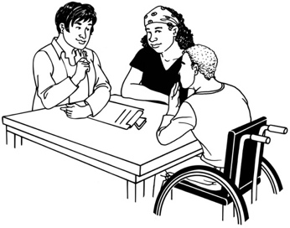
What happens if I take part? 18

Page number

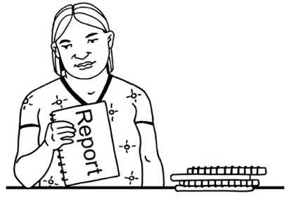
What we will talk to you about 21

Who you might like us to talk to…..22
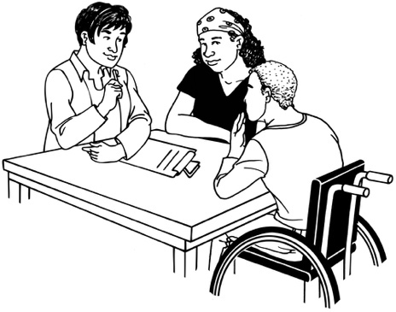
During the interview………………..22

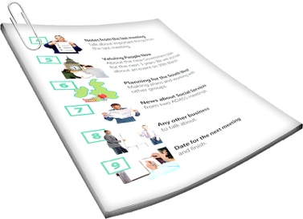
What we will do with the information…………………………..23

After the interview…………………..27

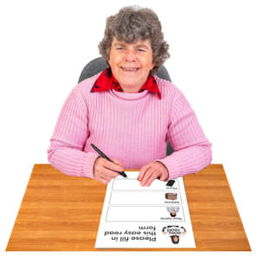
What to do if you want to take
part 26

What happens if you change
your mind 30

How to find out more 31

What is this invitation about?

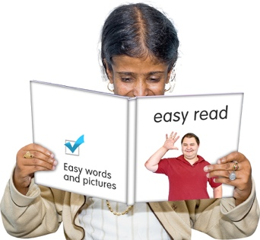
This is an Easy Read invitation to be part of a research project from the Donald Beasley Institute.

Research is when we:
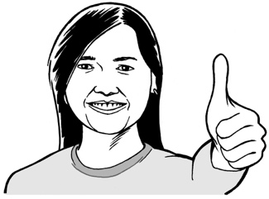
- look at what things have happened
- try to find ways to do things better.
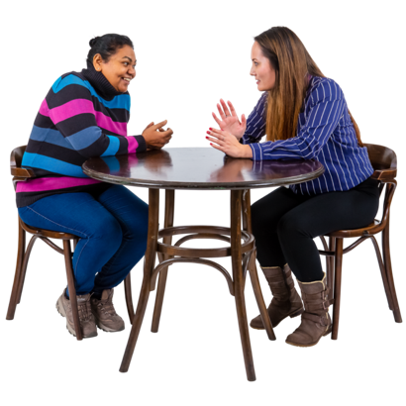

The Donald Beasley Institute does research with disabled people about their lives

The research project is called:
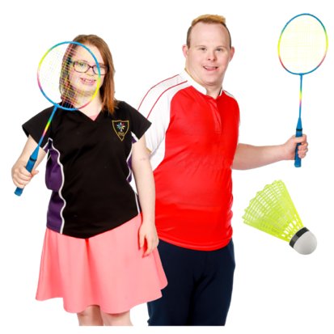
Being active, feeling good:
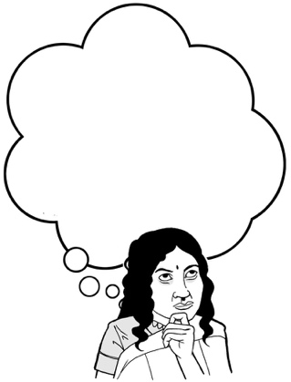
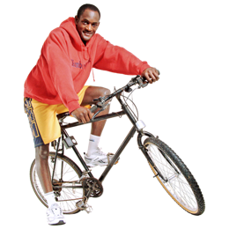
Young adults with a learning disability’s ideas about sport and activity

The research project will look at what young adults with a learning disability think about sport / physical activities.
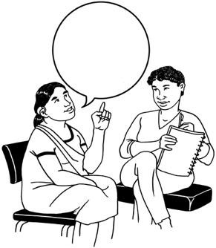
Learning disabilities can affect how you:
- use / understand words
- use / understand numbers
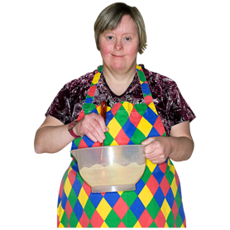
- use / move your body
- stay focused on a task.
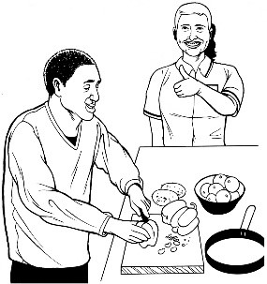
If you have a learning disability you might need support with doing everyday tasks like:
- doing things at home like
cooking / cleaning
- understanding information
- making friends / meeting new people
- looking after your money
- getting / keeping a paid job.

Activities are things you do:

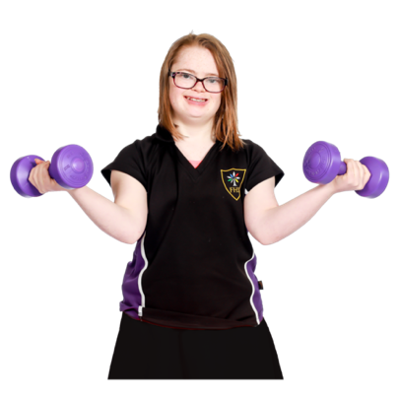
- by moving your body
- usually for fun

You can do physical activity by yourself, like;

- Walking / running
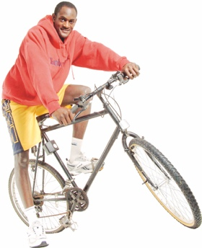
You can do physical activity with other people, like;

- Doing a yoga class

You can do physical activity in a team or organised sport, like:
- Play in a bowling league
- Play in a football team

We are interested in talking to young people with a learning disability whether you do lots of physical activity or are not doing very much at all at the moment.

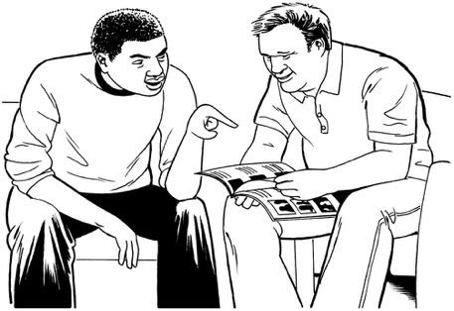
The information in this document is to support you to decide if you would like to take part in the research.

Who will be doing the research?
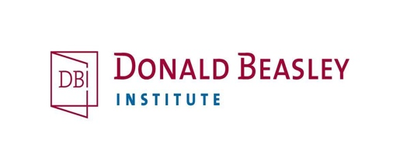
The people who will be doing this research are part of the Donald Beasley Institute research team.

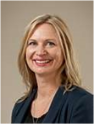
Their names are:
- Dr Brigit Mirfin-Veitch
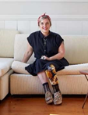
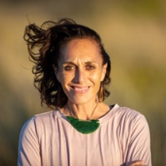
- Dr Kelly Tikao
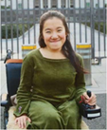
- Dr Robbie Francis Watene
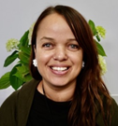
- Umi Asaka
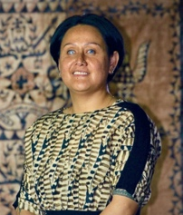
- Aroha Mules
- Jacinta Tevaga
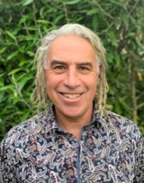
- Wally Noble.
- Paul Milner.

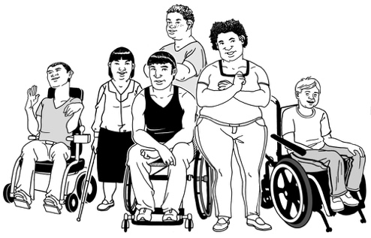
Some of the people on the research team:
- are disabled
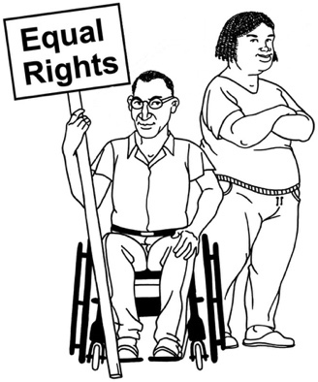
- have experience doing research about the rights of disabled people.

What is the research about?
The research is being paid for by Special Olympics New Zealand
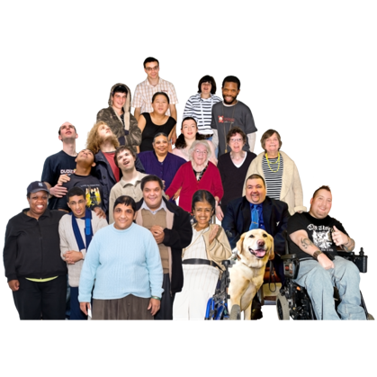

Special Olympics New Zealand is an organisation in Aotearoa New Zealand.
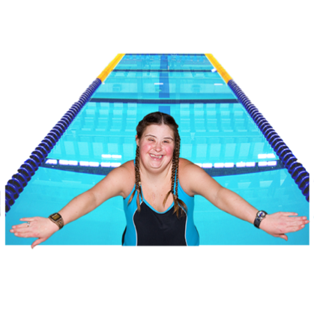
Special Olympics New Zealand encourages people with learning disabilities to get involved in:
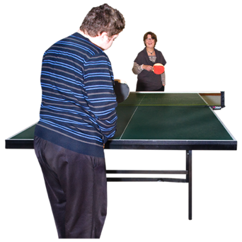
- Special Olympics
- sports
- physical activities.

Special Olympics is the biggest organisation in the world that supports people with learning disabilities to take part in sports.

Some people with learning disabilities:
- do not like doing physical activities
- have not had the chance to do physical activities or play sport
- do not know about Special Olympics
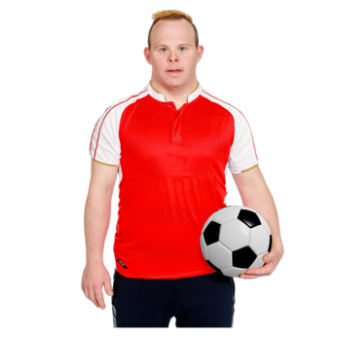
- cannot be a part of Special Olympics
- do not want to be a part of Special Olympics
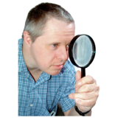

This research project will look at why this is happening.

We want to learn more about:
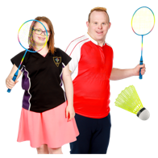
- What sports and activities young adults with a learning disability are doing.
- What sports and activities young adults with a learning disability would like to do if they could.
- What do young adults with a learning disability need to do the sports and activities they want to.
- What young adults with a learning disability know about Special Olympics.

To do this research well we will listen to:
- Young adults with a learning disability
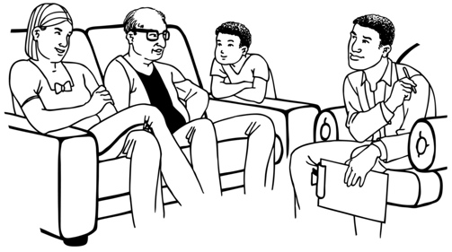
- the family / whānau / aiga of people with a learning disability
- people who support people with a learning disability.

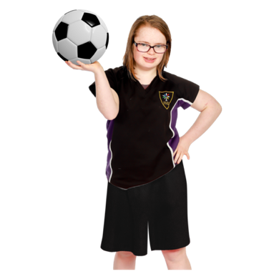
The information we find out will support Special Olympics to make sports / physical activities better for people with learning disabilities in the future.

Why is this research important?

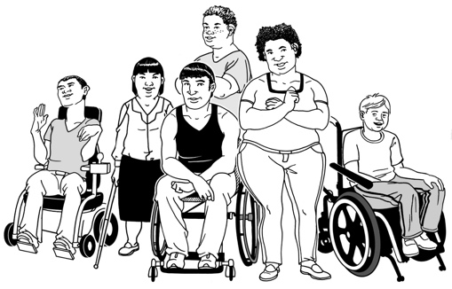
The things we find out from this research will be used to better support people with learning disabilities in Aotearoa New Zealand.
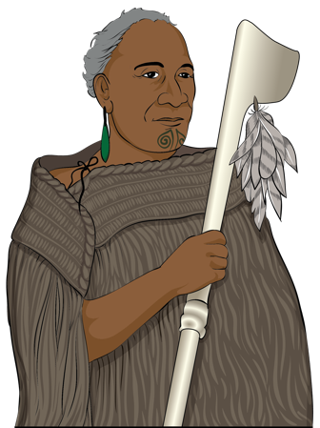

Our team believes in a Māori saying:

Mā te rongo ka mõhio
Mā te mõhio ka mārama
Mā te mārama ka mātau
Mā te mātau ka ora.

This saying means:

From listening comes knowledge
From knowledge comes understanding
From understanding comes wisdom
From wisdom comes wellbeing.
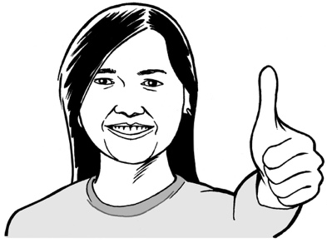
Wellbeing means how people feel about their lives.
Some of the things that are important to wellbeing are:
- having good health
- having enough money
- having a safe place to live
- choosing what you do and when you do it

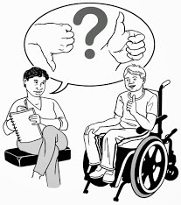
This saying tells us that by listening to what people tell us we can make things better for everybody.

Sports / physical activities are 1 way that people with a learning disability can improve their:
- health
- wellbeing.
If people with a learning disability are not able to get involved with sports / physical activities they might miss out on ways to have a good life.
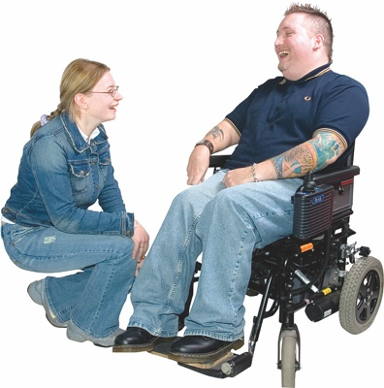

The research will support them to get involved if they want to.

Who do we want to talk to?

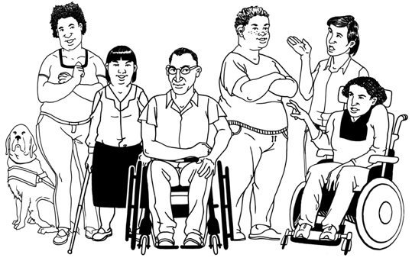
We want to talk to 15 young adults who have a learning disability.

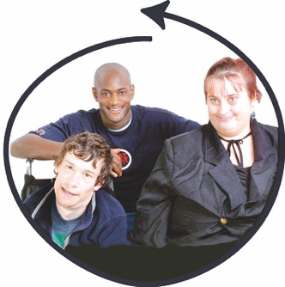
These people should be:
- aged 18 to 35 years old
- not involved with Special Olympics at the moment.
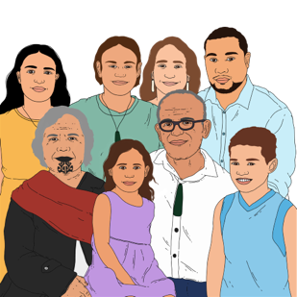

We also want to talk to:
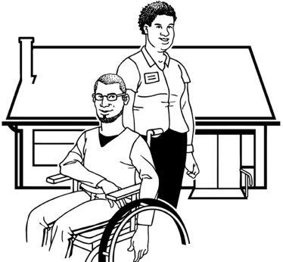
- their family / whānau / aiga
- other people who support them.

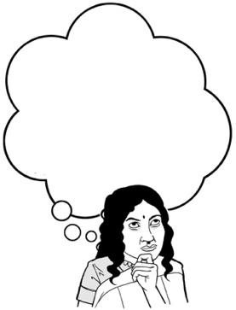
We will ask people with a learning disability who else they think we should talk to.
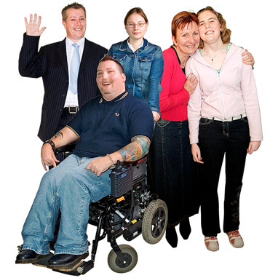
Everyone who takes part in the research must be:
18
- over 18 years old
- able to give informed consent to say they want to take part.

Informed consent means:
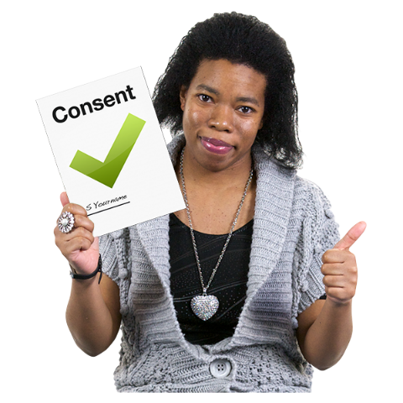
- you say yes to doing something
- it is your own choice to say yes or no
- you understand what you are saying yes to.

What happens if I take part in the research? How we will talk to you

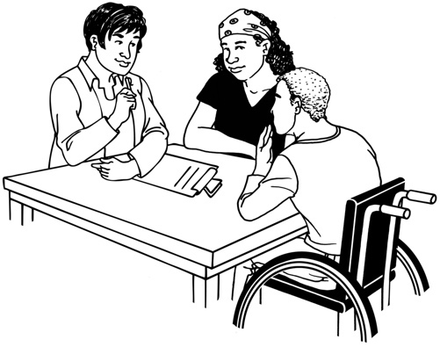
If you are chosen to take part in the research you will be asked to have 2 interviews with someone from the research team.

An interview is when:
- we ask you some questions
- you tell us what you think.
The 2 interviews will each take up to 1 and a half hours to do.
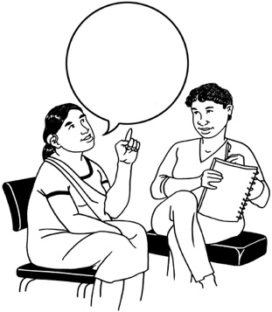

You can choose how you want to talk with us.

We want to make sure that when you talk to us you feel:
- safe
- comfortable.

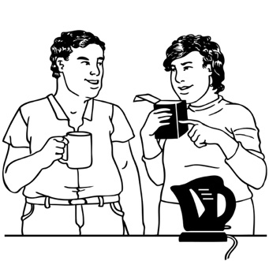
The sorts of ways you can talk with us include:
- sitting and talking in a place you feel comfortable
- going to a place that is important to you
- taking a walk while we talk
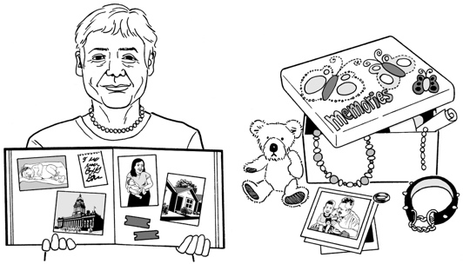
- sharing things that help you to remember / talk about your experiences like:
- photos / pictures
- other things.
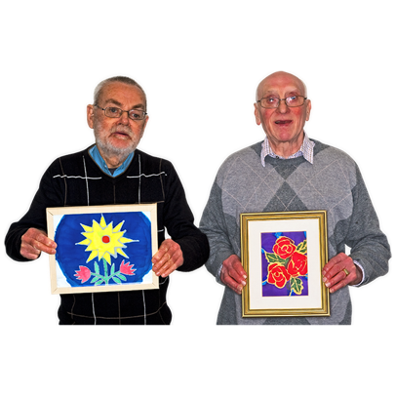
You can also talk with us about your experiences in creative ways like through:
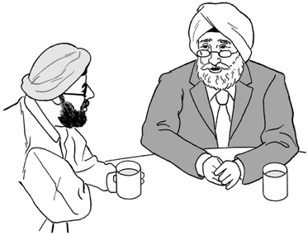
- art / pictures
- poetry
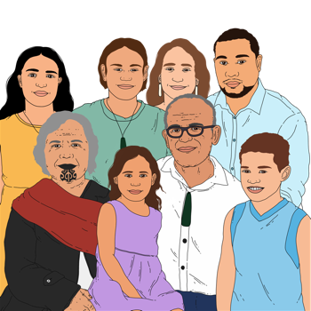
- waiata / song
- pūrākau / story telling.

We can arrange for any supports you might need to take part in the interview.

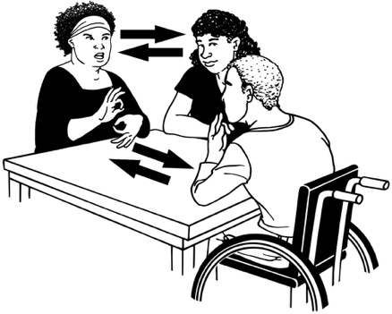
The supports you might need could be things like:
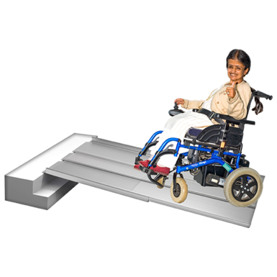
- having a New Zealand Sign Language interpreter
- holding the interview at a place that is accessible.

What we will talk to you about

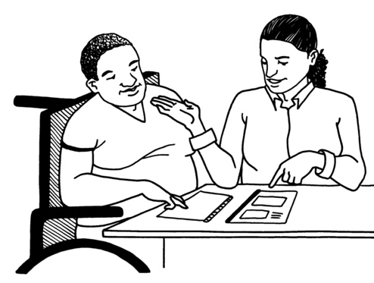
In the interview we will ask you about what sports / physical activities:
- you have done in the past
- you do now
- you want to do in the future
- What young adults with a learning disability need to do the sports and activities they want to
We will also ask what you know about Special Olympics.

Who you might like us to talk to

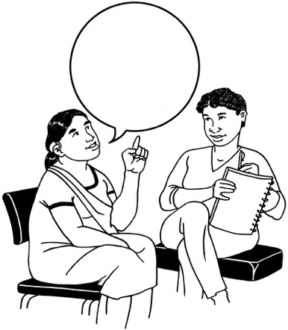
We will also ask you to tell us who else you think we should talk to like:
- people in your family / whānau / aiga
- other people who support you.

We will talk to these people 1 time.

During the interview

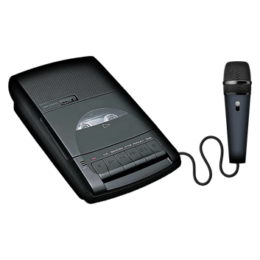
The research team will record the interview.

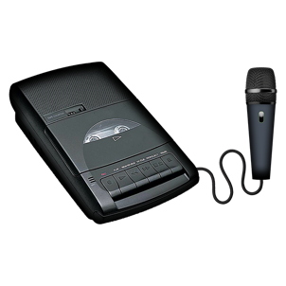
You can ask to have the recorder turned off at any time.

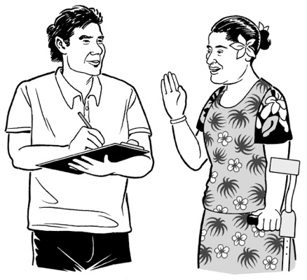
The researcher might also write down some notes:
- while the interview is taking place
- at the end of the interview.

What we will do with information
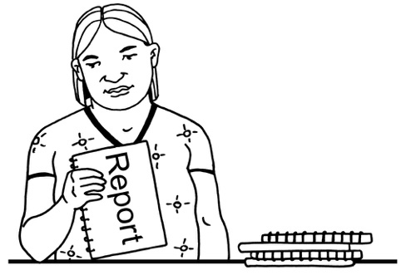
We will send you a written-out copy of the interview

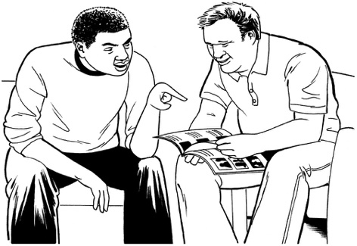
You will be able to:
- read this
- make any changes to the written-out copy you like

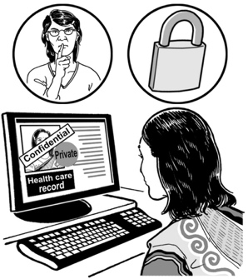
We will keep anything you tell us in the interviews private.

Private means we will not tell other people about the things you have told us.

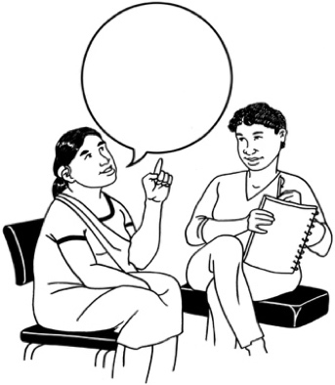
The only time we may share what you have told us with someone else is if we think:
- you might be in danger / are being harmed
- someone else might be in danger / is being harmed.

We will talk with you before we do this.

It is okay for you to have a support person with you if you need to.

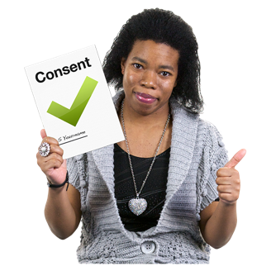
We will only use information told to us by people who have said we can do so.

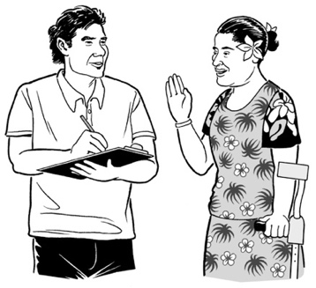
Any information you tell us will only be used for this research project.

We will write a report about the things we find out in the interviews.

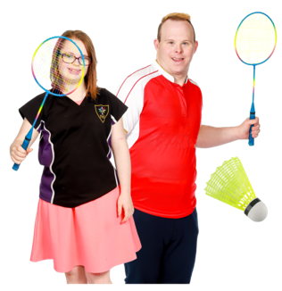
Special Olympics New Zealand might use the report to find ways to make sports / physical activities better for people with learning disabilities.

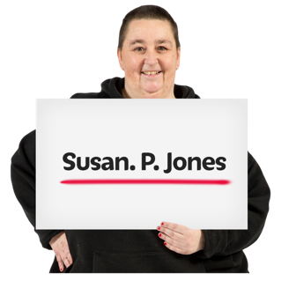
We will not:
- use your real name in the report
- include any information that might mean other people know it is about you.

We do not know how long it will take for us to:
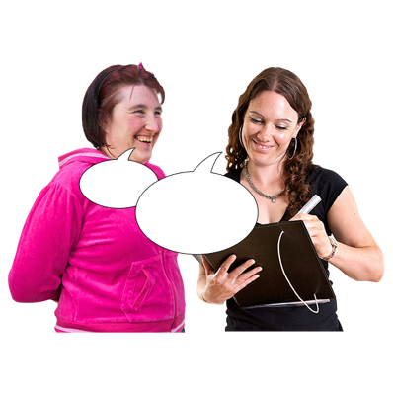
- do all the interviews
- write a final report.

Any information you tell us will be kept safe at the Donald Beasley Institute for 10 years.

After 10 years has passed will we destroy the information.

After the interview

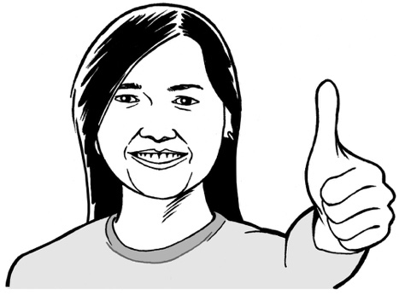
Everyone who takes part in the research will get a voucher of 50 dollars as a thank you.

A voucher is like money that you can only spend in some shops.

What to do if you want to take part

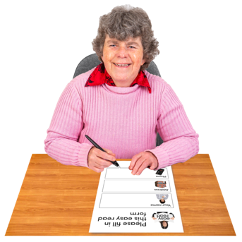
If you want to take part in the research you should fill out a Participant Interest Form.

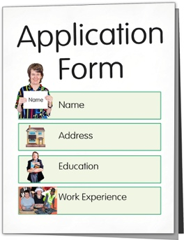
We have sent you a Participant Interest Form with this invitation.

You can send it back to us by post when you have filled it in.

There is an envelope with our address on it attached to the form.

It will not cost you any money to send this back to us.

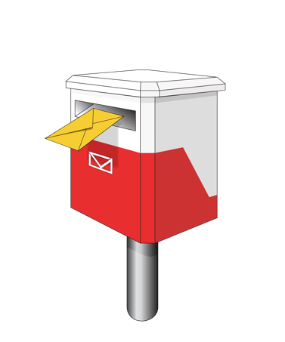

You can send the form back to us by post to:
Suite 4, Level 2
248 Cumberland Street
Dunedin 9016

You can also fill out the online form from here.
You can also call Paul Milner for more information about where to send the form on:
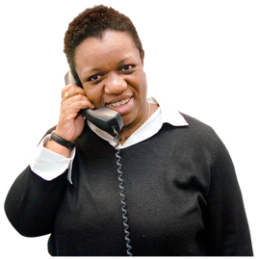
027 738 2684

You can also send your completed form to Paul by email at:
nottheotherpaulmilners @gmail .com

If you would prefer to contact us in New Zealand Sign Language you can send us a video to the email above.
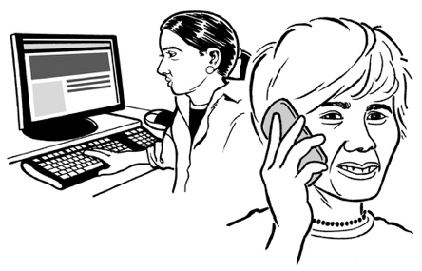
If you need someone to support you to fill in the form you can:
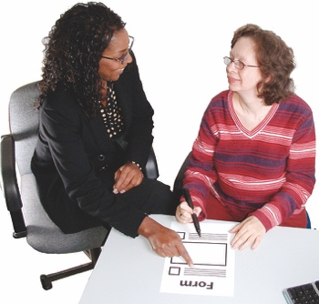
- contact us for support
- ask someone else to support you like a friend / someone in your family.
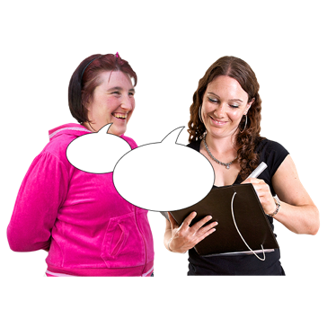
We will get in touch with you after we have received your Participant Interest Form to:
- talk to you about the research
- make sure you really want to take part.
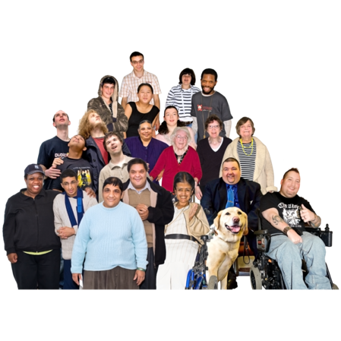

If a lot of people want to take part in the research, we might not be able to talk to / include everyone.

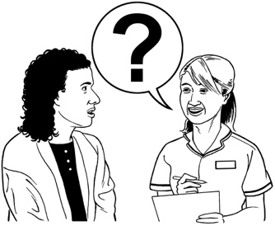
You can still tell us if you want to take part in research we do in the future.

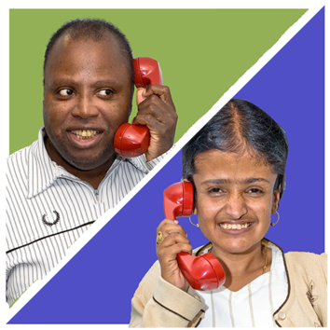
We will also get in touch with you to tell you how the research is going if you want us to.

What happens if you change your mind?
It is okay to change your mind about taking part in the research at any time.

It is up to you if you are happy for the researcher to still use any information you have told them.

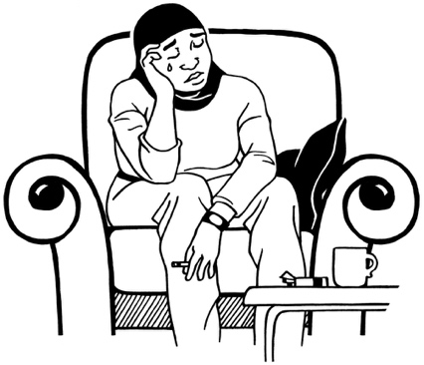
You should tell us if you feel unhappy at any time when you take part in the research.

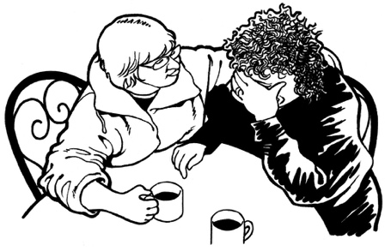
We will give you any support you need.

How to find out more

To find out more about this research project you can get in touch with:
- Brigit Mirfin-Veitch who is leading the research team
- Kelly Tikao who is our Kairangahau Māori Research Associate.
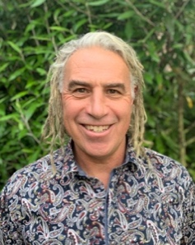
- Paul Milner who is helping with the research

You can contact Brigit:
- by phone on:
027 479 2021
- by email at:
bmirfin-veitch@donaldbeasley.org.nz

You can contact Kelly:
- by phone on:
027 482 6324
- by email at:
ktikao@donaldbeasley.org.nz

You can contact Paul:
- by phone on:
027 738 2682
- by email at:
- nottheotherpaulmilners@gmail.com

You can also:
- call the Donald Beasley Institute for free on:
0800 878 839
- find out more about the Donald Beasley Institute on our website at:
www.donaldbeasley.org.nz

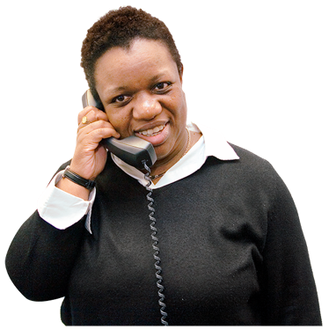
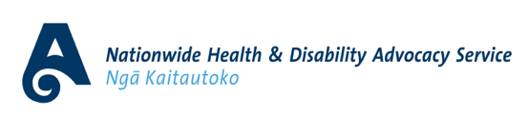
You can get advice from someone who is not part of the research from the Health and Disability Advocacy Service:
- by phone on:

0800 555 050
- by email at:
advocacy@advocacy.org.nz
- at their website at:
www.advocacy.org.nz/

This research will be watched over by:
- a Māori Advisory Rōpū / group
- Special Olympic athletes Tegan, Philip, Caleb, and Kim, who will also be providing specialist advice.

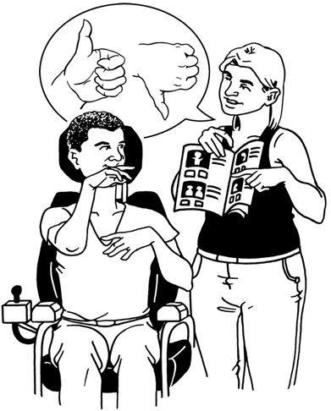
This is to make sure that the research we do is:
- ethical
- safe
- informed by young people with a learning disability

Ethical means we will make sure we do the research in a way that:
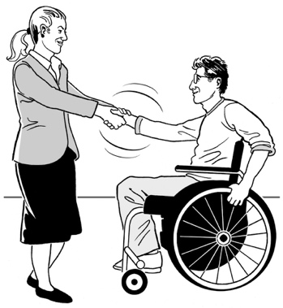
- is good / right for everyone who takes part
- will think about the needs of everyone who takes part.

You can contact the people who are on the ethics team by email at:

hdecs@moh.govt.nz

This information has been written by the Donald Beasley Institute.

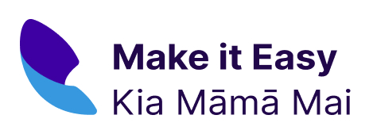
It has been translated into Easy Read by the Make it Easy Kia Māmā Mai service of People First New Zealand Ngā Tāngata Tuatahi.

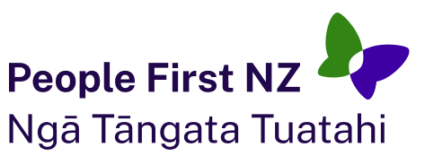
The ideas in this document are not the ideas of People First New Zealand Ngā Tāngata Tuatahi.

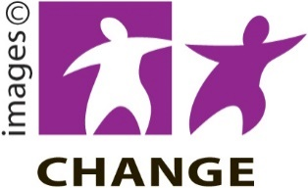
Make it Easy uses images from:

- Changepeople.org

- Photosymbols.com

- SGC Image Works

- Huriana Kopeke-Te Aho.
All images used in this Easy Read document are subject to copyright rules and cannot be used without permission.

