
Disabled Person-Led Monitoring
of the UNCRPD
My Experiences, My Rights:
Disability Supports and Services

Report 5 - Summary of Recommendations

Whakarakatira te tākata,
ahakoa ko wai, ahakoa nō hea.

Respect and treat all with dignity,
irrespective of who they are and where they come from.

Author: Donald Beasley Institute (DBI). The DBI is an independent charitable trust that conducts disability research and education. The DBI is committed to ethical, inclusive, and transformative research and projects that promote the rights of disabled people.
Citation Guidance: Donald Beasley Institute. (2025). Disabled Person-Led Monitoring of the UNCRPD: My Experiences, My Rights: Disability Supports and Services Report 5 - Summary of Recommendations. Disabled People’s Organisations Coalition.
Monitoring Team: Dr. Robbie Francis Watene, Umi Asaka, Jacinta Tevaga, Wally Noble, Ash Beales, Eden Cruice, Monica Leach, Aroha Mules, and Cha’nel Kaa-Luke, with research guidance and mentoring from Associate Professor Brigit Mirfin-Veitch and Dr. Kelly Tikao.
Disclaimer: The Disabled People’s Organisations Coalition (DPO Coalition) has made every effort to ensure the information in this report is reliable, but does not guarantee its accuracy and does not accept liability for any errors.
Kōrero Whakamārama: Kāi Tahu dialect is used when writing in te reo Māori, which includes Kāi Tahu specific words and replacing the 'ng' with a 'k'.
Tohu description: The DBI’s tohu depicts the round shape of a wharerau, a temporary shelter once built at mahika kai sites (food gathering areas). The top of the wharerau sits above the earth with a rau (lined pit) below. As a place of shelter and story sharing, the wharerau reflects the DBI’s commitment to working respectfully alongside whānau whaikaha to share and grow knowledge and understanding.
Project Artwork: Eve McCoy.

Ihiraki / Table of Contents
1 Whakarāpopototaka Mātua / Executive Summary 5
2 Whakatakika / Introduction 8
3 Summary of Reports 9
3.1 Report 1 - Whaikaha l Ministry of Disabled People 9
3.2 Report 2 - Consultation and Engagement 9
3.3 Report 3 - Disability Support Services (DSS) 10
3.4 Report 4 - Enabling Good Lives (EGL) 11
4 Tūtohi / Recommendations 12
4.1 Key themes in practice 16
5 Kupu Whakamutaka / Concluding Remarks 20
6 Tohutoro / References 22

1 Whakarāpopototaka Mātua / Executive Summary

Project brief
In 2021, the Disabled People’s Organisations Coalition (DPO) asked the DBI to do disabled person-led monitoring of the United Nations Convention on the Rights of Persons with Disabilities (UNCRPD). The DBI monitored disabled people’s experiences of disability supports and services in Aotearoa New Zealand. As a result, five reports were produced. This final report sets out a summary of recommendations that emerged from reports 1-4.

Summary of reports
Report 1 - Whaikaha - Ministry of Disabled People: The first findings report included the perspectives of disability sector leaders, and disabled people and their families, whānau, aiga and close supporters in relation to the new Whaikaha Ministry of Disabled People.
Report 2 - Consultation and Engagement: The second report included the perspectives of disabled people and their families, whānau, aiga and close supporters on government consultation and engagement processes relating to decision-making about disability funding, supports and services.
Report 3 - Disability Support Services (DSS): The third report focused on the experiences of supports and services reported by disabled people and their families, whānau, aiga and close supporters.
Report 4 - Enabling Good Lives (EGL): The fourth report included participants’ reflections on Enabling Good Lives (EGL) and the impact of its eight principles on DSS.

Recommendations
Across the four reports, 30 recommendations were made for improving disability supports and services in Aotearoa. A thematic analysis approach was used to refine recommendations into four themes presented in this report:
- Diverse disabled leadership,
- Genuine partnership,
- Rights-based foundation, and
- Transformative policy.

Diverse disabled leadership - Participants wanted to see disability supports and services co-designed and led by disabled people with diverse lived experiences.

Genuine partnership - Participants wanted to see genuine, reciprocal relationships between the disability community and government, characterised by transparency, shared accountability, and respect for lived experience.

Rights-based foundation - Participants wanted to see a strong human-rights based foundation to all decision-making related to disability supports and services policy and practice. This includes consistent attention to obligations under Te Tiriti o Waitangi, the United Nations Convention on the Rights of Persons with Disabilities (UNCRPD), the New Zealand Disability Strategy, and the Health and Disability Commissioner (HDC) Code of Rights.

Transformative Policy - Participants wanted to see transformative policy reshaping how disability supports and services are conceptualised, funded, governed, and delivered, and by centring the EGL principles.

Key themes in practice
A further 10 priorities provide more specific instruction on what the four themes look like in practice:
- Invest in community development and capacity-building
- Prioritise intersectional lived experiences
- Ensure disabled person-led monitoring and evaluation
- Enable early and regular engagement
- Adopt a cross-agency approach
- Ensure equitable funding
- Build an inclusive and strengths-based support system
- Implement disabled person-led training
- Deliver culturally and age-appropriate care
- Provide accessible information

2 Whakatakika / Introduction
In 2021, the Donald Beasley Institute was contracted by the Disabled People’s Organisations Coalition (DPO Coalition) to conduct a cycle of Disabled Person-Led Monitoring on the progressive realisation of disabled people’s human rights with respect to disability supports and services in Aotearoa New Zealand. Disabled Person-Led Monitoring contributes to the obligation set out in Article 33.3 of the UNCRPD, which requires the New Zealand Government to ensure that civil society (in particular disabled people and their representative organisations) is involved in monitoring the Convention’s implementation (United Nations, 2006).

Soon after the project was commissioned, the establishment of Whaikaha - Ministry of Disabled People was announced, along with the news that Disability Supports and Services (DSS) would transition from the Ministry of Health to Whaikaha. In response to this evolving context, a decision was made to extend the monitoring cycle, enabling key findings to be presented across a Preamble (Donald Beasley Institute, 2025a) and four thematic reports (Donald Beasley Institute, 2025b; 2025c; 2025d; 2025e) that detail the primary concerns raised by disabled people throughout this period of uncertainty. Even so, the disabled people and their family, whānau, aiga and close supporters who took part in this monitoring project were clear on what needs to change to improve support and services for disabled people. What they shared offers solutions to the challenges currently being experienced by the disability community.

This final report, Report 5, utilised thematic analysis to identify key themes across the 30 recommendations of the four reports. It begins with a brief summary of reports 1 to 4, followed by the four key themes that underpinned participant recommendations for an improved DSS system, along with 10 priorities aimed at improving practice.

3 Summary of Reports

3.1 Report 1: Whaikaha - Ministry of Disabled People
In the first findings report (Donald Beasley Institute, 2025a), disability sector leaders as well as disabled people and their families, whānau, aiga and close supporters shared their perspectives on the structure and operations of the new Whaikaha Ministry of Disabled People, as well as their fears, hopes and recommendations for the new Ministry. While the establishment of Whaikaha was grounded in Te Tiriti o Waitangi, the UNCRPD, and Enabling Good Lives (EGL) principles, participants expressed concern that these were not always respected in practice. There was a call to implement a disabled-led approach and to strengthen partnerships between tākata whaikaha Māori, disabled people, and the Crown. Participants also emphasised the importance of well-resourced Disability Supports and Services (DSS) to achieve equity for disabled people, including addressing disparities between disability funding from DSS and that from the Accident Compensation Corporation (ACC). Participants also felt frustrated by the lack of accessible information about the function of Whaikaha. They were concerned about the impact that changes in government have on the Ministry’s direction and about the exclusion of certain disability groups, such as people with psychosocial disabilities, chronic health conditions, and older disabled people, who were prevented from benefiting from the new Ministry.

3.2 Report 2: Consultation and Engagement
Less than two years after the launch of Whaikaha, a change in government led to alterations in the structure and operations of the new Ministry. Notably, the Government began making significant, unsolicited changes to policy and legislation that directly impacted the disability supports and services provided to disabled people (Donald Beasley Institute, 2025c). For example, on 18 March 2024, Whaikaha announced changes to DSS and Purchasing Rules as well as to the Equipment and Modification Services (EMS) (Whaikaha Ministry of Disabled People, 2024). Then, in August 2024, following an independent review, the Cabinet announced a reduction in the new Ministry’s functions and the transition of DSS to the Ministry of Social Development (MSD), while removing Whaikaha from MSD (Disability Support Services, 2025). These changes, amongst others, led to distress within the disability community and sector, with many accusing the Government of making decisions ‘about us without us’ - that is, decisions that directly impact disabled people and their families were made without proper engagement or consultation.
Following the initial monitoring report that detailed disabled people’s perspectives on Whaikaha and its acquisition of DSS, this second monitoring report examined the views of disabled people and their families, whānau, aiga and close supporters regarding Government consultation and engagement processes. Report 2 highlighted concerns about the government’s approach to decision-making on disability funding, supports, and services, as well as the immediate and adverse effects these decisions had on the care and support of disabled people in their everyday lives.

3.3 Report 3: Disability Support Services (DSS)
The third monitoring report focused on the experiences of supports and services reported by disabled people and their families, whānau, aiga and close supporters (Donald Beasley Institute, 2025d). In this report, participants shared first-hand experiences of being left behind by a system they say is underfunded, overly complex, and failing to deliver on its promises - experiences that intensified during and after the sector changes. Participants struggled to find or understand accessible information about disability supports and services, felt that eligibility rules were too strict and that funding systems were unfair. For example, participants who were older than 65 years of age, who received their disability diagnosis overseas, or had ‘natural supports’ reported they were unable to access disability supports and services easily. Participants again highlighted funding disparities between the DSS system and ACC. Many participants reported limited choice and control over funding, support hours, and who provides their care - findings that particularly impacted people living in residential care, who reported having little say over any aspect of their support. Participants reported workforce issues, including underpaid and undertrained staff, as well as agency shortages, resulting in unstable, unsafe, or inappropriate care. Monitoring participants also noted that cultural safety and inclusion are limited within services, with Māori, Pacifica, LGBTQIA+, and older disabled participants sharing experiences of exclusion and unmet needs.

3.4 Report 4: Enabling Good Lives (EGL)
The fourth monitoring report included participants’ reflections on Enabling Good Lives (EGL) and the impact of its eight principles on DSS (Donald Beasley Institute, 2025e). Disability sector leaders aspired for the EGL principles to be adopted as a way of life for disabled people and a guiding framework for organisations. Participants highlighted the importance of EGL being disabled-led and co-designed with the disability community and the public sector. Intersectionality was recognised as a critical factor when building relationships and ensuring representation, as well as government investment, which participants wanted to continue. There were concerns that many disabled people still do not know about EGL. People who had access to EGL reported that the needs assessment processes were more empowering and strengths-based, and that they had experienced improvements in their everyday lives. These improvements were attributed to the flexibility of funding and having greater choice and control over their supports. However, unease persisted among some people about having to ask for permission to use their funding packages for specific purposes, and about the power some connectors held over disabled people’s access to support and resources. Other reported concerns included the lack of continuity in the EGL funding model, a lack of security and consistency in their day-to-day support, and a lack of understanding of the EGL principles among disability support and services providers.

4 Tūtohi / Recommendations
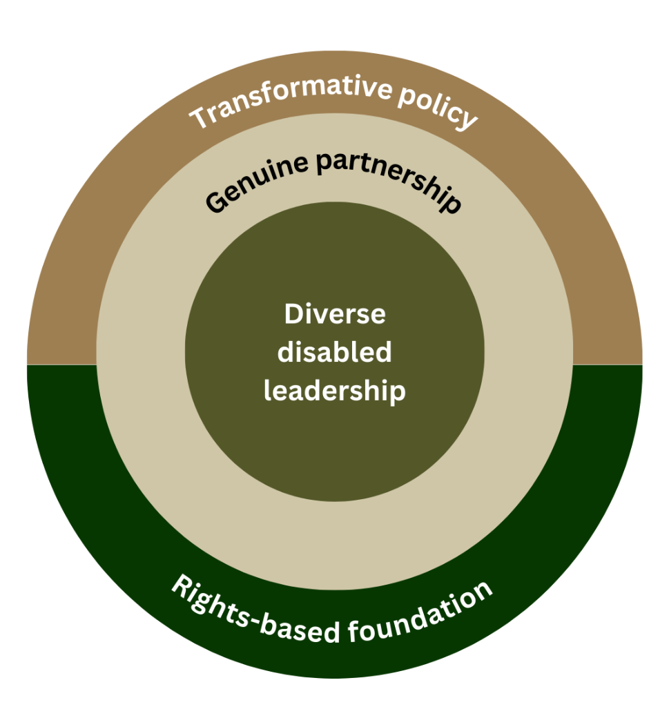
During the monitoring process, participants shared their ideas and recommendations for improving disability supports and services in Aotearoa. In total, 30 recommendations were made across the four reports. Using a thematic analysis approach, participant recommendations were then re-analysed and refined, resulting in four key themes that participant responses indicated would underpin an improved disability support system. These were:
- Diverse disabled leadership,
- Genuine partnership,
- Rights-based foundation, and
- Transformative policy.

These four themes were then imagined within an ecological model framework, enabling them to be conceptualised at the individual, relationship, community, and system levels, as demonstrated in the image on the right.

[Image Description: Three layers of circles, reflecting the ecological model and the four interrelated themes in earthy colours. ‘Diverse disabled leadership’ is at the centre of other elements and is the innermost circle. The next biggest circle is ‘Genuine partnership’. The outermost circle is divided into two parts; the bottom half says ‘Rights-based foundation’, while the top half says ‘Transformative policy’.]

Importantly, this framing illustrates how the four themes are interrelated and interdependent, where one cannot be realised without the others. That is, when diverse disabled leadership is supported, then genuine partnership between government agencies and disabled people, tākata whaikaha Māori, Pacific disabled people, and other diverse disability communities will occur. Disability leadership and genuine partnership drive the system to operate from a rights-based foundation, ultimately leading to the transformation of legislation and policies to align with, and be accountable to, Te Tiriti o Waitangi, the UNCRPD, and the New Zealand Disability Strategy. The four themes are discussed in further detail below.

Diverse disabled leadership
Participants expressed a strong preference for disability supports and services that are not only co-designed with the disability community, but led by disabled people, and those who know them best - their families, whānau, aiga, and close supporters. They emphasised that leadership must include disabled people with diverse lived experiences, including people with intersecting identities related to culture, gender, age, socio-economic background, and geographic location. Ensuring this diversity in leadership and decision-making was considered essential to creating services that accurately reflect the communities they serve. This key theme is firmly grounded in the well-established disability rights mantra, “nothing about us, without us.”

“That it would be disability led. That, in fact, we would be assessing the providers, not the providers assessing us, but those who are disabled who have been for a long time, whether they’re new to a disability or not, with the experience of living with that disability and their families. My greatest dream is that we would bring that funding back into communities. That, in fact, the disability community would be a part of assessing who would hold that money for the disabled. That would be totally disabled focussed, totally driven.” (ACC Focus Group)

Genuine partnership
Participants reported that the hard-earned, authentic partnerships they had developed with government agencies over the years had been eroded. They described a shift in recent decision-making processes - both in how decisions were made and in the outcomes produced - that left them feeling their lived experience and expertise were undervalued or overlooked. According to many participants, this gradual erosion of trust meant they felt tokenised in decision-making processes, rather than actively engaged as equal partners. In response, participants expressed a strong and consistent desire to re-establish genuine, reciprocal relationships between the disability community and government, characterised by transparency, shared accountability, and respect for the expertise that comes from lived experience.

“I think then the independent, the Te Tiriti partner and the disabled people and family partners will need resourcing to go out and develop an independent collective voice around from a tāngata whaikaha Māori and Māori iwi perspective, you know, those formal relationships and also disabled people, so that together, they can also hold Whaikaha to account.” (Disability Sector Leader)

Rights-based foundation
A strong human-rights foundation was considered fundamental to all decision-making related to disability supports and services policy and practice. This meant that decisions should not only meet the immediate support needs of disabled people but also actively uphold their inherent rights, dignity, and autonomy. Participants emphasised that a rights-based approach requires consistent attention to the Government’s obligations under Te Tiriti o Waitangi - including genuine partnership with tākata whaikaha Māori, as well as alignment with the Articles of the United Nations Convention on the Rights of Persons with Disabilities (UNCRPD), the New Zealand Disability Strategy, and the Health and Disability Commissioner (HDC) Code of Rights.
A rights-based foundation positions disabled people as rights-holders rather than passive recipients of care, and it places responsibility on duty bearers (government agencies, service providers, and decision-makers) to protect, promote, and realise those rights. This includes ensuring equitable and reliable access to supports, respecting self-determination, enabling informed choice and control, and embedding accountability when rights are not upheld.
“So there's a hell of a lot more that needs to be done at the government level to really start making some meaningful change for us.” (Pacific Focus Group)

Transformative policy
Participants emphasised that meaningful and sustained systemic change could only occur through transformative policy and practice, rather than incremental or surface-level adjustments. They described transformative policy as reshaping how disability supports and services are conceptualised, funded, governed, and delivered, and by centring the EGL principles.
Without such transformation, participants did not believe that duty bearers across the DSS system would reliably and proactively deliver a rights-based approach, uphold genuine partnership with disabled people and tākata whaikaha Māori, or invest in diverse disability leadership. Transformative policy was therefore considered not an optional aspiration but a necessary lever to shift culture, expectations, and accountability. It provides the structural mandate to drive behavioural change, redistribute power, and ensure the system moves beyond the charity and medical models of disability to the social and human rights models.

“So we need the rules to be looked at. The policies to be looked at so that they are clear that the aim is to enable people to live, not just in their homes, but in the community. And the actual support that's delivered needs to be designed in a way that it'll allow you to do that. At the moment, the rules are a barrier. The priority is to stay at home. [...] I don't think we do good on Article 19.” (Home and Community Support Focus Group)

4.1 Key themes in practice
As outlined in the more detailed graphic below, a further 10 priorities provide more specific instruction on what the four themes look like in practice.
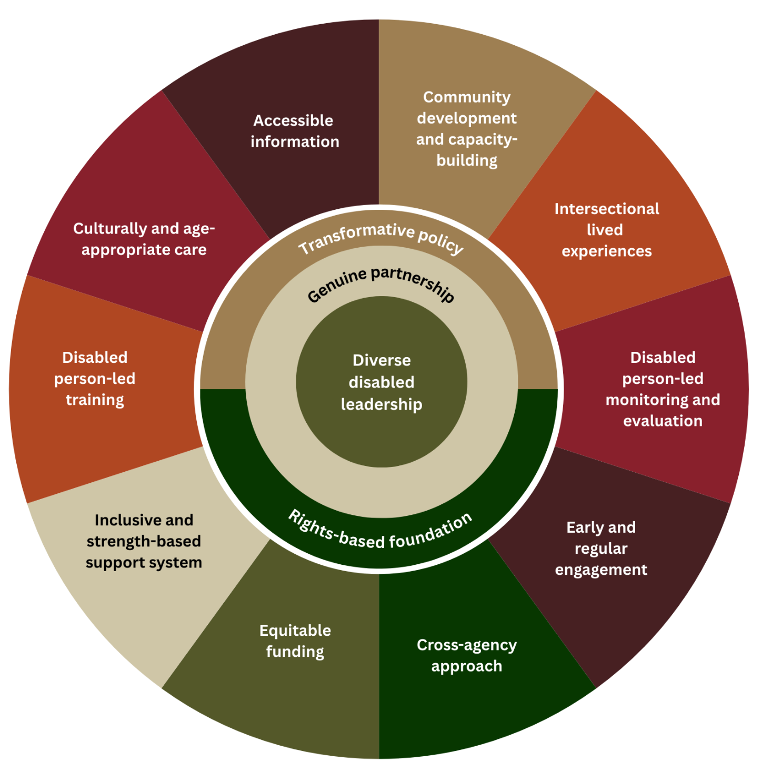
[Image Description: A doughnut chart divided into 10 sections, each with different earthy colours. In the middle of the doughnut is the ecological model depicting the 4 key themes. The 10 sections of the outer doughnut say (clockwise from the top): community development and capacity-building, intersectional lived experience, disabled person-led monitoring and evaluation, early and regular engagement, cross-agency approach, equitable funding, inclusive and strength-based support system, disabled person-led training, culturally and age-appropriate care, and accessible information.]

Invest in community development and capacity-building
Investments in community development and capacity-building ensure that disabled people, tākata whaikaha, Pacific disabled people, and their families, whānau, aiga, and close supporters have opportunities to come together, strengthen their collective voice, and actively participate in planning for the national rollout of Enabling Good Lives (EGL). These investments support community-led initiatives, including organising hui and other accessible, welcoming spaces that foster collaboration and inclusion.

They also promote peer-to-peer learning and leadership development, creating pathways for emerging disabled leaders to learn from experienced leaders, observe effective leadership in action, and gradually assume leadership roles themselves. By building skills, knowledge, and leadership capacity within the community, this approach enhances continuity, shared expertise, and long-term sustainability in disability advocacy and decision-making.

Prioritise intersectional lived experiences
Disability leadership and the wider disability community are strengthened when they reflect the full intersectional diversity of disabled people. This means creating opportunities that are accessible, equitable, and safe for tākata whaikaha Māori, Pacific disabled people, disabled migrants, disabled people from the LGBTQIA+ community, people with learning disabilities, D/deaf and hard-of-hearing people, and people with multiple and complex disabilities and for their families, whānau, and aiga. Ensuring this breadth of representation helps build a leadership landscape that genuinely reflects the communities it serves and supports inclusive decision-making.

Ensure disabled person-led monitoring and evaluation
Monitoring and evaluation of DSS and the implementation of Enabling Good Lives (EGL) are led by disabled people, ensuring that assessment and accountability processes are grounded in lived experience and community-defined priorities.

Enable early and regular engagement
Engagement and consultation processes led by government agencies occur early and regularly, ensuring disabled people’s voices are respected and taken seriously, and that their input leads to tangible, meaningful outcomes.

Adopt a cross-agency approach
Whaikaha provides leadership on disability issues across the government, while other government agencies also take proactive responsibility for improving their policies and practices that affect disabled people and their supports and services. These efforts are guided by a commitment to align with Te Tiriti o Waitangi, the UNCRPD, and EGL principles.

Ensure equitable funding
Equitable funding involves allocation at two levels: first, ensuring that Whaikaha has sufficient resources to serve the disability community effectively; and second, increasing investment in disability supports and services more broadly, including raising the Disability Support Services (DSS) funding to achieve equity with ACC funding. The Enabling Good Lives (EGL) funding model is prioritised to guide this investment and ensure funding aligns with community needs and principles.
These supports and services are designed to be flexible, responsive and reliable, ensuring that disabled people (including those in residential care and other living situations) have choice and control over their support and do not experience gaps or unmet needs. At the same time, the support workforce is recognised and valued as a meaningful and respected career.

Build an inclusive and strengths-based support system
A strength-based system ensures the entire journey of disability supports and services is grounded in the needs and strengths of disabled people, tākata whaikaha Māori, Pacific disabled people, and their families, whānau, and aiga. This approach includes expanding the scope of Whaikaha and broadening eligibility criteria for DSS to better encompass people with Fetal Alcohol Spectrum Disorder (FASD), chronic health conditions, psychosocial disabilities, and people over 65 years old. Needs assessments are conducted promptly and reflect these flexible eligibility criteria, placing people’s abilities, aspirations, and rights at the centre of support planning.

Implement disabled person-led training
Disabled person-led disability rights training is provided for government officials, service providers, connectors, assessors, and support workers. This training covers, among other topics, effective ways to engage and consult with the disability community, duty bearer obligations under the UNCRPD, and how to implement supported decision-making within disability supports and services. By centring the perspectives of disabled trainers, the program ensures that learning is grounded in lived experience and practical understanding.

Deliver culturally and age-appropriate care
Disability supports and services recognise both disability culture and the full intersectional identities and experiences beyond disability. Services are designed to be culturally responsive, gender- and age-appropriate, and delivered in a manner that is safe and respectful for all service users.

Provide accessible information
Information is a crucial gateway for accessing appropriate and relevant supports and services. Disability-related information is available early, easily accessible, written in plain language, and provided in alternative formats to meet diverse needs. Health care workers are often the first point of contact for disabled people seeking support. Consequently, doctors and other health professionals need training to effectively guide disabled people in accessing relevant disability supports and services.

5 Kupu Whakamutaka / Concluding Remarks
Throughout this monitoring research, participants generously shared their hopes, dreams and concerns about Whaikaha - Ministry of Disabled People, the Government’s consultation and engagement processes, disability supports and services, and Enabling Good Lives. The recommendations highlight a wide variety of solutions to the challenges and rights violations they have experienced, while demonstrating their expertise and knowledge about what they need to live good lives.

While the Government’s announcement in September 2025 regarding greater flexibility, choice and control for future Individualised Funding users and standardised needs assessments indicates a move in the right direction, many of the challenges identified in these monitoring reports remain unaddressed. It is also uncertain who will lead the redesign of assessment processes and allocations, the impact of averaged Individualised Funding budgets, and when the pause on EGL will end. In summary, it is yet to be determined whether this new approach will achieve the progressive realisation of disabled people’s human rights in a real and meaningful way.

It is therefore essential that the findings of this monitoring cycle continue to inform the design and delivery of a disability supports and services system that is fit for purpose, and aligned with Te Tiriti o Waitangi, the UNCRPD, and the New Zealand Disability Strategy. Importantly, in order to meet the obligations of the UNCPRD, participants envisioned a supports and services system underpinned by diverse disability leadership, genuine partnership, disability rights and transformative policy. In practice, this means ensuring New Zealand’s disability support system is community-driven, equitable, and grounded in lived experience. It means sufficient investment in community capacity-building and leadership development, with the active inclusion of diverse identities and experiences. Strong, early, and ongoing engagement supported by disabled person-led evaluation, training, and culturally responsive practice is central to achieving the desired change. A cross-agency commitment, supported by equitable and flexible funding, will ensure that services can be redesigned to uphold disabled people’s choice, rights, and self-determination. Ultimately, these priorities work collectively to shape an inclusive and strengths-based system where disabled people and their families, whānau, aiga and close supporters are empowered to lead decision-making and influence the systems that exist to serve them.

6 Tohutoro / References
Disability Support Services. (2025). Independent review. https://www.disabilitysupport.govt.nz/about-us/taskforce/independent-review

Donald Beasley Institute. (2025a). Disabled Person-Led Monitoring of the UNCRPD: My Experiences, My Rights: Disability Supports and Services - Preamble. Disabled People’s Organisations Coalition.

Donald Beasley Institute. (2025b). Disabled Person-Led Monitoring of the UNCRPD: My Experiences, My Rights: Supports and Services Report 1 - Whaikaha - Ministry of Disabled People. Disabled People’s Organisations Coalition.

Donald Beasley Institute. (2025c). Disabled Person-Led Monitoring of the UNCRPD: My Experiences, My Rights: Disability Supports and Services Report 2 - Consultation and Engagement. Disabled People’s Organisations Coalition.

Donald Beasley Institute. (2025d). Disabled Person-Led Monitoring of the UNCRPD: My Experiences, My Rights: Disability Supports and Services Report 3 - Disability Support Services (DSS). Disabled People’s Organisations Coalition.

Donald Beasley Institute. (2025e). Disabled Person-Led Monitoring of the UNCRPD: My Experiences, My Rights: Supports and Services Report 4 - Enabling Good Lives (EGL). Disabled People’s Organisations Coalition.

United Nations. (2006). Convention on the Rights of Persons with Disabilities – Articles. https://www.un.org/development/desa/disabilities/convention-on-the-rights-of-personswith-disabilities/convention-on-the-rights-of-persons-with-disabilities-2.html

Whaikaha Ministry of Disabled People. (2024). Whaikaha - Purchasing Rules and Equipment and Modification Services (EMS) Update. https://www.whaikaha.govt.nz/news/news/whaikaha-purchasing-rules-and-equipment-and-modification-services-ems-update



Hereafter, ‘Aotearoa’.
Hereafter, ‘Whaikaha’.

