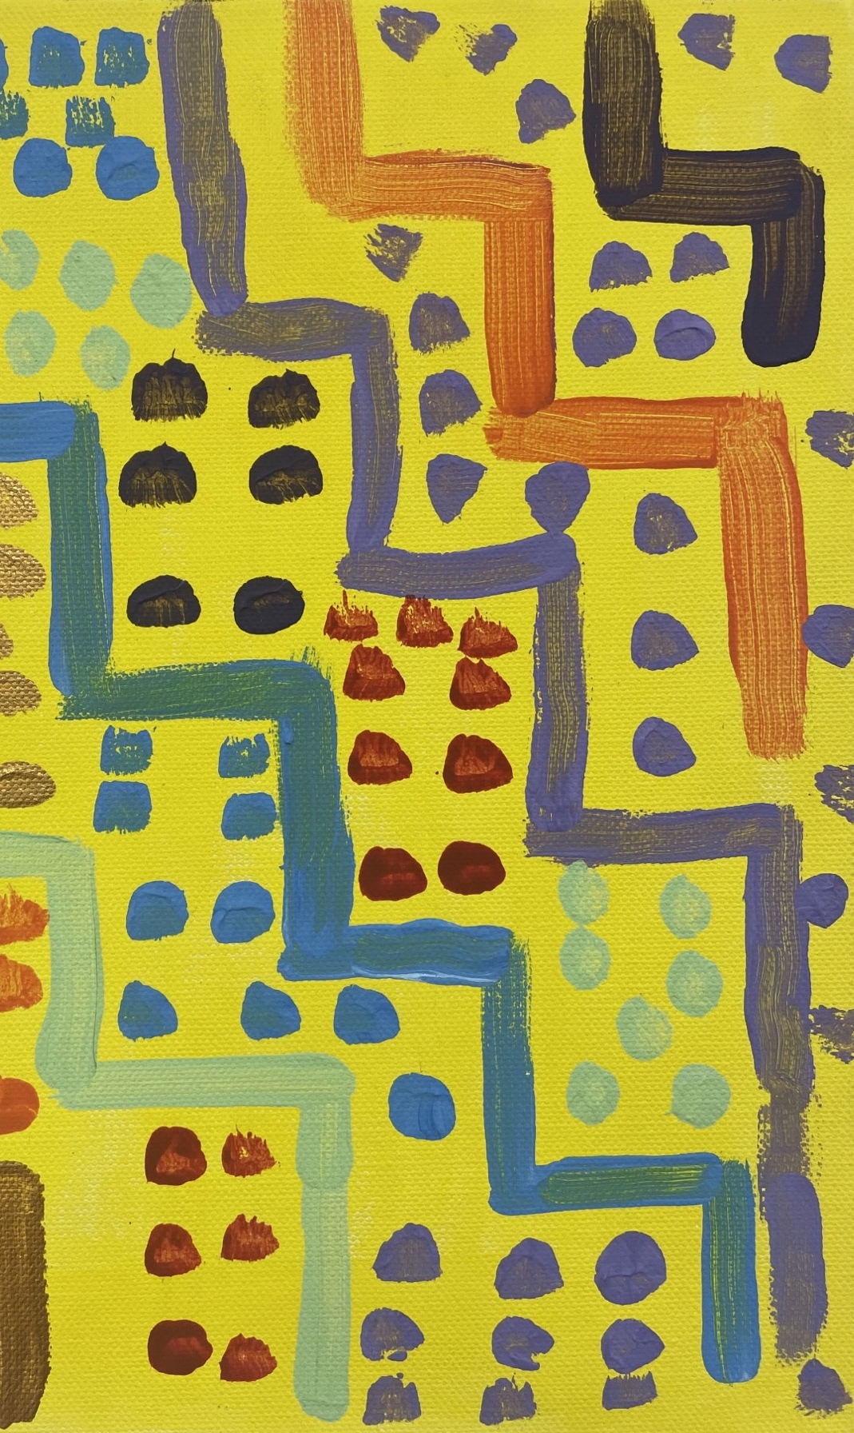

The Meaning of ‘Family’ in a Multicultural Context:

Disabled People’s Perspectives on Article 23 of the UNCRPD

Summary Report

Kā Whakamihi / Acknowledgements
We are deeply grateful to the participants of this study for entrusting us with their stories and perspectives. We also acknowledge the staff, kaumātua, and advisory group members who guide all of the DBI’s research with wisdom and expertise.

Author: Donald Beasley Institute (DBI). The DBI is an independent charitable trust that conducts disability research and education. The DBI is committed to ethical, inclusive, and transformative research and projects that promote the rights of disabled people.

Citation Guidance: Donald Beasley Institute. (2024). The meaning of ‘family’ in a multicultural context: Disabled people’s perspectives on Article 23 of the UNCRPD. [Summary Report]. Jubilee Trust.

Research Team: Dr. Robbie Francis Watene, Dr. Solmaz Nazari, Jacinta Tevaga, Ash Beales, Umi Asaka, Lydie Schmidt, and Eden Cruice, with research guidance and mentoring from Associate Professor Brigit Mirfin-Veitch and Dr. Kelly Tikao.

Kōrero Whakamārama: We apply the Kāi Tahu dialect when writing in te reo Māori, that includes Kāi Tahu specific words and replacing the ng with a k.

Project Artwork: Jeffery Oliver

Disclaimer: The Jubilee Trust assisted in the funding of this report but had no input into its preparation or content and does not guarantee its accuracy or accept any liability for any errors or omissions. The Jubilee Trust had no role in the design, execution, analysis or interpretation of this work.

Whakarāpopototaka Mātua / Executive Summary
This research facilitated a disability-led conversation about family/whānau and the home. It explored disabled people’s perspectives on Article 23 of the United Nations Convention on the Rights of Persons with Disabilities (UNCRPD) – the right to respect for home and the family within the multicultural context of Aotearoa New Zealand. The full research report and visual report can be accessed through the Donald Beasley Institute’s website.
Research has consistently shown that disabled people experience discrimination in relation to relationships, marriage, reproductive health, forming a family, and establishing a home (Vikström et al., 2020). Furthermore, family, whānau, aiga and close supporters of disabled people can experience significant financial, physical, and emotional challenges when caring for their disabled family member, and upholding their rights, will and preference (Donald Beasley Institute, 2022).
In order to capture disabled people’s diverse perspectives in relation to home and family, this research was guided by three key questions:
- What does ‘family/whānau’ mean to you?
- What does ‘respect for home and family’ mean for disabled New Zealanders?
- How is Article 23 of the UNCRPD realised within multicultural communities?
The social and human rights models of disability, Te Tiriti o Waitangi, and the United Nations Convention on the Rights of Persons with Disabilities, specifically, Article 23 were all used as foundations for the research.
Following an integrative literature review, 81 disabled people, family, whānau, aiga, and close supporters completed a questionnaire with a further 14 people taking part in a qualitative interview. Participants had a wide range of disabilities, ethnicities, and identities.

Kiteka / Key Findings
Findings from the questionnaire and qualitative interviews are centred on six key themes reflecting the perspectives of disabled people and their family, whānau, aiga and close supporters on disability, home and family. These themes are my family; my roles and responsibilities; my culture; my supports; my aspirations; my home; and barriers to home and family.

1. My Family, My Whānau
Participants shared their definitions of family, whānau and aiga, and what it means to them. For some participants, family includes their immediate relations through blood or by marriage, while for other participants, family includes extended family, people unrelated by blood or marriage, people with shared identities, ancestors, and sometimes pets. Participants highlighted the rich tapestry of family networks that extended beyond traditional Western concepts, including cross-generational family members and chosen family.

2. My Roles and Responsibilities
Participants highlighted the significance of family roles and responsibilities - that contributing to their households and reciprocating support was an important part of their home and family life. Participants emphasised that they were involved and contributing members of their families through familial roles, leadership roles or task-oriented roles (like being a responsible pet owner). Importantly, these roles were no different from the roles filled by other non-disabled family members, even though participants sometimes needed extra support and accommodations to fulfil these roles effectively.

3. My Culture
Culture influences values, goals, beliefs, and behaviours (Bámaca‐Colbert et al., 2019). Participants shared that culture influenced the structure of their households, their role and responsibilities as children and adults, and the respect they had for each other within their family and also for their wider communities. Culture also influences how people understand disability and how a family or community supports its disabled members (Office for Disability Issues, 2021). A Māori participant described how their whānau Māori responded to their disability differently to their Pākehā family, articulating that Māori understandings of disability do not focus on impairments but focus on the person first and treat them as equals. One Deaf participant emphasised the role of family in instilling cultural values.

4. My Supports
Supports can be an important part of disabled people’s lives (Thompson, et al., 2014). Some participants shared that this support was provided by immediate family in the forms of emotional, financial, practical, childcare and household management support. Other people used disability and other formal services to access support for daily living. Many participants highlighted that support was an integral part of fulfilling their family and home roles and responsibilities.

5. My Aspirations
Participants shared their home and family aspirations - they spoke about their dreams of marrying and having children, becoming grandparents, and passing on their knowledge and experiences to future generations. A further aspiration was greater choice and control when it came to home and family - something that is not always experienced by disabled people. Participants wanted to see change - more acceptance of disability, and greater respect for different cultural understandings of disability, home and family.

6. My Home
According to participants, home can be physical or symbolic - a space where people feel physically, emotionally, and culturally safe. Participants shared the importance of having a home that is accessible, safe, and a place where they are respected. Other participants mentioned the lack of accessible housing options, and the negative impact this had on their sense of home. Accessibility also went beyond the physical environment, for some participants. For instance, accessible communication was a significant characteristic of home for Deaf participants. One queer participant highlighted that safety was an essential part of home, noting that being in a safe home can positively impact physical health, mental health and relationships with others.

7. Barriers to Home and Family
Throughout participant responses, it was evident that many disabled people experience barriers to realising their right to respect for home and the family.
These included:
- Barriers to roles and responsibilities: for example, negative assumptions or attitudes about which roles disabled people could and could not fulfil within their families;
- Barriers to cultural expressions of disability, home and family: for example, the limiting nature of Western concepts of disability, home and family, and the ongoing impacts of colonisation;
- Barriers to support: for example, inadequate or inappropriate support and care arrangements as well as support systems which are difficult to navigate; and
- Barriers to home and family aspirations; for example, many disabled people face assumptions about their ability to, or appropriateness of establishing a home and forming a family.

Kōrerorero / Discussion
Within this research, many of the findings were unsurprising, and reflected the everyday roles, responsibilities, expectations, pressures, concerns, and joys of any other family or individual. However, as shared by participants, there are also nuances to disability, home and family; complexities that can only be understood through lived experience.

There were four broad themes that emerged throughout the conversations with participants:
- aspirations - same, but different;
- the intersections of culture, disability, home and family;
- natural supports and reciprocity; and
- formal supports - family-like, but not family.

Aspirations: Same but different
Participants’ aspirations were impacted by attitudes, systems, and environments that are inherently ableist or disablist. Ableism is indirect discrimination through the preferential treatment of those who fit within society’s idea of ‘normal’ (Lewis, 2022). Disablism is direct discrimination and prejudice against disabled people (Miller et al., 2004). Although participants did not report blatant discrimination, they identified barriers that indicated underlying prejudices and harmful ideologies in Aotearoa that inhibited disabled people’s experiences of home and family. These systemic barriers impede disabled people’s ability to carry out home and family responsibilities, in contradiction with Article 23 of the UNCRPD.

Intersections of culture, disability, home and family
Participants shared their unique cultural contexts, and how this affected perceptions of disability as well as disabled family member’s roles and responsibilities. For example, some participants drew attention to Western (individualistic) approaches to disability and support, which often embody values such as independence and self-reliance (Humphrey & Bliuc, 2022). On the other hand, collectivist cultures, as was highlighted by Māori and Pacific participants, tend to focus more on whānau and aiga, and each member’s contributions and shared responsibility to support and maintain the group’s wellbeing. Deaf participants described family as primarily being blood relations, while drawing attention to the importance of Deaf culture, Deaf community and sign language in the context of home and family, particularly in regards to communication and relationships. LGBTQIA+ participants also extended their definition of family to include those with shared queer and disability identities, with home being a place where they felt safe in their identity. These findings highlight the intrinsic link between culture, disability, home and family.

Natural supports and reciprocity
Participants shared that informal supports, or natural supports were important in their home and family. Participants wanted support to be mutual and not one sided, however, participants’ ability to reciprocate support was impacted by their ability to access formal supports. If participants were unable to access appropriate formal supports, they were unable to enjoy their right to respect for home and the family. Barriers to formal support are often underpinned by negative attitudes about disability and disabled people. This can lead to assumptions, processes, and practices that undervalue disabled people’s contribution to home and family roles.

Formals supports: family-like but not family
Formal and paid supports are a critical part of daily life for some disabled people (Robinson et al., 2021 & Thompson et al., 2014). Support workers can help with disabled people’s independence, social connections, and community participation. However, participants said that formal supports, such as support workers, were family-like, but not family. Formal supports were considered transactional in nature, with no expectation for reciprocal exchange. Participants highlighted that formal supports were a tool that enabled participants to not only fulfil their familial roles and responsibilities, but to reciprocate the care and support they received from natural supports (such as family, whānau and aiga).

Enabling Good Lives (EGL)
The findings of this research, along with the discussion themes, can be easily linked to the eight principles of the Enabling Good Lives (EGL) approach. The disability community has long expressed concerns about disability supports and services not working well for disabled people and their families due to a lack of choice and control (Ministry of Social Development, n.d.). Developed by the disability community, Enabling Good Lives (EGL) is an approach that enables disabled people and their families to have a say in their lives, easy access to support and services and systems-level influence. EGL is based on eight core principles that can be applied in any given situation and has been recommended as a single principles-based system for application throughout the work of all government agencies (Enabling Good Lives, 2024). This includes the government’s work to progressively realise home and family obligations contained in Article 23 of the UNCRPD.

Kupu Whakamutaka / Concluding Remarks
This research has started an important disability-led conversation about home and family. Participants talked about their home, whānau, aiga, close supporters and formal supports. They also identified barriers to home and family, and their aspirations. The findings provide unique insight, guidance, and direction for duty-bearers on the right to respect for home and family which can be used to inform policy and practice.

For LGBTQIA+ communities, families were also considered as those who shared connections that were not blood or by marriage, but who shared identity in a familial way. This is sometimes referred to as ‘chosen’ family (Jackson Levin et al., 2020).

