
Disabled Person-Led Monitoring
of the UNCRPD
My Experiences, My Rights:
Disability Supports and Services

Report 5 - Summary of Recommendations
Executive Summary

Whakarāpopototaka Mātua / Executive Summary

Project Brief
In 2021, the Disabled People’s Organisations Coalition (DPO) asked the DBI to do disabled person-led monitoring of the United Nations Convention on the Rights of Persons with Disabilities (UNCRPD). The DBI monitored disabled people’s experiences of disability supports and services in Aotearoa New Zealand. As a result, five reports were produced. This final report presents a summary of recommendations from reports 1-4.

Summary of reports
Report 1 - Whaikaha - Ministry of Disabled People: The first report included the perspectives of disability sector leaders, disabled people and their families, whānau, aiga, and close supporters in relation to Whaikaha - Ministry of Disabled People.
Report 2 - Consultation and Engagement: The second report included participants' perspectives on government consultation and engagement processes related to disability funding, supports, and services.
Report 3 - Disability Support Services (DSS): The third report focused on participants' experiences with supports and services.
Report 4 - Enabling Good Lives (EGL): The fourth report included participants’ reflections on Enabling Good Lives (EGL) and the impact of its eight principles on DSS.

Recommendations
Across the four reports, 30 recommendations were made for improving disability supports and services in Aotearoa. A thematic analysis approach was then used to refine the recommendations into key themes, which are presented and discussed in this current report, Report 5:
- Diverse disabled leadership - Participants wanted disability supports and services co-designed and led by disabled people with diverse lived experiences.
- Genuine partnership - Participants sought genuine, reciprocal relationships between the disability community and government, characterised by transparency, shared accountability, and respect for lived experience.
- Rights-based foundation - Participants wanted a strong human rights-based foundation for all decision-making related to disability supports and services policy and practice. This includes consistent attention to obligations under Te Tiriti o Waitangi, the UNCRPD, the New Zealand Disability Strategy, and the Health and Disability Commissioner (HDC) Code of Rights.
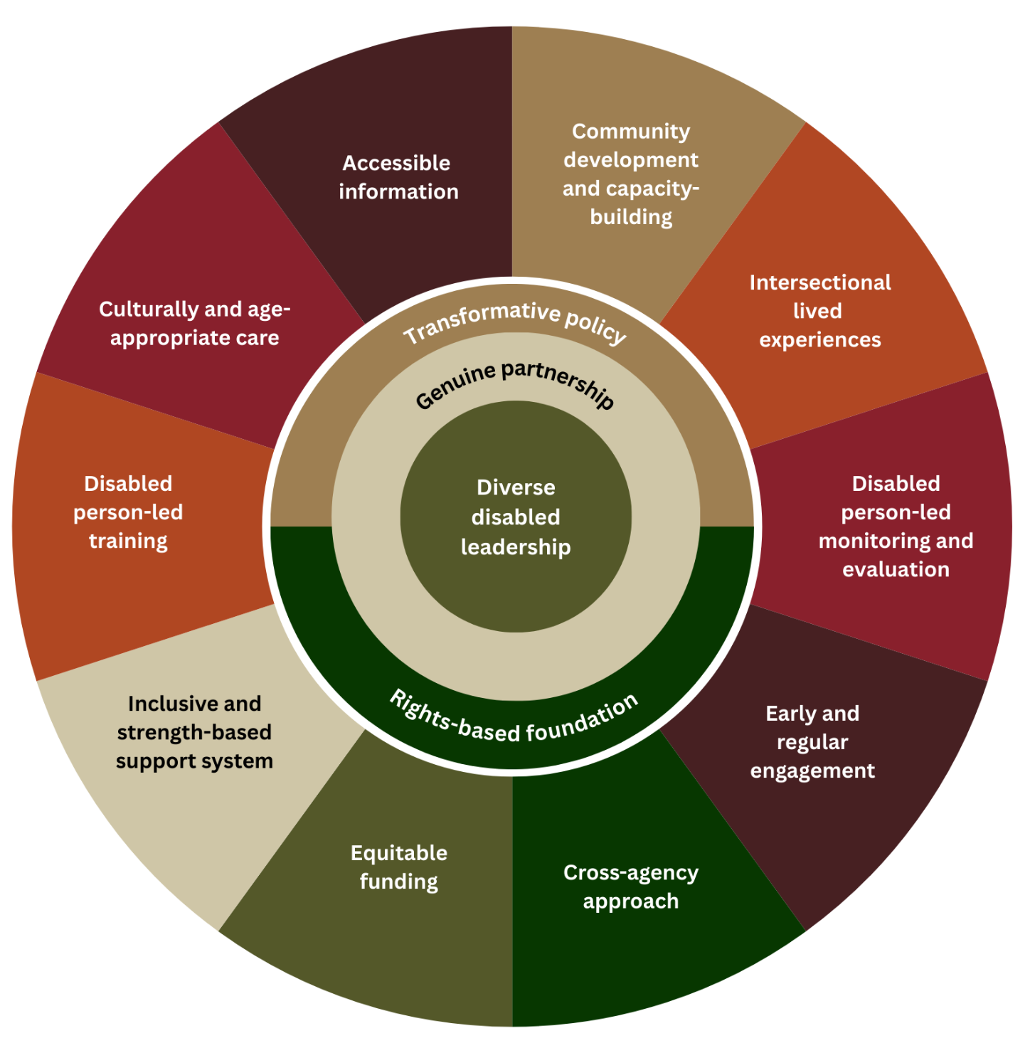
- Transformative Policy - Participants wanted transformative policies that reshape how disability supports and services are conceptualised, funded, governed, and delivered, centred on EGL principles.

The four themes were then imagined within an ecological model. This framing illustrates how the four themes are interrelated and interdependent; none can be realised without the others. With diverse disabled leadership, a genuine partnership between the disability community and the government emerges, resulting in transformative policy grounded in a human rights-based framework.

Key themes in practice
A further 10 priorities provide more specific instruction on how the Government can implement the four themes in practice:
- Invest in disability community development and capacity-building
- Prioritise intersectional lived experiences
- Ensure disabled person-led monitoring and evaluation
- Enable early and regular engagement
- Adopt a cross-agency approach
- Ensure equitable funding
- Build an inclusive and strengths-based support system
- Implement disabled person-led training
- Deliver culturally and age-appropriate care
- Provide accessible information about supports and services
The recommendations highlight a wide range of solutions to the challenges and rights violations participants have experienced, while demonstrating their expertise and understanding of what they need to live good lives. While the Government’s September 2025 announcement regarding greater flexibility, choice and control for future Individualised Funding users, and standardised needs assessments, indicates a move in the right direction, many of the challenges identified in these monitoring reports remain unaddressed. It is therefore essential that the findings of this monitoring cycle continue to inform the design and delivery of a disability supports and services system that is fit for purpose, and aligned with Te Tiriti o Waitangi, the UNCRPD, and the New Zealand Disability Strategy.



