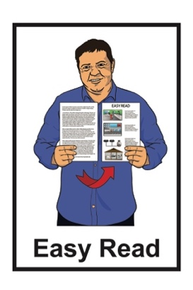


Preamble / Introduction –

Monitoring of My Experiences My Rights: Disability Supports and Services


Published: January 2026

Before you start


This document talks about abuse.

This information may upset some people when they are reading it.

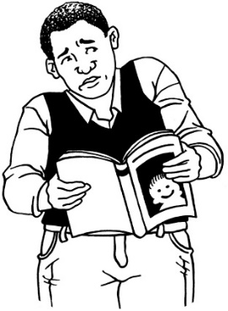

This information is not meant to scare anyone.

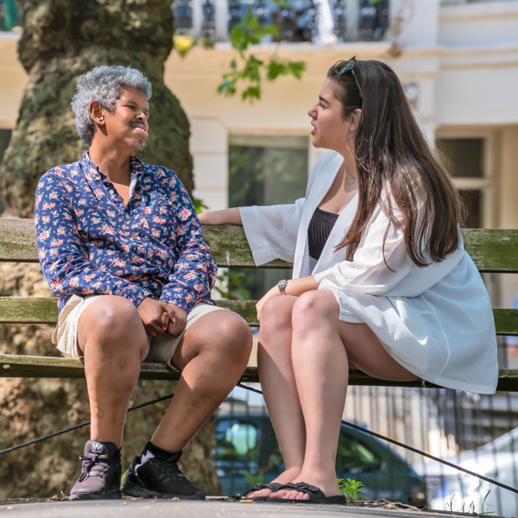
If you are upset after reading this document you can talk to your:
whānau / family
friends.

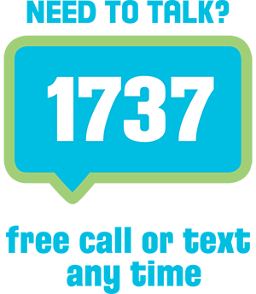
You can also contact Need to Talk by:
calling 1737
texting 1737.


It does not cost any money to call / text 1737.

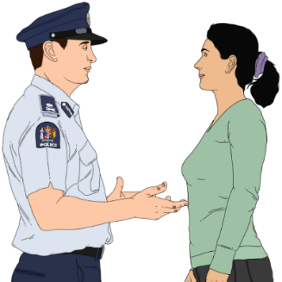
If you do not feel safe call the police on 111.

What is in this document

Page number:
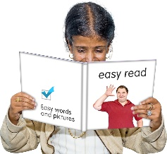

What is this Easy Read about? 5

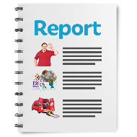
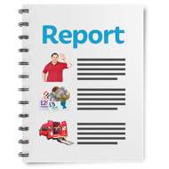
How to read the reports 10


Why we chose to monitor
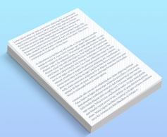
disability supports and services 11
What the UNCRPD says about
supports and services 14

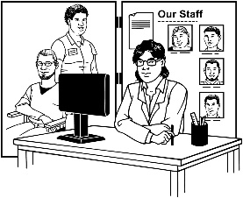
Supports and services in
Aotearoa New Zealand 17

Page number:

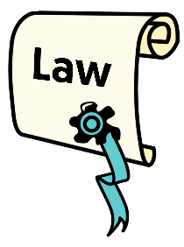
Laws about disability supports
and services 20

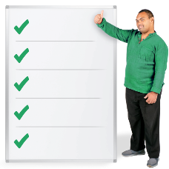
How DSS has changed
over the years 21

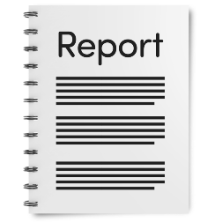
Royal Commission of Inquiry
and the HDC report 26

What is this Easy Read about?

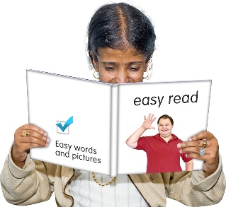
This Easy Read is a
preamble / introduction to some monitoring work done by the Donald Beasley Institute.


Here monitoring means watching how the Government does something to see how well they are doing it.


The Donald Beasley Institute does research about disability.

They are based in Dunedin in Aotearoa New Zealand.


In this document the Donald Beasley Institute will be called the DBI.
In this document we / us / our
means the DBI.

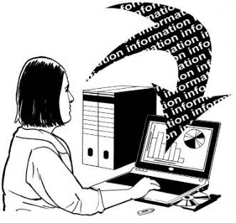
Research is when a lot of information about something is put together to learn about it.

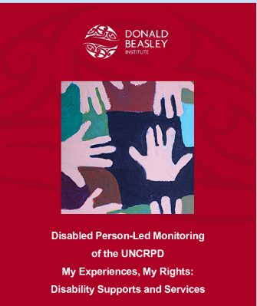
The monitoring has been done as part of the Disabled Person-Led Monitoring of the UNCRPD project.

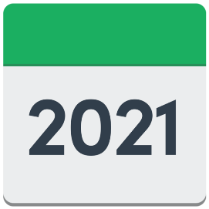
The Disabled People’s
Organisations Coalition / DPO Coalition asked the DBI to start doing this research in 2021.

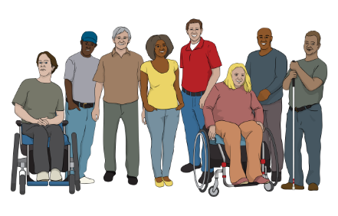
The Disabled People’s Organisations Coalition / DPO Coalition is a group of people who come from different disability organisations.


A coalition is a group of organisations that work towards shared goals.

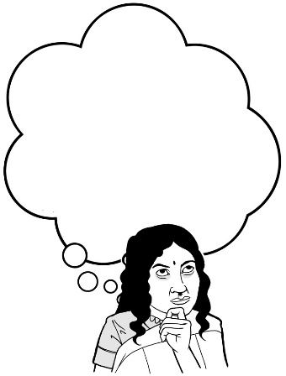
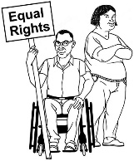
The DPO Coalition wanted to know how well the Aotearoa New Zealand Government was making the United Nations Convention on the Rights of Persons with Disabilities work in this country.

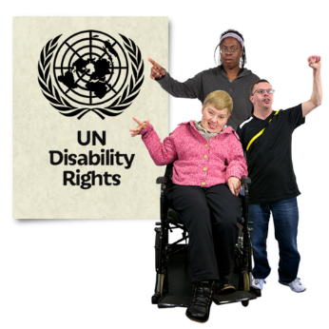
The United Nations Convention on the Rights of Persons with Disabilities / UNCRPD is a law lots of countries have agreed to.

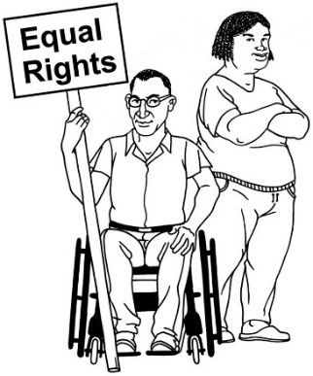
It says what governments must do to make sure disabled people get the same rights as everybody else.

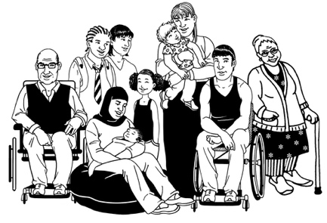
Rights are things everyone should:
have
be able to do.

Rights are things like:
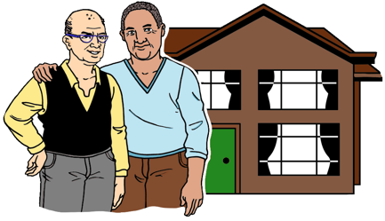
having a safe place to live
being able to get married.

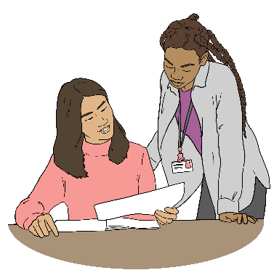
This Easy Read
preamble / introduction
explains things like:
why we are doing monitoring
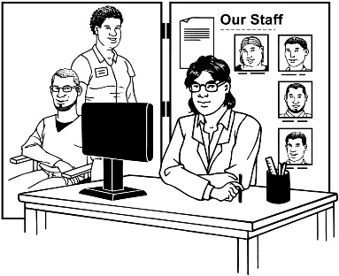
what has happened with disability supports and services in the past few years.

How to read the reports
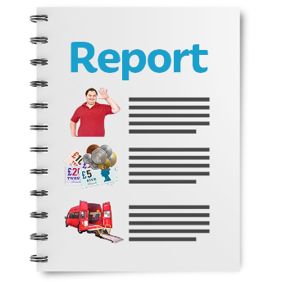
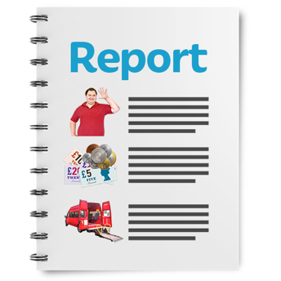

We have chosen to write what we have found out during our monitoring in a set of reports.

These reports are:

Preamble
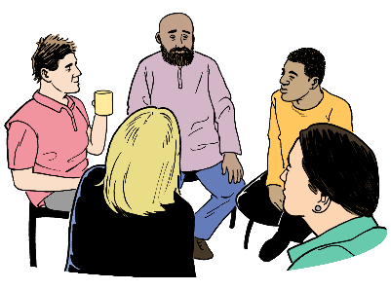
Report 1: Whaikaha Ministry of Disabled People
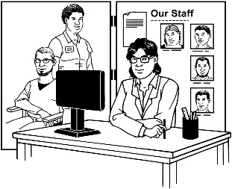
Report 2: Consultation and Engagement
Report 3: Disability Supports and Services

Report 4: Enabling Good Lives

Report 5: Summary of Recommendations.

Why we chose to monitor disability supports and services


In 2008 the New Zealand Government agreed to work towards making the UNCRPD happen in Aotearoa New Zealand.


The Government also agreed in 2016 to the UNCRPD optional protocol.
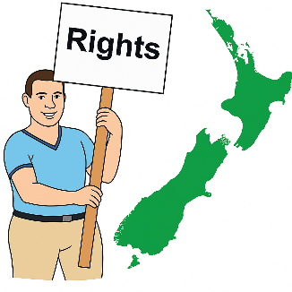

The optional protocol gives disabled people in Aotearoa New Zealand the right to:
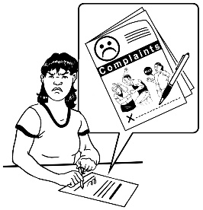
complain to the United Nations
if their rights are not being met
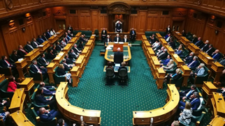
have the New Zealand Government respond to their complaints.
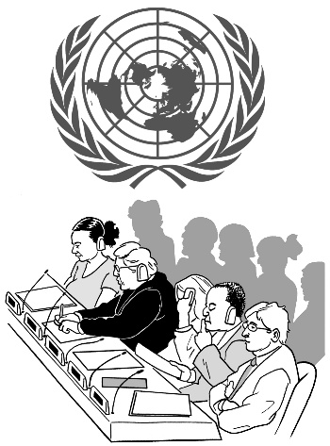
The United Nations is a group of countries that work together to do things like:
talk about problems
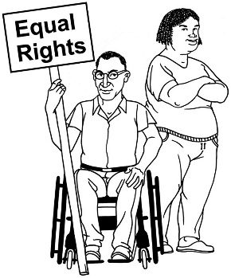
keep peace
protect human rights.

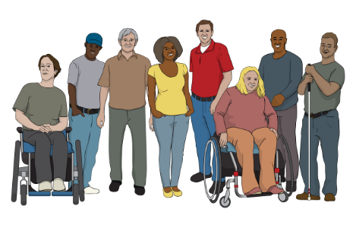
Article 33.3 of the UNCRPD says what the New Zealand Government must do as part of the monitoring.

It says monitoring how the Government is following the UNCRPD must be done with:
disabled people
DPOs.
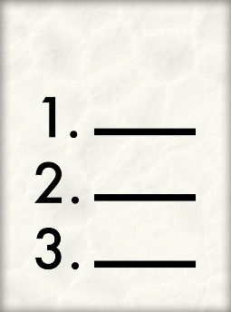

In this document an article means a part of the UNCRPD.



DBI has been doing UNCRPD monitoring led by disabled people since 2018.


DBI has found in other monitoring work that disability supports and services affect:
housing / where people live

health
wellbeing / people living good lives.

Because of what we found out disability supports and services was chosen as the third thing we monitored from 2022 to 2024.

What the UNCRPD says about supports and services

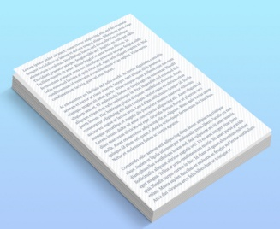
The UNCRPD does not have an article that is only about disability supports and services.
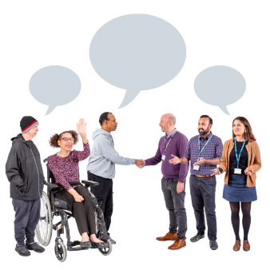

There are other articles that talk about things important to disability supports and services like:
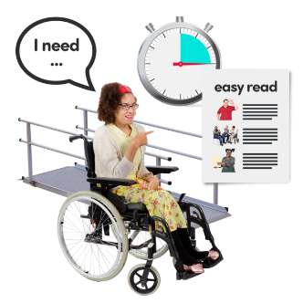
Article 9 talks about accessibility

Article 16 talks about safety from people hurting / using disabled people
Article 19 talks about disabled people:
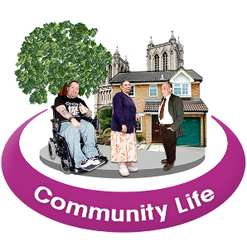
- living independently
- being part of the community.
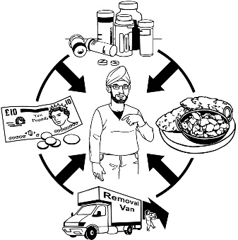
Living independently means a disabled person living a life where they:

can make choices about their life
have control over what they do.

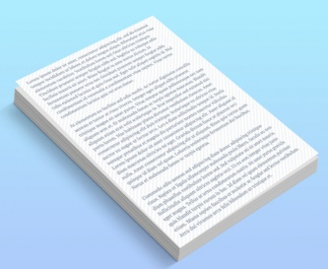

Other articles that talk about things important to disability supports and services are:
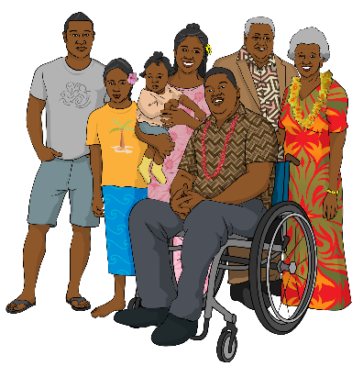
Article 20 which talks about personal mobility / being able to get from 1 place to another place
Article 23 which talks about respect for:
- whānau / families
- homes

Article 24 which talks about education.
Other articles that talk about things important to disability supports and services are:
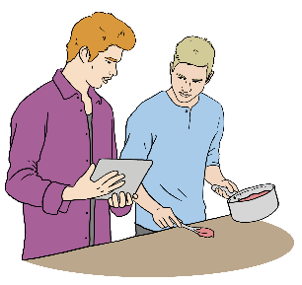
Article 26 which talks about:
- habilitation
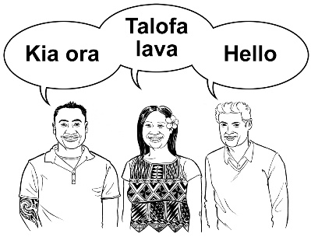
- rehabilitation
Article 30 which talks about taking part in things people do:

- as part of their culture
- for fun.

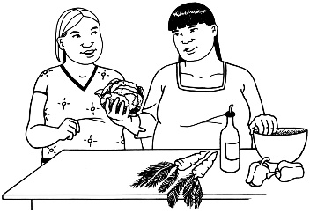
Habilitation means teaching people how to do everyday things they have not learnt how to do.


Rehabilitation means supporting people to relearn how to do things they could do before.

Supports and services in
Aotearoa New Zealand

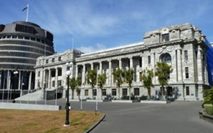
In Aotearoa New Zealand disability supports and services are provided by the Government.


The types of support a disabled person gets from the government is decided by:
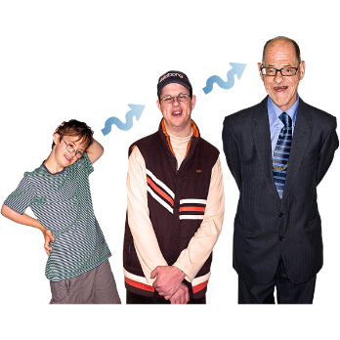
how the person became disabled
the age of the disabled person.

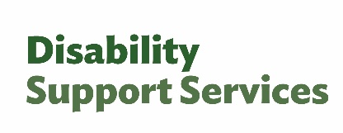
Disability Support Services / DSS provides support to:
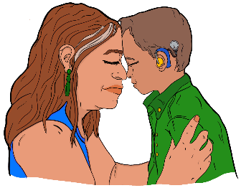
people born with a disability
people who have a disability caused by a health issue.

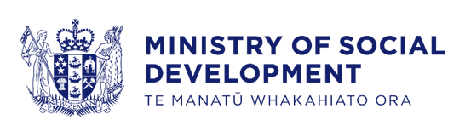
DSS is funded by the Ministry of Social Development.

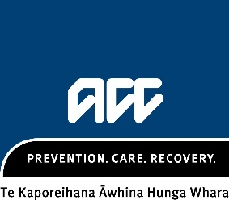
The Accident Compensation
Corporation / ACC provides support to people who have a disability because of an:
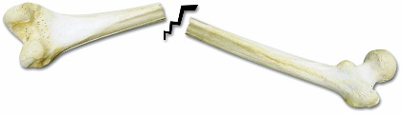
accident
injury.

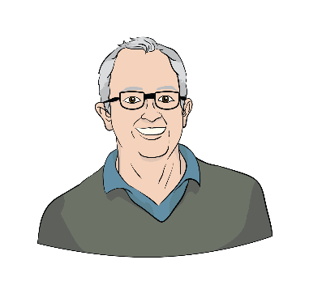
Health New Zealand provides support to disabled people:
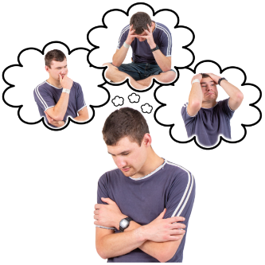
65 years and older
with psychosocial disabilities.

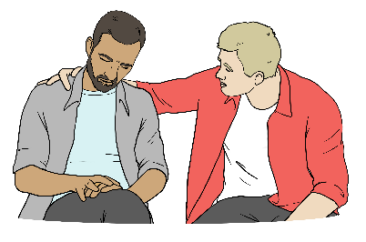
A psychosocial disability is when someone:
has a mental health condition

and
their mental health condition makes it hard for them to live a good life.


The Ministry of Education provides supports and services to disabled children when they are at school.

Laws about disability
supports and services

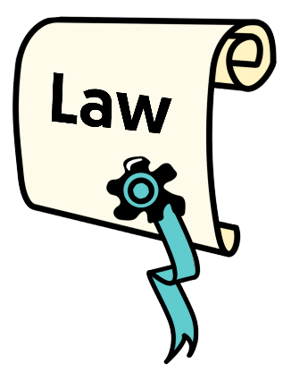
Aotearoa New Zealand has laws that DSS must follow like:
Pae Ora (Healthy Futures) Act 2022
Health and Disability Commissioner Act 1994
Health and Disability Services (Safety) Act 2001
Intellectual Disability (Compulsory Care and Rehabilitation) Act 2003.


Laws are rules a country has that everyone in the country needs to follow.

How DSS has changed over the years
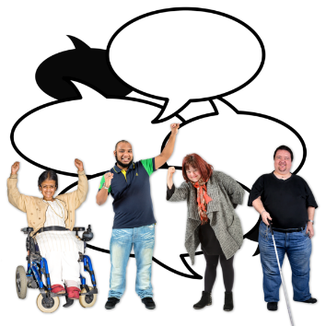

Disabled people have been asking for changes to DSS for over 30 years.

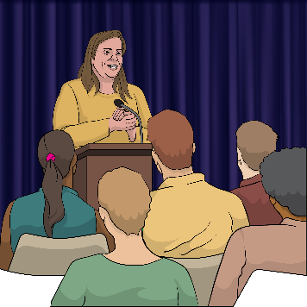
In October 2021 the New Zealand Government said:
- there would be a new ministry called Whaikaha – Ministry of Disabled People

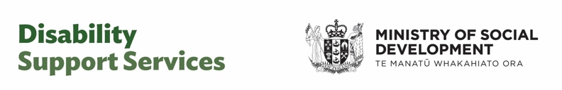
- DSS would change from being run by the Ministry of Health to being run by Whaikaha – Ministry of Disabled People.

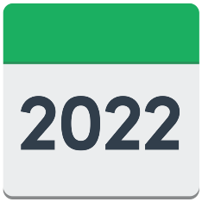
These things happened in July 2022.


Whaikaha – Ministry of Disabled People was to make sure:
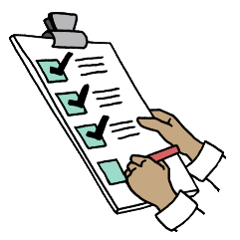
all disabled people and their families had access to Enabling Good Lives
government policies worked with what is written in the UNCRPD.
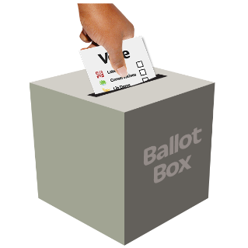

The New Zealand Government changed in 2023.


In March 2024 the new Government placed restrictions on funding with new:

purchasing guidelines
rules for Equipment and Modification Services / EMS.


Here restrictions on funding means:

disabled people could not spend their funding on things they used to be able to spend it on
there was no extra funding for disabled people.

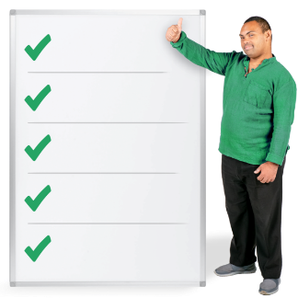
Here purchasing guidelines are rules for what can / cannot be
bought with disability funding.

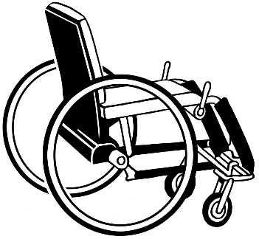
Equipment and Modification Services / EMS is the part of DSS that provides disabled people with:
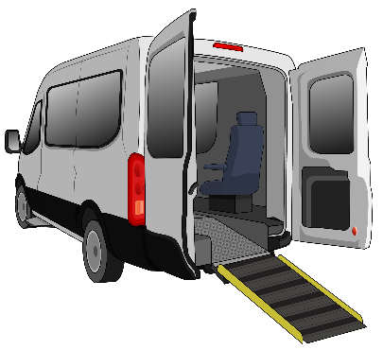
equipment like wheelchairs
modifications like changes to a car to make it easier for a disabled person to drive.
An independent review was then done on:

Whaikaha
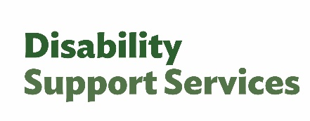
DSS.


An independent review is when a group of people who are not part of the Government look into something to see how well it is working.


The group who did the review made some recommendations after the first part of the review was done.


Here recommendations are things the group who did the review said should happen.


DSS was then moved from Whaikaha to the Ministry of Social Development.

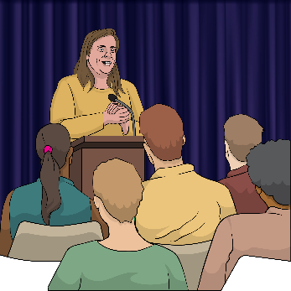
In September 2025 more announcements were made after the second part of the review.

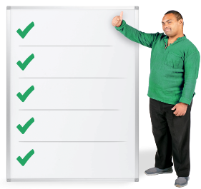
The announcements said:
some purchasing guidelines would be removed
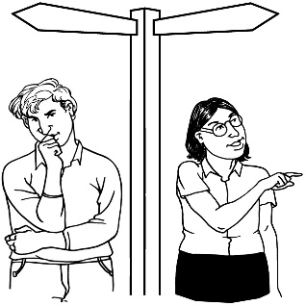
more choice and control would be given back to people with individualised funding

the amount of individualised funding each person would get in the future would be based on how much of their funding they had spent from June 2023 to June 2025.

Royal Commission of Inquiry and
the HDC report

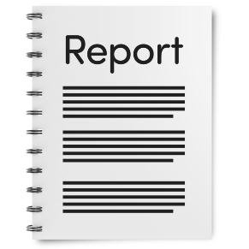
In July 2024 the Royal Commission of Inquiry into Abuse in State Care released its report.


The report showed how disabled people were:

1 of the biggest groups of people institutionalised in the past
abused which means being hurt a lot on purpose
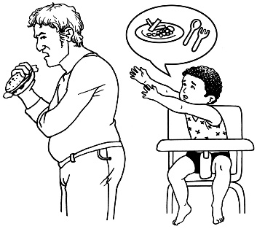
neglected which means not having basic needs taken care of like getting food.


Institutionalised means being sent to a place where:
you live with other disabled people
there are staff who are meant to take care of you
you cannot leave when you want.

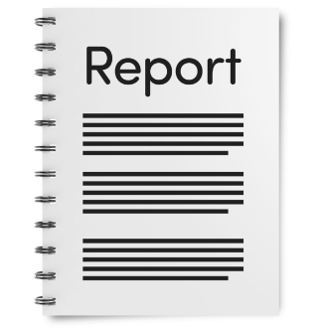
The Health and Disability Commissioner / HDC also released their report about complaints made about residential disability support services / residential care.

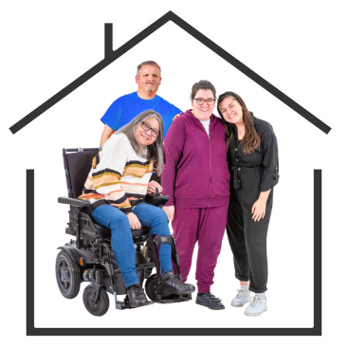
Residential disability support services / residential care means homes where disabled people live together with the support of staff.

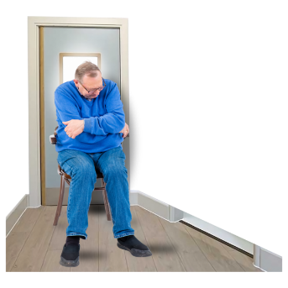
The HDC report showed that disabled people are still being abused / neglected in smaller residential care places that are funded by DSS.

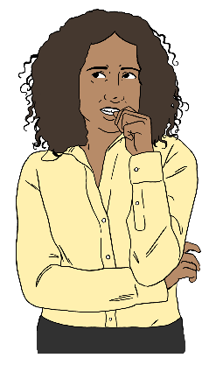
Because of all the things that the Royal Commission and HDC reports said had happened:
the DPO Coalition was worried
the monitoring team was worried.

Because of this worry they chose to keep monitoring disability supports and services until 2025.


This information has been written by the Donald Beasley Institute.

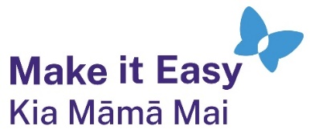
It has been translated into Easy Read by the Make it Easy Kia Māmā Mai service of People First New Zealand Ngā Tāngata Tuatahi.

The ideas in this document are not the ideas of People First New Zealand Ngā Tāngata Tuatahi.

All images used in this Easy Read document are subject to copyright rules and cannot be used without permission.


Make it Easy uses images from:

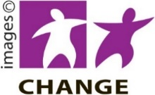
- Photosymbols

- Change Images


- Huriana Kopeke-Te Aho

- SGC Image Works

- T Wood


- Studio Rebeko

- Inga Kramer.

