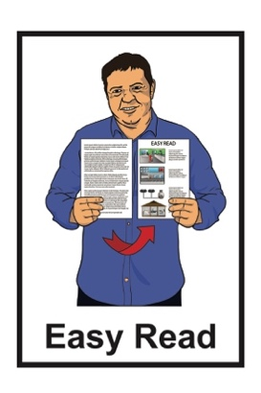


Summary of findings –

Monitoring of
My Experiences My Rights:
Disability Supports and Services


Report 5:
Recommendations
Published: February 2026

Before you start

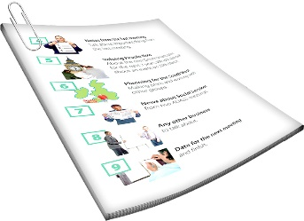
This is a long document.


It can be hard for some people to read a document this long.

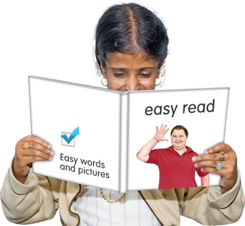
Some things you can do to make it easier are:
read it a few pages at a time
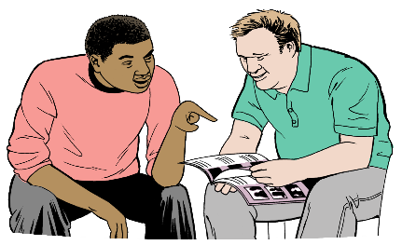
set aside some quiet time to look at it
have someone read it with you to support you to understand it.

What you will find in here

Page number:

5

About this Easy Read 3

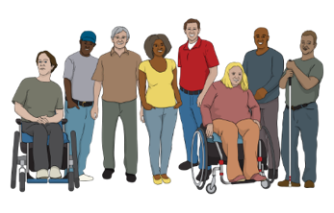
What was the research about? 6

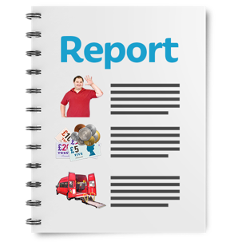
Summary of the reports 10




Recommendations 15

Priorities 25


More information 36

About this Easy Read


This Easy Read is a summary of findings from research done by the Donald Beasley Institute.


A summary:
is shorter than the full document
tells you the main ideas.


Research is when a lot of
information about something is put together to learn about it.


The Donald Beasley Institute is a place that researches things to do with disability.

It is based in Dunedin in Aotearoa New Zealand.

In this Easy Read the Donald Beasley Institute will be called
the DBI.


5
This is the fifth report of what the DBI found out from their research.


This report is a summary of the recommendations from the other 4 reports.

A recommendation is something that would be good to do.
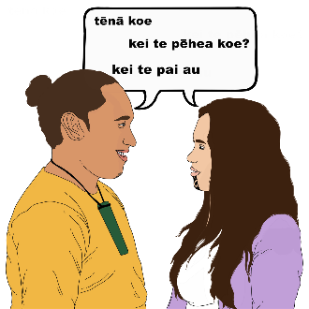
In this report the DBI uses the Kāi Tahu way of speaking te reo
Māori / Māori language.

Kāi Tahu is an iwi / tribe in
Te Waipounamu / the South Island.

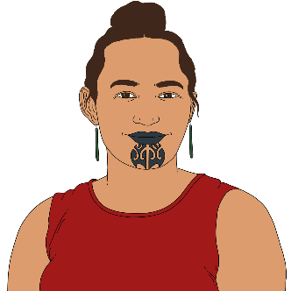
Using Kāi Tahu words means they use the letter k instead of the letters ng.

Tākata whaikaha
Māori

For example Kāi Tahu say tākata whaikaha Māori instead of tāngata whaikaha Māori when they are talking about Māori disabled people.


In this Easy Read
Whaikaha – Ministry of Disabled People will be called Whaikaha.

What was the research about?


The Disabled People’s
Organisations Coalition / DPO asked the DBI to start doing this research in 2021.

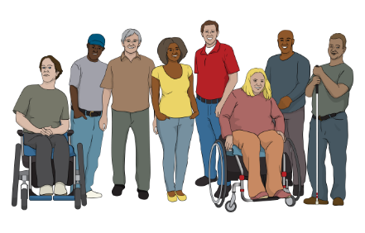
The Disabled People’s Organisations Coalition / DPO is a group of people who come from different disability organisations.


A coalition is a group of organisations that work towards shared goals.

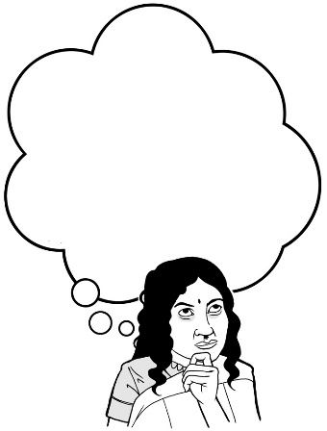
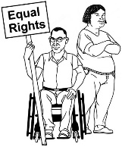
The DPO wanted to know how well the New Zealand Government was making the United Nations Convention on the Rights of Persons with Disabilities work in Aotearoa New Zealand.

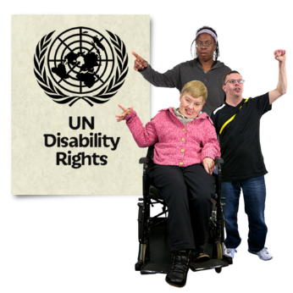
The United Nations Convention on the Rights of Persons with Disabilities / UNCRPD is a law lots of countries have agreed to.

It says what governments must do to make sure disabled people get the same rights as everybody else.

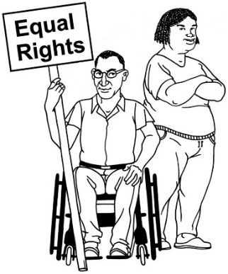
Rights are things everyone should:
have
be able to do.


The DPO Coalition asked the DBI to research what disability supports and services are like in New Zealand.


Many big changes happened to disability supports and services when DBI was doing the research.


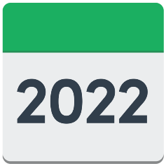

These changes include:
- Whaikaha starting in 2022
- changes in disability support services in March 2024
- changes to what Whaikaha can do in August 2024.


The research was done mostly by talking to:
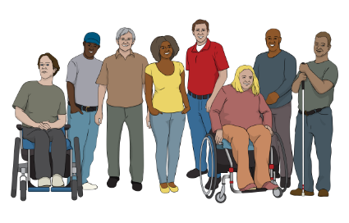
people who were leaders in the disability sector
disabled people
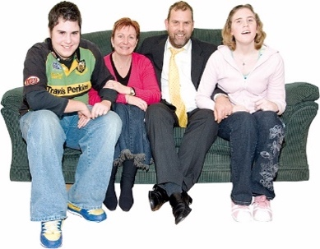
whānau / families
close supporters of disabled people.

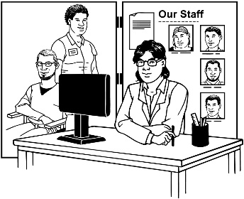
The disability sector includes:
disability support services
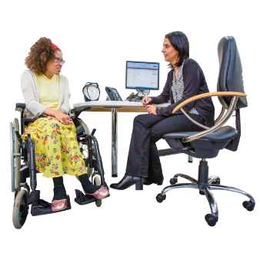
health services
government departments.

Summary of the reports

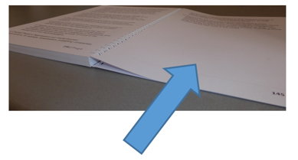
There is information about where you can read the reports on pages
36 and 37 of this Easy Read.

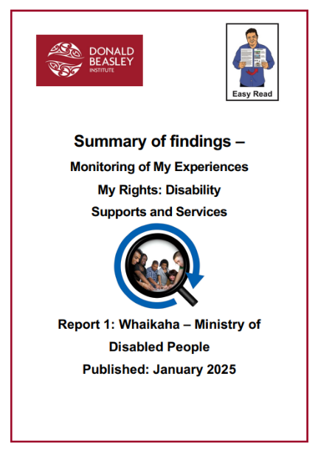
Report 1: Whaikaha – Ministry of Disabled People

The first report was about what disabled people and their families thought of Whaikaha.

Report 2: Consultation and engagement
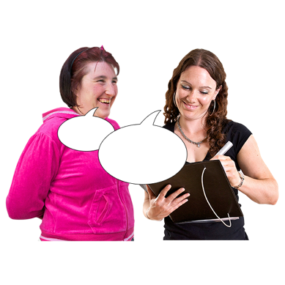
Here consultation is when the Government asks people what they think about things the Government is planning to do.

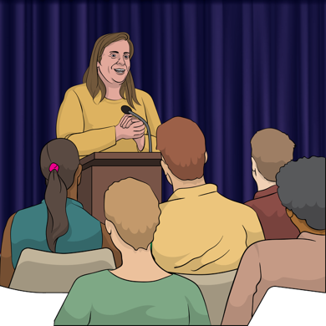
Here engagement is all the ways
the Government tells people:
what it is doing
how to have their say about what the Government does.

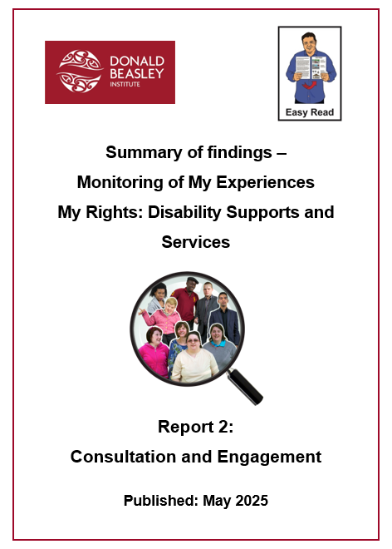
The second report was about how well people thought the Government was doing consultation and engagement about disability:
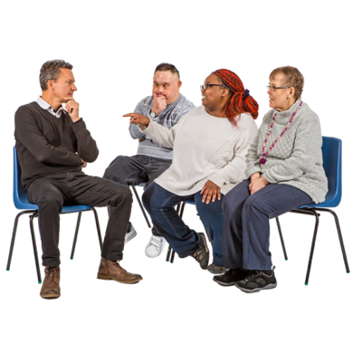
funding
support
services.

Report 3: Disability Support Services

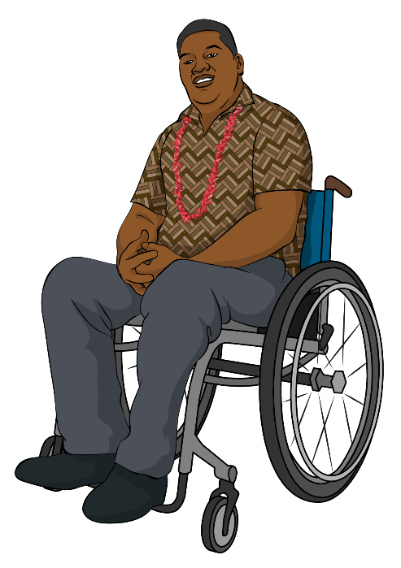
Here Disability Support Services means all the ways the Government supports disabled people like paying for:

equipment like a wheelchair
homes for disabled people
support workers.

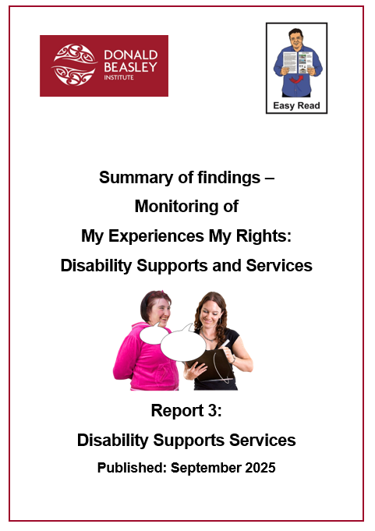
The third report was about what using Disability Support Services was like for disabled people.

Report 4: Enabling Good Lives


Enabling Good Lives is a different way of thinking about disability support.

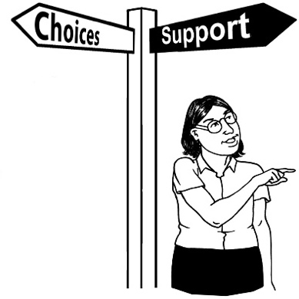
Enabling Good Lives is about having:
choice
control
the support you:

- need
- want
a good life.

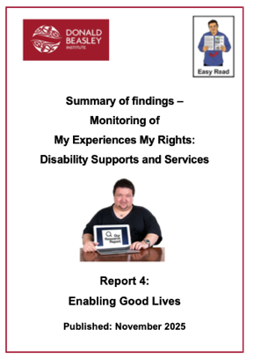
The fourth report was about:
what people thought about Enabling Good Lives
the effect of Enabling Good Lives on disability supports and services.

Recommendations


In the reports there were 30 recommendations to make disability supports and services better.


The researchers grouped the recommendations into 4 themes.


Here a theme is a way of grouping information together to make 1 main idea.

Diverse disabled leadership
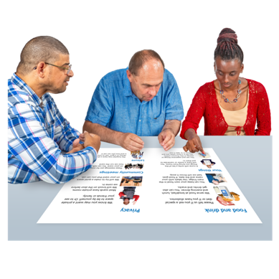
Participants wanted disability supports and services that were:
designed with disabled people
led by disabled people.

Here participants are people who answered questions as part of the research.


They said disabled leaders should have a lot of different lived experience.

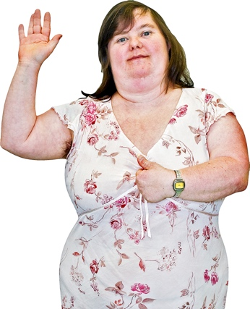
Here lived experience means:
the things you have:
- done
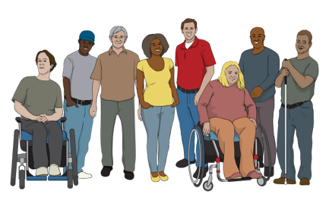
- had happen to you
your background like your:

- disability
- way of life
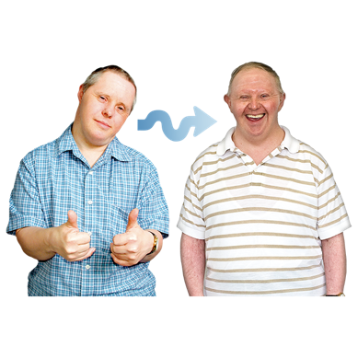
- age
- gender.

Gender is if you are:
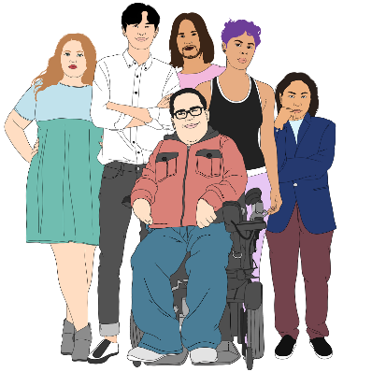
a man
a woman
another gender like nonbinary.

Genuine partnership

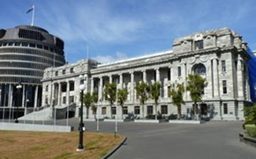
Participants wanted good relationships between:
the Government
and
the disability community.

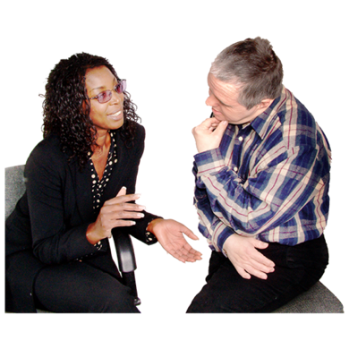
They said a good relationship would be when everyone:
is listened to
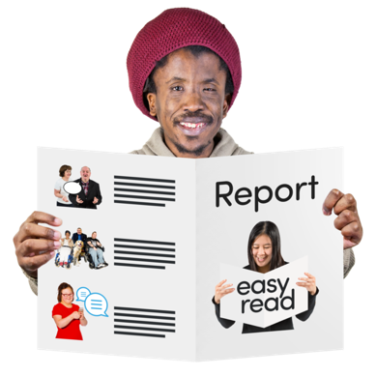
shares information so everyone can understand what is happening

works together to make things right
can respect the lived experiences people have.
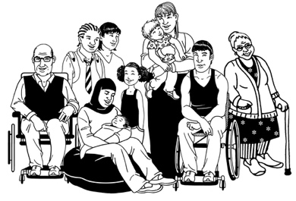
Here respect means understanding that everyone has lived experience that:
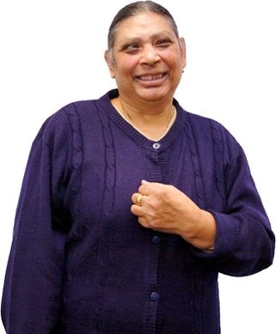
is different
is important
means they know a lot about what works for them.

Rights-based foundation
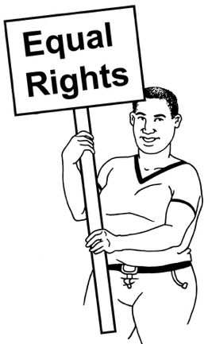
Participants said that human rights should be an important part of every decision about disability supports and services.

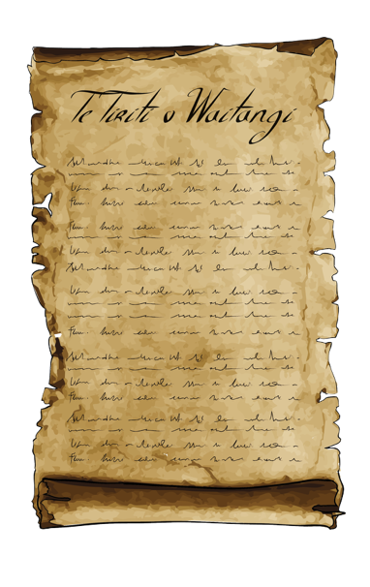
Participants said the Government should remember what it has promised under:
Te Tiriti o Waitangi / the Treaty of Waitangi
the UNCRPD
the New Zealand Disability Strategy
the Health and Disability Commissioner Code of Rights.

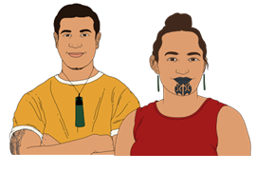
Te Tiriti o Waitangi / the Treaty of Waitangi is an important agreement between:
Māori
and
the Crown.

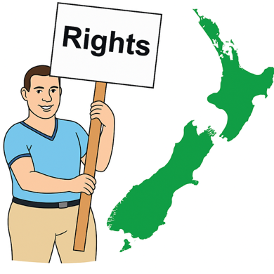
The purpose of Te Tiriti is to:
protect Māori:
- rights
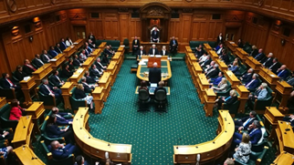
- taonga
keep peace and order
set up government.


Peace and order means to follow laws / rules.

Taonga means treasures such as:
land / rivers
te reo Māori / Māori language

objects like
pounamu / greenstone
traditional food growing places
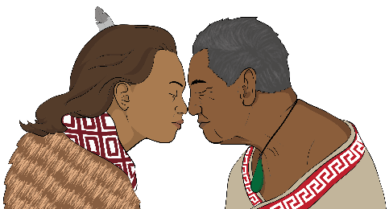
spiritual ideas
ways of life.

The New Zealand Disability Strategy tells the Government how to make things better for disabled people in Aotearoa New Zealand.

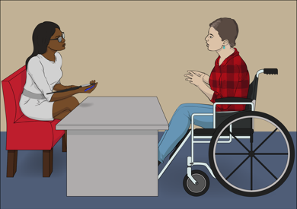
The Health and Disability Commissioner Code of Rights
says what rights people have when they:
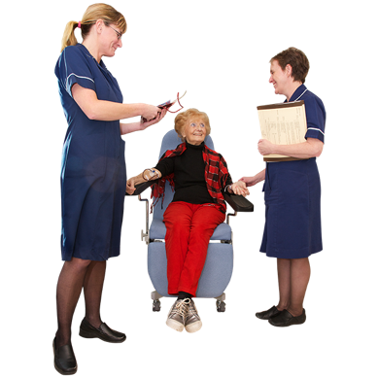
use disability services
get health care.

Transformative policy
Participants said the Government needs to make big changes to its policies about disability.


Here policies are rules the Government makes.

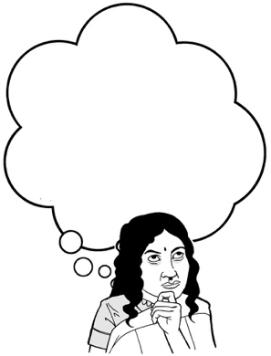
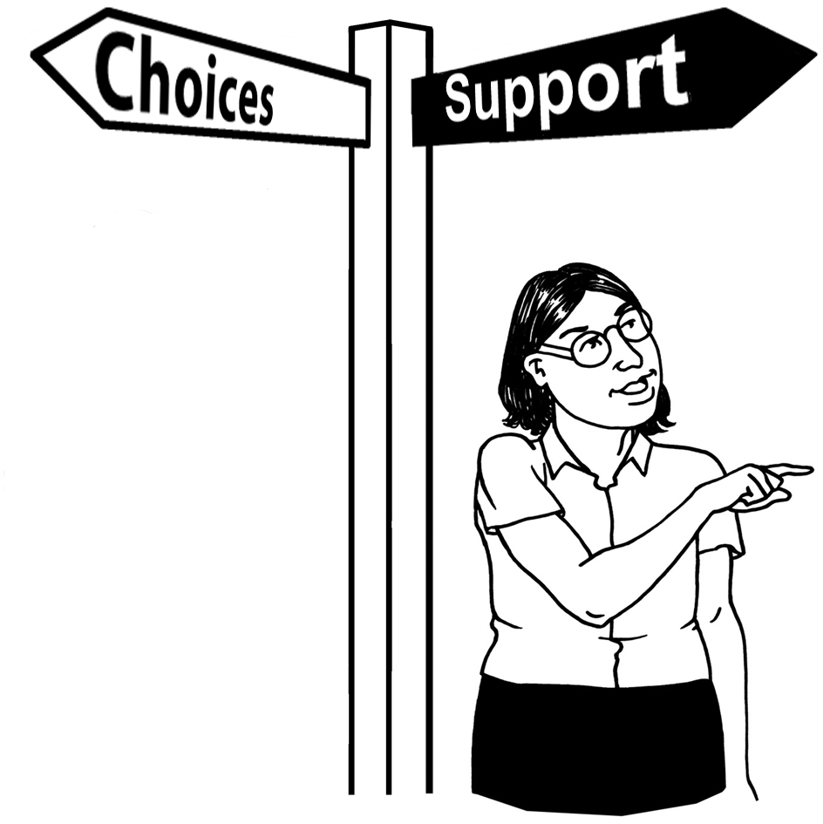
The Government needs to change:
how it thinks about disability support

the sort of disability support people can get
how it spends money on disability support.

Participants said that all disability supports and services should be based on Enabling Good Lives.

Priorities


Priorities are the most important things to do.

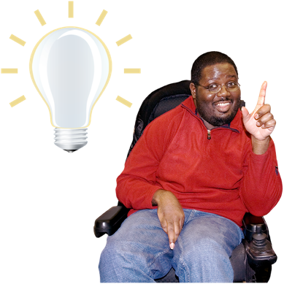
The recommendations have a lot of ideas to make disability supports and services better.

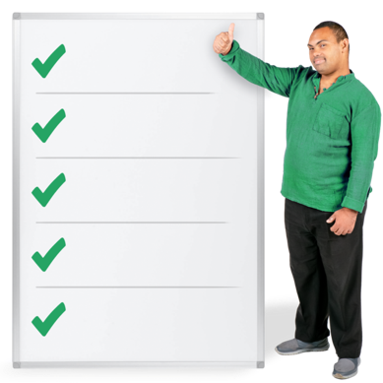
These are the ideas that the DBI thinks:
are the most important
should be done first.

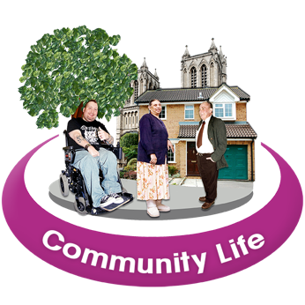
Community development

The Government should invest in building communities of:
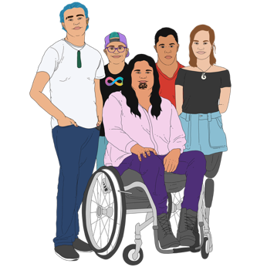
disabled people
tākata whaikaha / Māori disabled people
Pacific disabled people
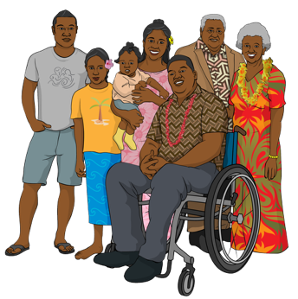
whānau / families / aiga
supporters.


Invest means to spend:

money
time
effort.


People in these communities could:
support each other
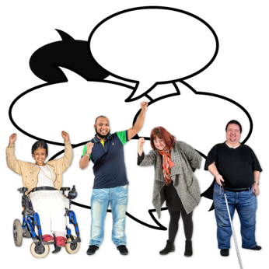
learn together
speak up for each other.

Intersectional lived experience
Intersectional means thinking about all the things that make up the life of a person.

Leaders in the disability sector should have a lot of different lived experiences.

This means making it easier for lots of different people to become leaders.

Disabled person led monitoring

Disabled people should lead the work to check how well disability supports and services are working.

Engagement
The Government should consult with disabled people:
early

often.

The Government should listen to what disabled people say.

Cross agency approach
A lot of different parts of the Government do things that affect disabled people.


All parts of the Government should work together to make things better for disabled people.

Equitable funding
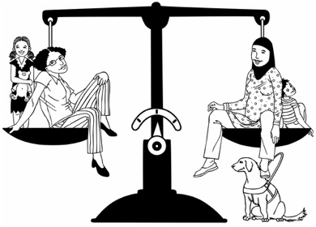
Equitable means something is fair for everyone.

The Government needs to make sure it spends enough money on disability so that:
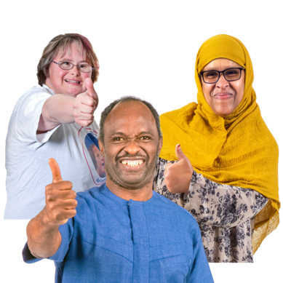
Whaikaha can do its work well
disabled people can get better supports and services
more people can get disability supports and services.

Inclusive support

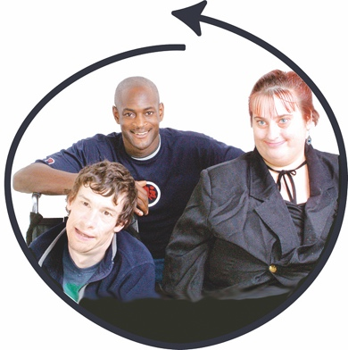
The Government needs to make sure disability supports and services are:
inclusive
strengths based.

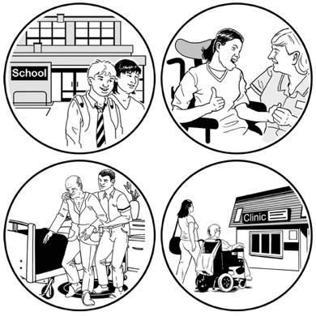
Here inclusive means something:
works for everyone
meets a lot of different needs.


Here strengths based means
paying attention to what people:
can do
are good at.

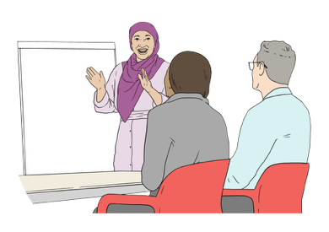
Disabled person led training

There should be training about disability for people who work:
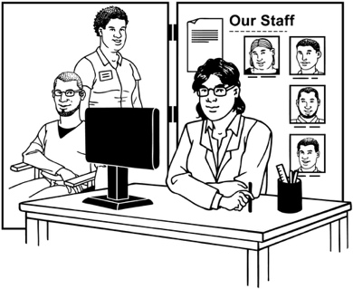
for the Government
in disability services.

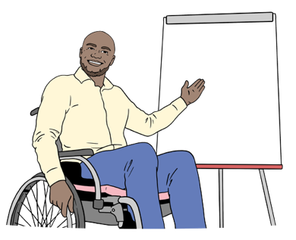
This training should be led by disabled people.

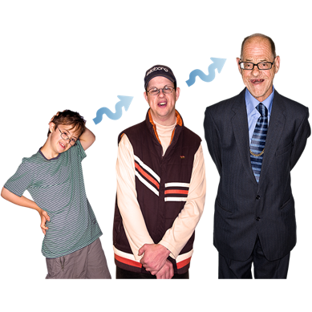
Appropriate care

Everyone should be able to get disability supports and services that are right for their:
age

culture.

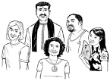
Culture is a way of:
thinking that a group shares
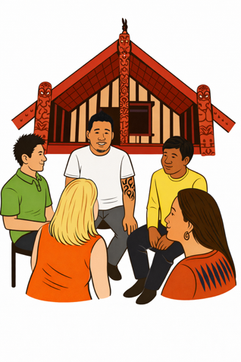
doing things as a group.

Some different cultures in Aotearoa New Zealand are:
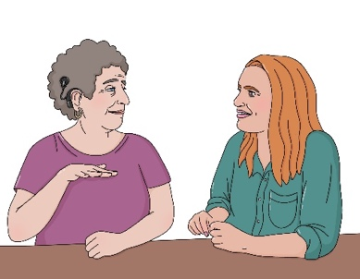
Māori culture
Pacifica culture
Deaf culture.

Accessible information

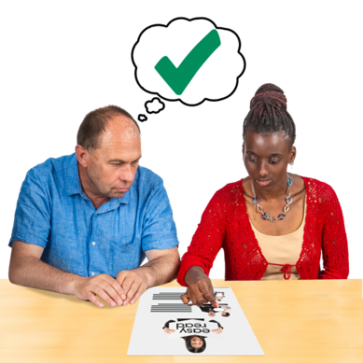
Everyone should be able to get information about disability supports and services that is easy to:
find
understand.
This picture shows how the priorities fit together with the themes.
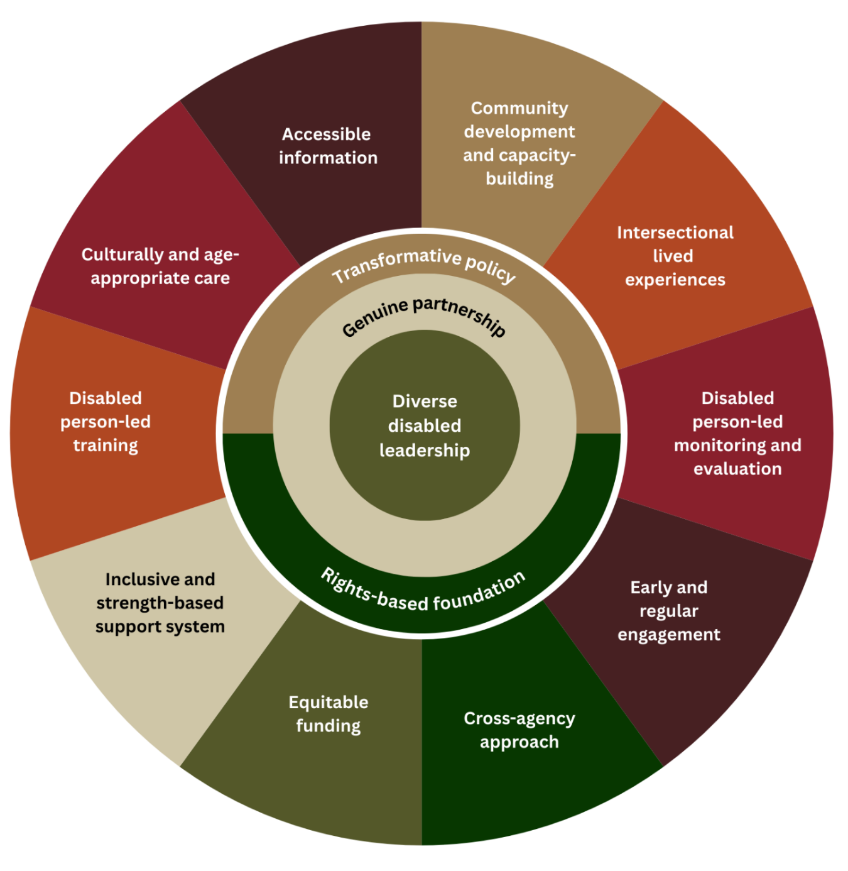

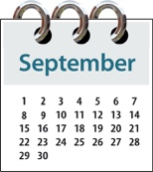
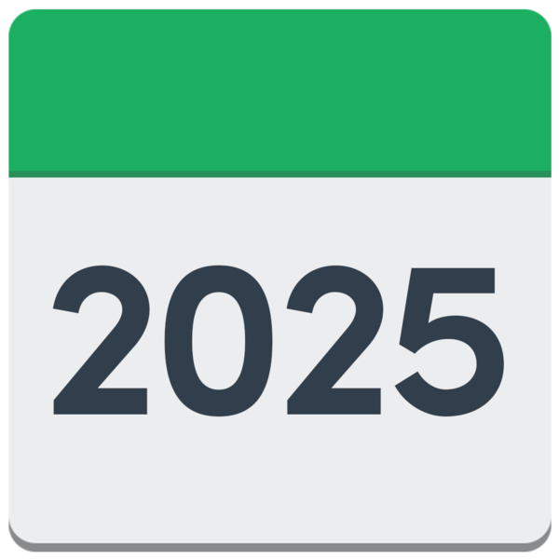
In September 2025 the Government made some changes to disability support funding.

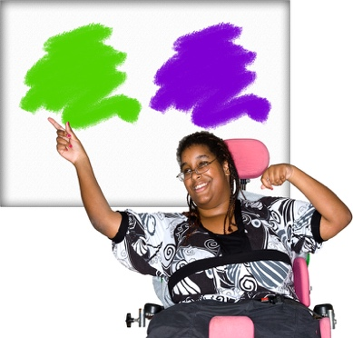
These changes mean disabled people have more choices about how they use their disability support funding.


These changes are a move in the right direction.


There is still a lot of work to do to make disability supports and services better.

It is important that the Government pays attention to all the recommendations in this report.

More information

You can read the full report on the DBI website at:

https://tinyurl.com/yn5sjpdk
You can read Part 1 of the report in Easy Read at:

https://tinyurl.com/2z6er67s

You can read Part 2 of the report in Easy Read at:

https://tinyurl.com/2zb7v3xr

You can read Part 3 of the report in Easy Read at:

https://tinyurl.com/4k88we75

You can read Part 4 of the report in Easy Read at:

https://tinyurl.com/2apjajxf

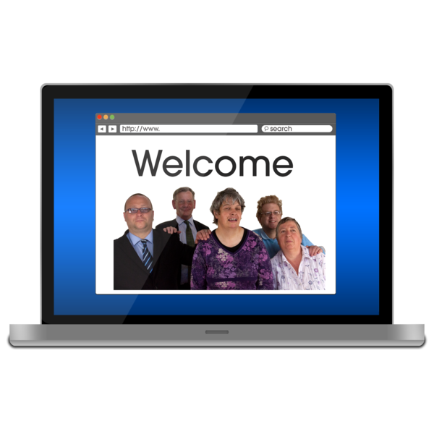
For more information about what DBI does you can go to the DBI website at:

www.donaldbeasley.org.nz


You can contact DBI by phone on:

0800 878 839



It does not cost money to phone this number.

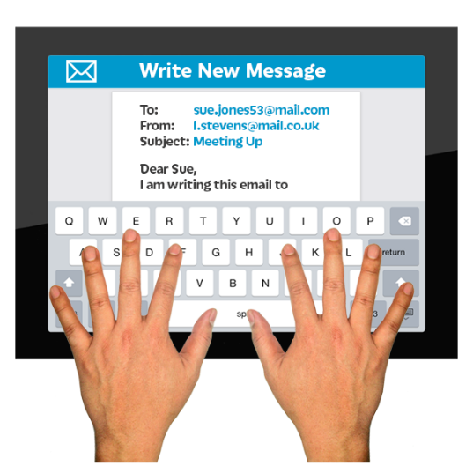
You can email DBI at:

admin@donaldbeasley.org.nz


This information has been written by the Donald Beasley Institute.

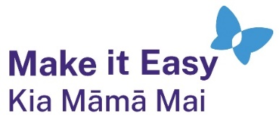
It has been translated into Easy Read by the Make it Easy Kia Māmā Mai service of People First New Zealand Ngā Tāngata Tuatahi.

The ideas in this document are not the ideas of People First New Zealand Ngā Tāngata Tuatahi.

All images used in this Easy Read document are subject to copyright rules and cannot be used without permission.


Make it Easy uses images from:


- Photosymbols

- Change Images


- Huriana Kopeke-Te Aho

- SGC Image Works

- T Wood


- Studio Rebeko

- Inga Kramer.

