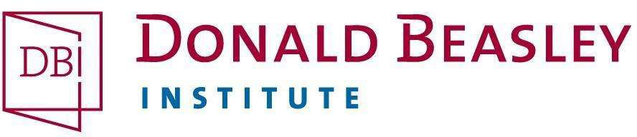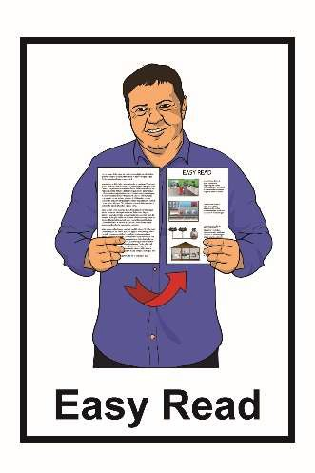

Hinonga Rangahau
Kōrero mai mōu
Puka Aronga Kaiuru
Mei 2021

Te uru mai ki te rangahau

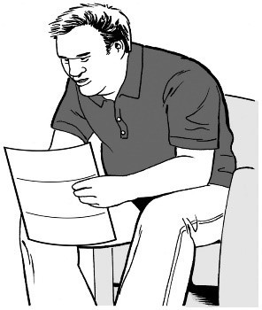
Tēnā, i te tuatahi, kia hua mai tō pānui i te Puka Pārongo Kōrero mai mōu

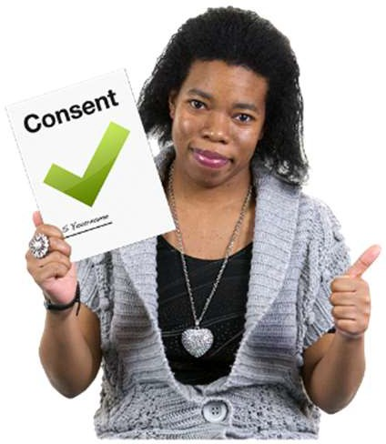
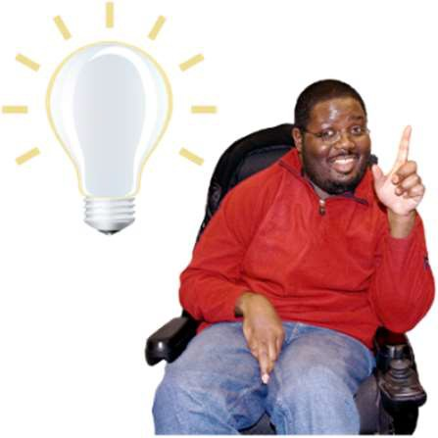
Kei taua pukapuka rā te kōrero roa me mōhio mai ai koe ki te hiahia rānei ki te uru mai ki tēnei hinonga rangahau.

Ko tō whakakī i tēnei pukapuka, ko tō tohu mai e hiahia ana koe ki te uru mai ki te ranghau.

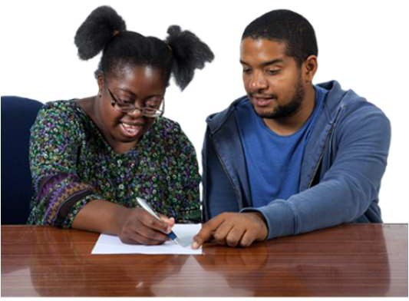
Ka pātai rānei koe ki tētahi atu ki te āwhina atu ki a koe ki te whakakī i te puka nei.

Ko ngā ara ka whāia ki te whakakī i te puka nei

He nui ngā ara hei tuku mai ki a mātou te puka kua whakakīia.

Ka īmēra mai te puka ki a:

admin@donaldbeasley.org.nz

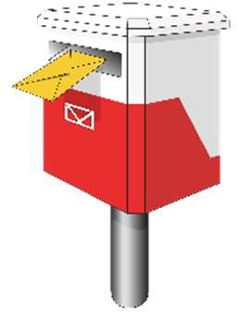
Ka tukuna ā-reta mai tō puka ki te kōpaki i whakawhiwhia ki te taha o te puka nei, ā, kua tuhia kētia ki tō mātou wāhi noho.

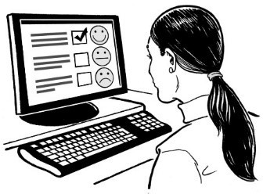
Ka whakautua ki te puka ā-ipurangi ki tō mātou pae tukutuku:

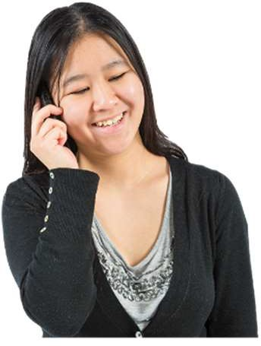
www.donaldbeasley.org.nz/tell-me-about-you

Ka waea mai rānei ki:

03 479 2162

Kōrero mai mōu

Tēnā, tuhia ō whakautu ki ia rārangi.

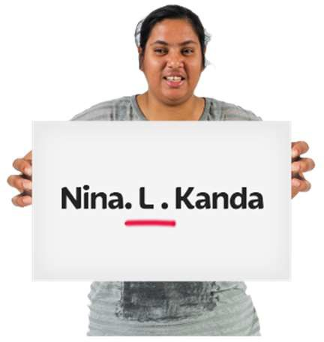
- Tō ingoa:

…………………………………………..

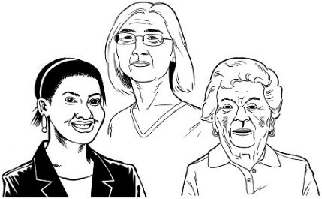
…………………………………………..

Tō pakeke:

…………………………………………..

Tō wāhitau īmēra:

…………………………………………

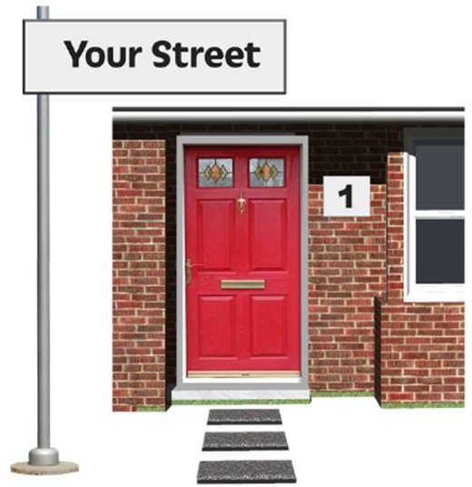
Te wāhi noho i tae atu ai ō mēra:

…………………………………………..

…………………………………………..

…………………………………………..

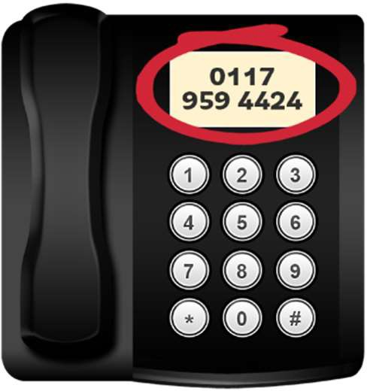
Tō nama waea:

…………………………………………..

…………………………………………..

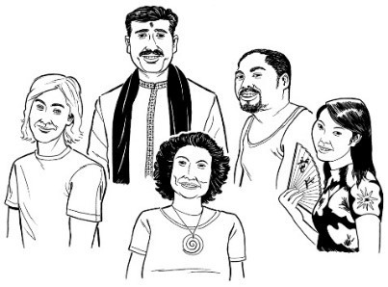
Ko wai tō iwi?

Tohua te pouaka ki te tohu tika (tick) ✓ ki te whakaatu mai i tō whakautu.

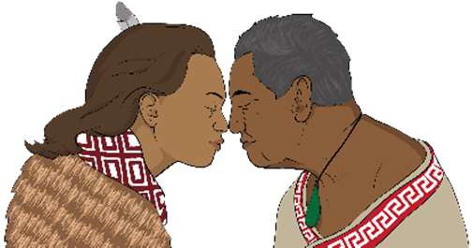 Māori

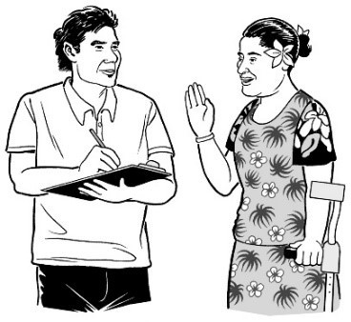
European New Zealander

Pacific person

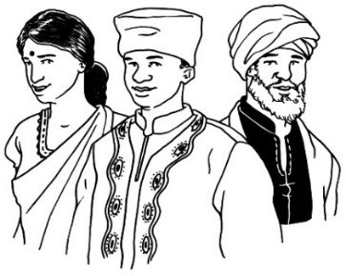
Chinese

Tētahi atu – tēnā tuhia mai ki konei:

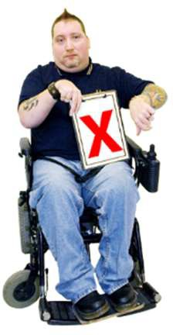
………………………………
Kāore au i te hiahia whāki atu.

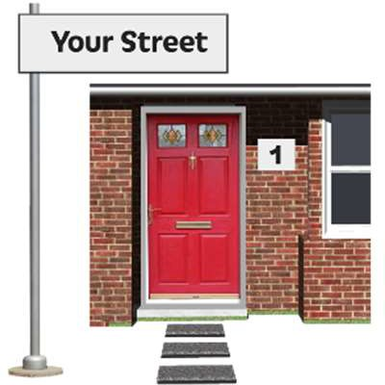
E noho ana koe ki hea ināianei?

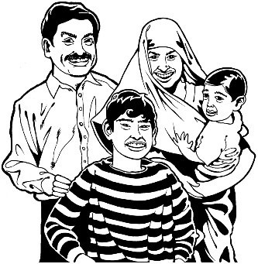
Tohua te pouaka ki te tohu tika (tick) ✓ ki ngā whakautu e hāngai ana ki te wāhi e noho ana koe ināianei.
Kei te noho tahi au ki taku whānau.

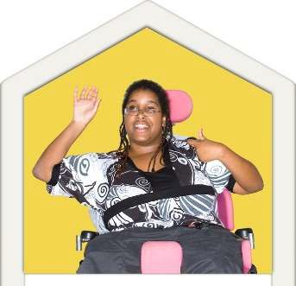
Kei te noho au ki ahau anō

Kei te noho au ki ētahi atu, ehara i te mea nō taku whānau.

Tētahi atu – tēnā whakamōhio mai:

……………………………………………

………………………………..................

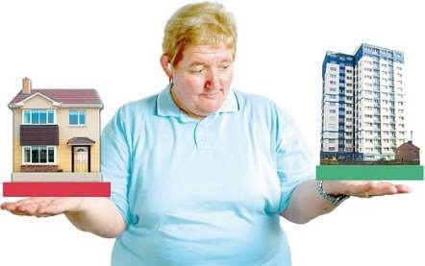
I noho kē koe ki hea i mua?

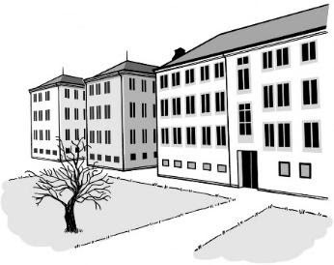
Tohua te pouaka ki te tohu tika (tick) ✓ ki ngā wāhi i noho kē ai koe i mua.

Whakanōhanga

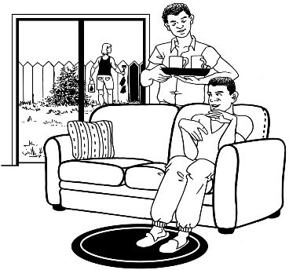
Ratonga hauā

Ratonga tānga manawa

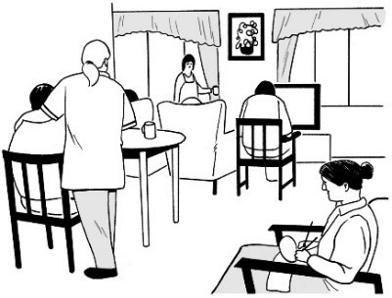
Whakanōhanga hinengaro hauā, mate hinegaro rānei.

Ngā wāhi i whakahaerehia e ngā hāhi.

He wāhi anō kei te whārangi e whai nei.

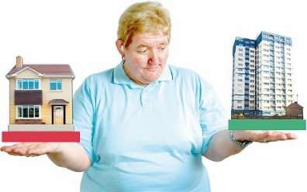
- I noho kē koe ki hea i mua?

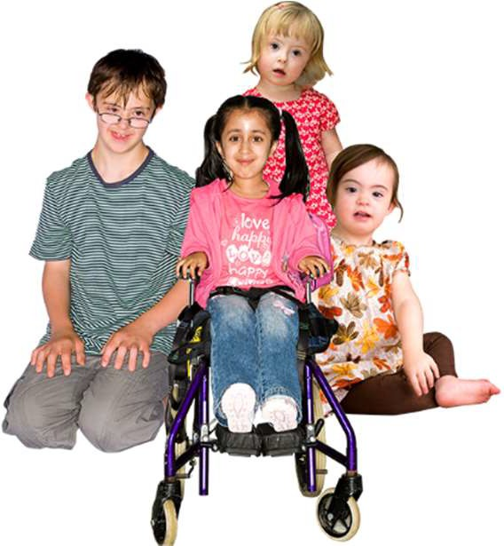
Tohua te pouaka ki te tohu tika (tick) ✓ ki ngā wāhi i noho kē ai koe i mua.

Ngā ratonga tamariki pēnei nei:

  - whare whakatau tamariki

  - whare taurima

  - ratonga whāngai

  - kura, kura kōhungahunga rānei.

He wāhi anō kei te whārangi e whai nei.

- I noho kē koe ki hea i mua?

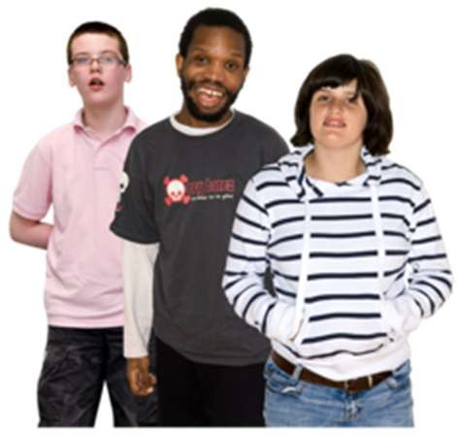
Tohua te pouaka ki te tohu tika (tick) ✓ ki ngā wāhi i noho kē ai koe i mua.

Ratonga manatika taiohi pēnei nei:

  - whare manatika taiohi

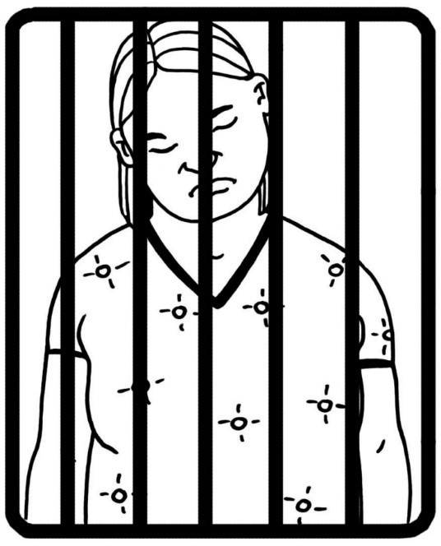
  - nohopuni hauora

  - whare herehere Pirihimana

  - whare herehere Kōti

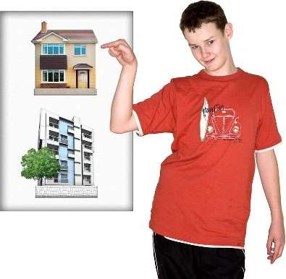
  - whare whakatau o te Pirihimana.

Tētahi atu – Tēnā, whakamōhio mai

…………………………………………………………………………

…………………………………………………………………………

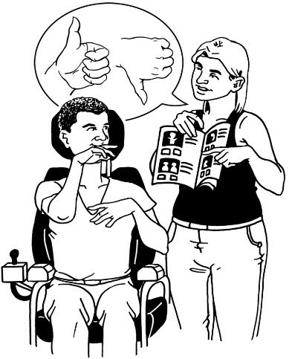
Ki te hiahia koe ki tētahi pou tautoko ki tō taha i a koe e uru mai ki te rangahau?

Tohua te pouaka ki te tohu tika (tick) ✓ ki te whakautu mai.

Āe

Kāo

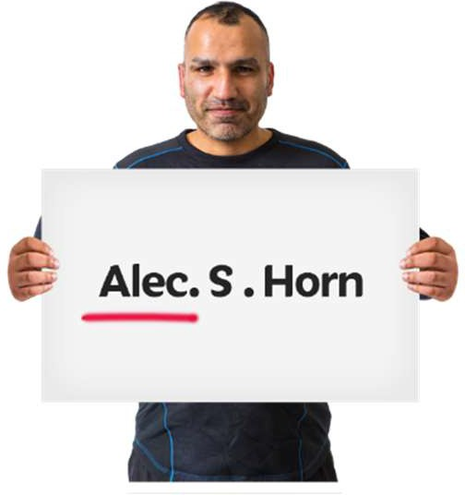
Te ingoa o tō pou tautoko:

…………………………………………..

…………………………………………..

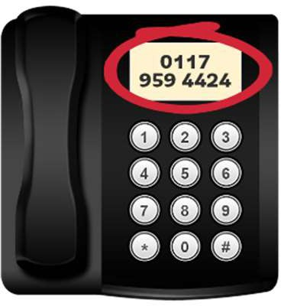
Te nama waea ki te waea atu ki tō pou tautoko:

…………………………………………..

…………………………………………..

Te īmēra o tō pou tautoko:

…………………………………………..

…………………………………………..

Me pēhea te whakapā mai ki a mātou

Mēnā he pātai āu, tenā whakapā mai.

Waea mai ki:

03 479 2162

- 0800 878 839

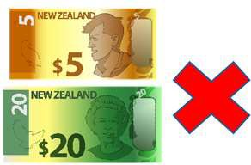
He mea kore utu te nama 0800

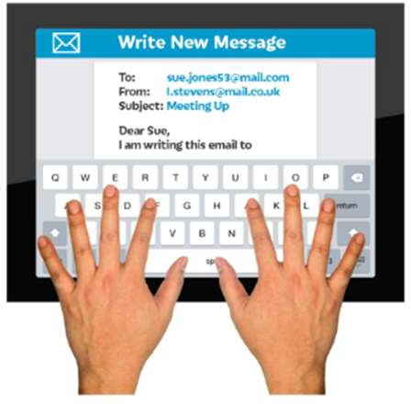
Īmēra mai ki:

admin@donaldbeasley.org.nz

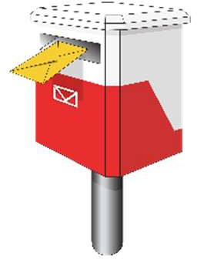
Ka tuku reta rānei ki:

Donald Beasley Institute Suite 4, Level 2
348 Cumberland Street

Dunedin 9016 New Zealand.

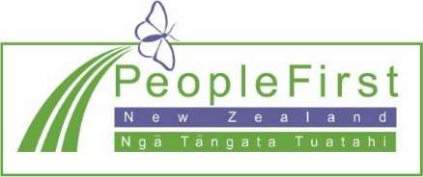
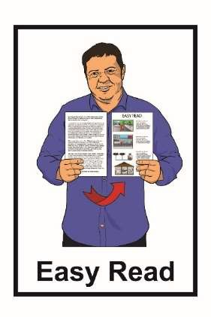

He mea tuhi tēnei nā te Donald Beasley Institute.

Kua whakamāmāhia te pānui nei nā te ratonga Make It Easy, nā, Ngā Tāngata Tuatahi.

Ehara ngā whakaaro ki roto i tēnei tuhinga i te whakaaro o Ngā Tāngata Tuatahi.

Kua tīpakohia e Make It Easy ngā whakaahua nā:

- Changepeople.org

- Photosymbols.com

- Sam Corliss

E noho ana ngā whakaahua o te tuhinga Māmā te Pānui nei ki raro i te ture o te mana pupuri, ā, e kore e whakamahia ki te kore e whakaaetia.

