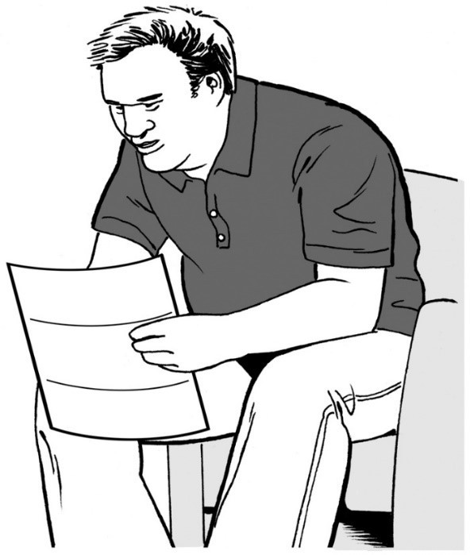
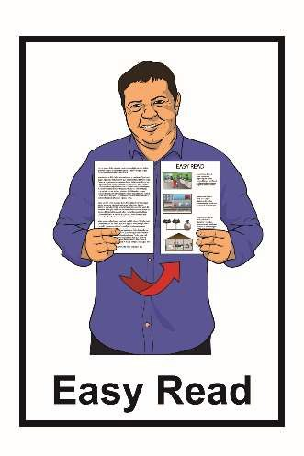

Hinonga Rangahau
Kōrero mai mōu
Puka Pārongo
Mei 2021

Ka kitea te aha ki roto i tēnei Puka Pārongo

Whārangi:
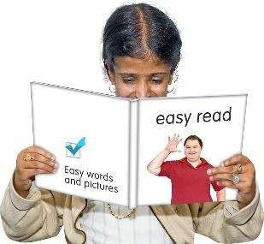 I mua i tō pānui i tēnei tuhinga….…3
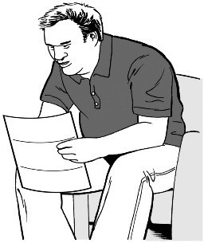
He aha ki roto i tēnei Puka Pārongo? 5
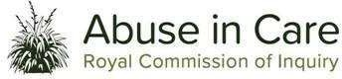 Ko wai kei te utu i tēnei rangahau? 9
Ka korero mātou ki a wai? 10

He aha te tikanga o tēnei rangahau? 12

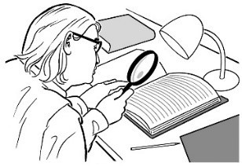

Ko wai kei te whakahaere i te rangahau nei? 14

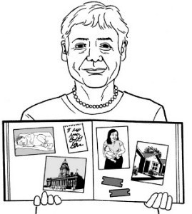
Whārangi:

Ka ahatia ngā kōrero nei? 17

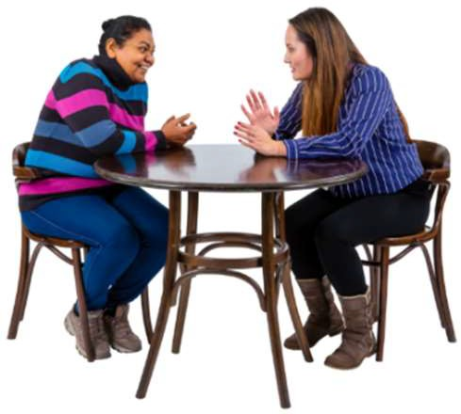
Te tūtaki i tō hoa tuhi 19

Ngā ara tuku i tō kōrero 21
Ko tā mātou rongo mō te tūkino 25
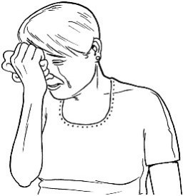
Ka ahatia au mēnā ka riri, ka rongo rānei au i te mamae? 26

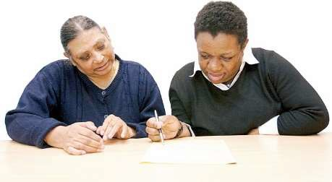
Ka aha au mēnā kei te pīrangi au ki te
uru ki te rangahau, ki te hiahia rānei au i ētahi atu kōrero? 31

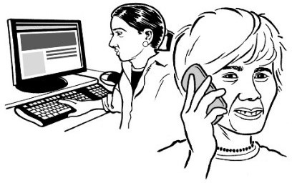
Ka whakapā atu au ki a wai ki te hiahia
au i ētahi atu kupu āwhina? 33

I mua i tō pānui i tēnei tuhinga

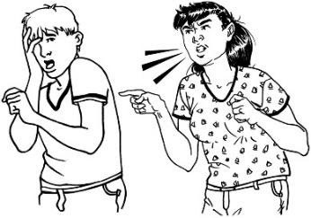
Ko te Tūkino te kaupapa nui o tēnei tuhinga ‘Māmā te Pānui’.
Ko te Tūkino ka pā ki te tangata ina:

- i kore i tiakina tika

- kua rongo i te mame

- kua takakinotia ia

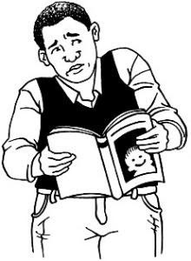
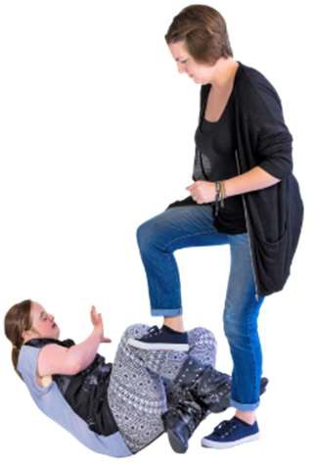
Ko ētahi o ngā kōrero ki roto i te tuhinga nei ka whakapāpōuritia pea te tangata i a rātou e pānui ana.

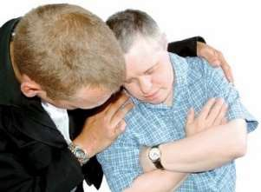
Ehara i te mea kua tuhia ēnei kōrero ki te whakapāpōuri i tētahi.

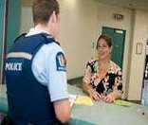
Ki te kore koe e noho haumaru ana i tēnei wā tonu, me waea ki te pirihimana ki 111.

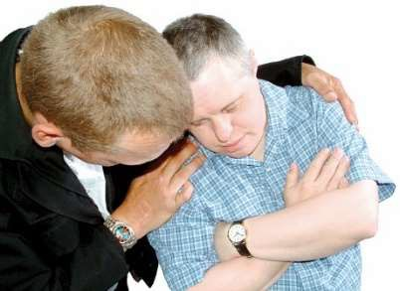
Ki te āwangawanga koe, ki te mānukanuka koe i tō pānui i tēnei tuhinga, ka kōrero ki ēnei kua whakarārangi ki raro iho nei:

- tō whānau

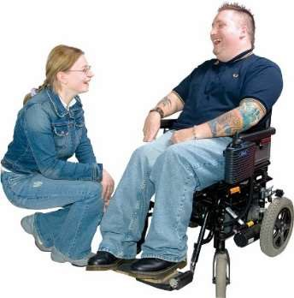
- ō hoa

- ō kaiāwhina.

He aha ki roto i tēnei Puka Pārongo?

He puka ‘Māmā te Pānui’ tēnei mō ētahi rangahau e kīia nei ko Kōrero mai mōu e whakahaerehia nei e te Donald Beasley Institute.

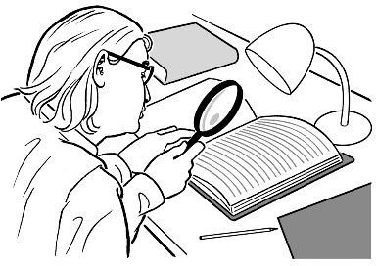
Ko te rangahau ko te:

- titiro ki ngā mea kua pāhawa
- Ka whāia i tētahi ara i pai ake ai te koke.

He nui te rangahau o te Donald Beasley Institute ki ngā kaupapa whakahirahira.
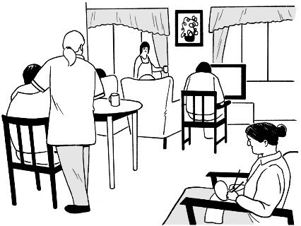
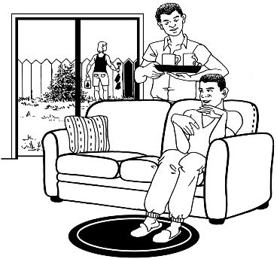
He mea rapu kōrero te rangahau nei mō te hunga hauā i te noho ki ngā whare taurima ki Aotearoa i waenga i ngā tau 1950-1999.
1950
1999

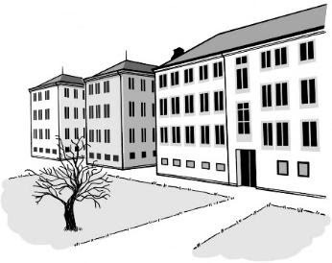
Ko rātou i te noho taurima, i noho ki ngā momo wāhi pēnei i te:

- whakanōhanga

- ratonga hauā

- ratonga tānga manawa

- whakanōhanga hinengaro hauā, mate hinegaro rānei.
Ko te tikanga o te noho ki te whare taurima, ko tō noho ki raro i te tāwharautanga o te kāwana rānei o tētahi hāhi rānei.
care.

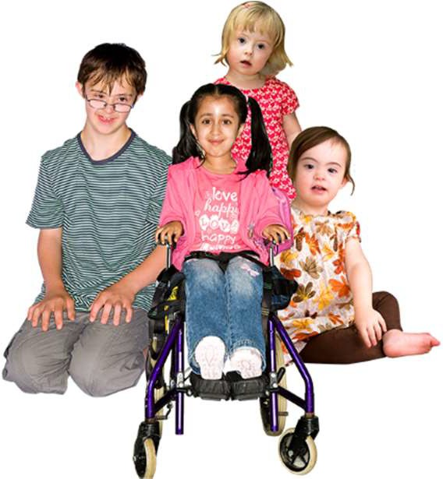
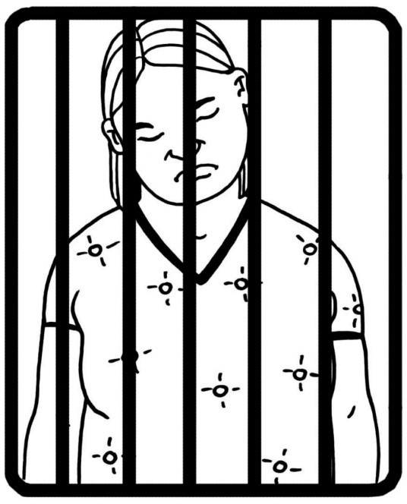
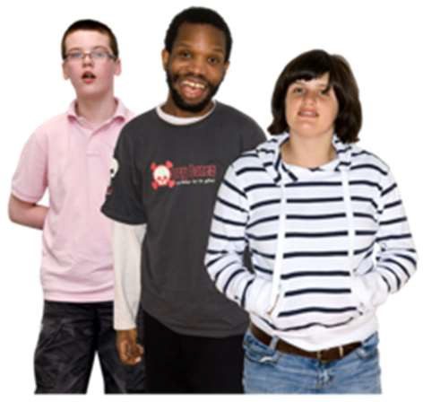
Ko rātou i te noho taurima, i noho hoki ki ngā momo wāhi pēnei i:

- Ngā ratonga tamariki pēnei nei:

  - whare whakatau tamariki

  - whare taurima

  - ratonga whāngai

  - kura, kura kōhungahunga rānei

- ratonga manatika taiohi pēnei nei:

  - whare manatika taiohi

  - nohopuni hauora

  - whare herehere Pirihimana

  - whare herehere Kōti

  - whare whakatau o te Pirihimana.

I noho rānei ēnei tāngata ki ngā wāhi i whakahaerehia e ngā hāhi, e ngā rōpū whakapono rānei.

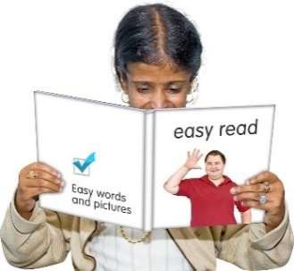
Kei tēnei pukapuka te kōrero roa ki te pīrangi koe ki te uru mai ki te rangahau nei.

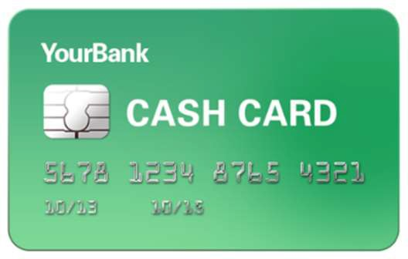
Ki te whai wāhi koe ki te rangahau nei, ka tukuna he kūpane $100 hei mihi ki a koe i tō urunga mai.
$100 Gift Voucher

Ka whakaea te utu o tēnei rangahau i a wai?

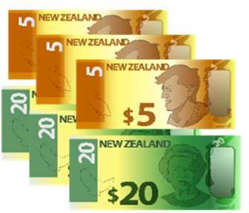
Nā te Royal Commission Inquiry into Abuse in Care te pūtea i homai ki te Donald Beasley Institute ki te whakahaere i tēnei rangahau.

Ko te Royal Commission of Inquiry into Abuse in Care, ko te huinga mātanga e whai kōrero ana i te tangata kua rongo i te tūkino i ā rātou e noho ana ki ngā whare taurima.

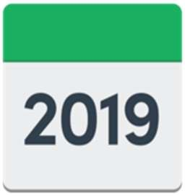
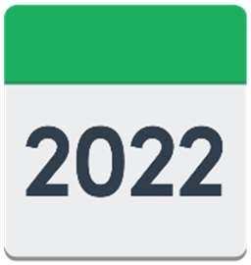
I timata i te Royal Commission of Inquiry into Abuse in Care i te tau 2019.

Ka mutu hei te 2022.

Ka korero mātou ki a wai?

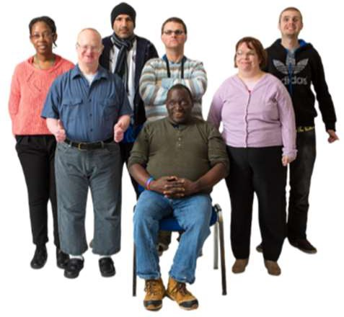
Ki tēnei rangahau Kōrero mai mōu kei te pīrangi ki te kōrero ki te rua-ngahuru tāngata:

20

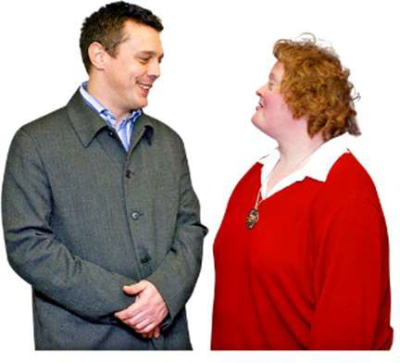
- he mate tōna ki te ako i noho ki tētahi whare taurima

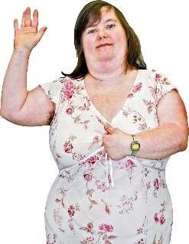
- tangata kanorau-io i noho ki tētahi whare taurima

18

- kua pakeke ake i te 18 tau te pakeke

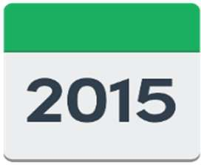
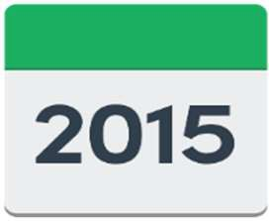
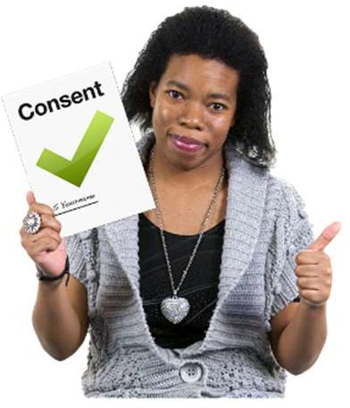
- i noho ki tētahi whare taurima i waenga i ngā tau 1950-1999.
1950
1999

- E mārama rawa ana te take i whakaae ai.

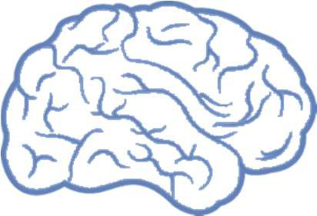

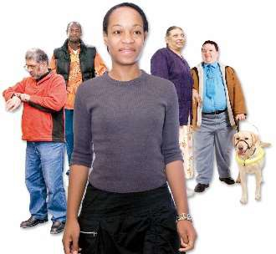
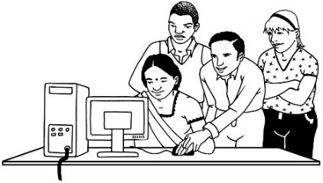
Ki te tēnei rangahau, ko te kanorau-io ko te:
Ko te tikanga o te tangata kanorau-io:

- he rerekē te whakahaere o ō rātou roro

- he rerekē te ara ka whāia ki te ako.

- hunga takiwātanga

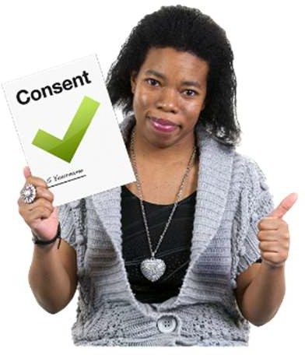
- hunga mate aro, mate hihiri (ADHD).

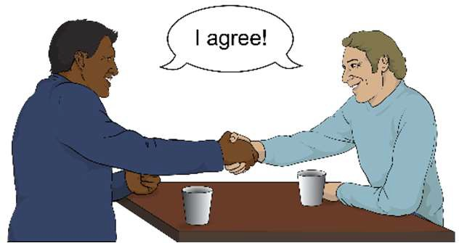
Ko te tikanga o te whakaaetanga e mārama ana, ko tō mārama ki:

- te mea e whakaaetia ana e koe

- ngā mahi ka puta ki te whakaae koe ki uru mai ki tēnei hinonga.

He aha te tikanga o tēnei rangahau?

Ko te tikanga o tēnei rangahau Kōrero mai mōu ko te rangahau i te hunga hauā i noho ki te whare taurima ki Aotearoa i waenga ngā tau 1950-1999.
1950
1999

Kei te hiahia mātou ki te rongo i ngā wheako o te hunga i te noho ki te whare taurima ki Aotearoa.

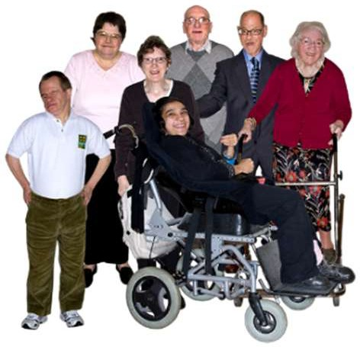
He nui ngā tāngata kua noho ki ngā whare taurima:

- te hunga he mate ō rātou ki te ako

- te hunga kanorau-io.

Kāore he nui ngā kōrero kua tuhia mō te wā i noho ai rātou ki te whare taurima.

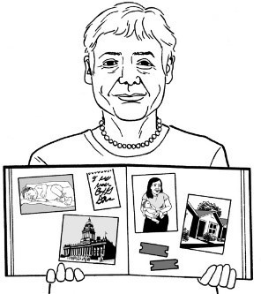
Ko tētahi o ngā whāinga o tēnei rangahau, ko te huranga atu o ā rātou kōrero.

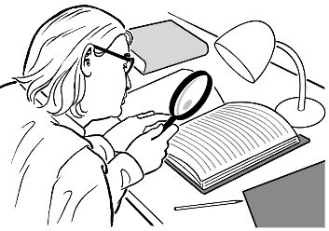
He kōrero whakahirahira ērā kia ako ai mātou i a rātou.

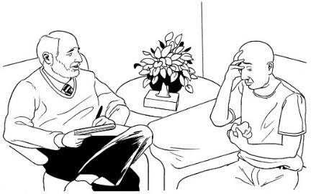
He mea whakahirahira ki te hunga e noho whare taurima ana, e taurima tika ana ki aua whare.

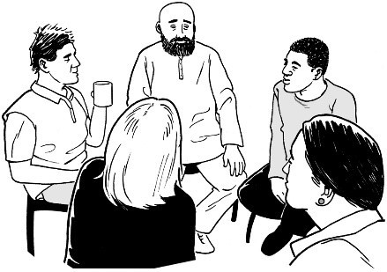
He mea whakahirahira hoki ki te hunga i tūkinotia i aua tū-noho, ka tautokona i ēnei rangi.

Ko wai kei te whakahaere i te rangahau nei?

He tokoono nō te Donald Beasley Instiutite e mahi ana i tēnei rangahau.

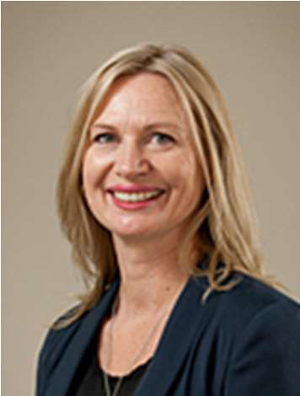
Ko ō rātou ingoa, ko:

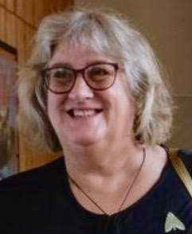
- Dr Brigit Mirfin-Veitch

- Dr Hilary Stace

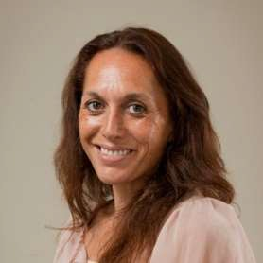
- Dr Kelly Tikao.

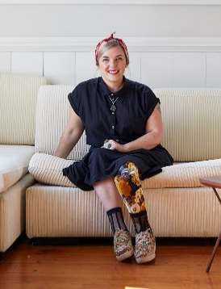
Ko ō rātou ingoa, ko:

- Dr Robbie Francis Watene

- Ms Eden Tuisaula

- Dr Patsie Frawley.

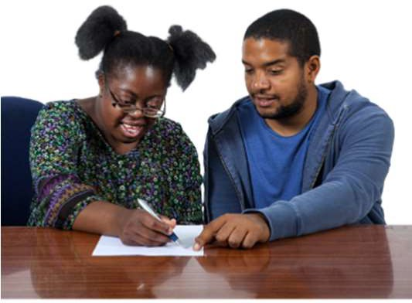
He roa te wā i te mahi ngātahi ai te katoa ki runga ki te hunga hauā.

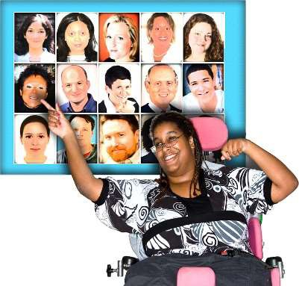
Māu anō e whiri, ka tautokona koe e a wai ki te tuku atu i tō kōrero.

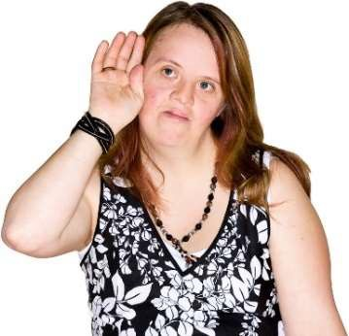
Kei tō mātou paetukutuku ka taea te whakarongo ki ētahi kōrero anō mō te tokoono o te tira rangahau nei:

www.donaldbeasley.org.nz/tell-me-about-you

Mā tō whakarongo ki a rātou koe e whakatau ai ki tērā e pīrangi ana koe.

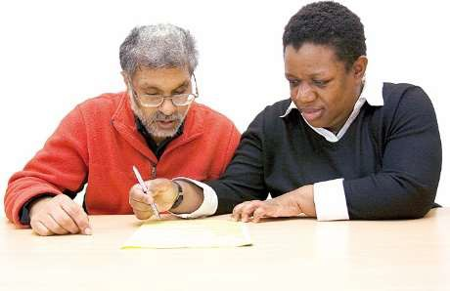
Ko tērā ka whiria e koe, ka noho mai ko tō hoa tuhi.

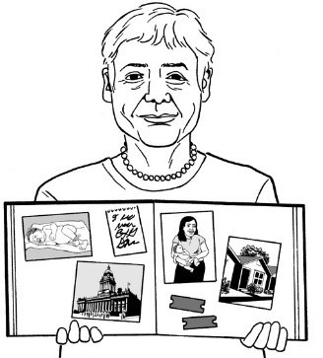
Ko koe i tēnei tūāhua ko te reo kōrero.

Ka ahatia ngā kōrero nei?

E toru ngā ara e whāia ai e ēnei kōrero.

Ko aua ara e toru ko:

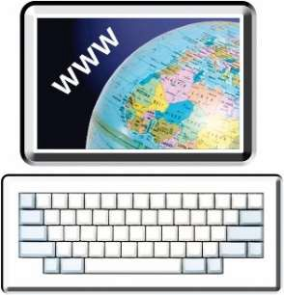
- te noho ki tētahi kohinga kōrero kei tō mātou paetukutuku, hei pānuitanga mā te marea.

- ā mātou kairangahau tuhi i ngā kōrero ā-tuhi mō ngā hua ka puta i te rangahau.

- te tuku atu ki ētahi rōpū hei tohu i a rātou ki te tiaki tika i ngā tāngata e noho whare taurima ana.
Ko te kohinga kōrero, tētahi kohinga o ngā kōrero ka noho ki te ipurangi hei pānuitanga mā te marea.

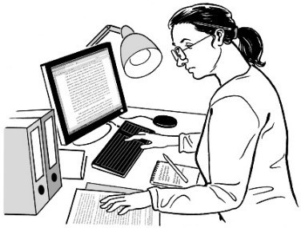
Ko te kōrero ā-tuhi tētahi tuhinga nā te kairangahau mō ngā putanga, nā hua kua puta i te rangahau

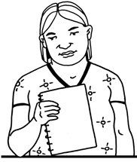
Ka pānuitia ēnei kōrero ā-tuhi nei e te hunga e pīrangi ana ki ngā hua kua kitea e ngā kairangahau.

Te tūtaki i tō hoa tuhi

Ka whakapā atu tō hoa tuhi ki a koe ki te pātai atu:

- ki te wā e hiahia ana koe ki te hui

- ki te wāhi e hiahia ana koe ki te hui.

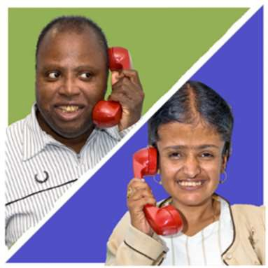
Ki te noho tawhiti, ka kōrero tuatahi pea ki te waia.

Hei te wā ka tūtaki koe ki tō hoa tuhi ka:

- utua e ia ō pātai

- uia koe e ia ki te hiahia tonutia koe ki te noho tonu ki te rangahau.

Ka kōrero pea kōrua ko tō hoa tuhi mō ngā momo kaupapa pēnei i:

- te āhua o tō ao i mua i tō noho ki te whare taurima?

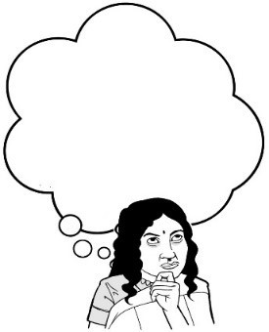
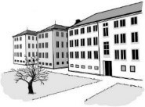
- te āhua o tō ao i a koe e noho ana ki te whare taurima?

- te āhua o tō ao ināianei?

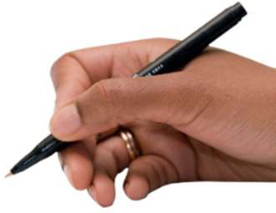
Me mōhio mai koe:

- ehara te mea ko te katoa o āu kōrero ki tō hoa tuhi ka noho ki te rangahau nei, ki te kore e pīrangi

- ka tohua rātou e koe kia kaua e tuhia ētahi o āu kōrero ki te kore koe e pīrangi.

Ka hui kōrua ko tō hoa tuhi kia kotahi anō te wā.

Ngā ara ki te tuku i tō kōrero

Māu anō e whiri te āhua o tō tuku i tō kōrero ki tō hoa tuhi.

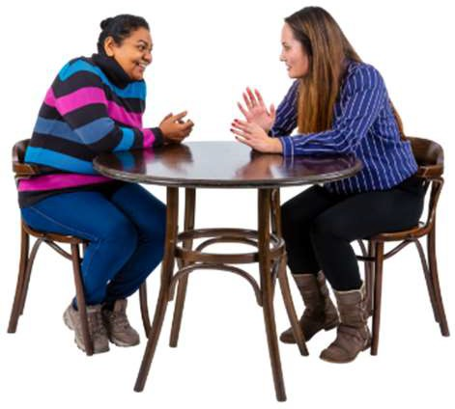
Anei ētahi ara tuku kōrero rerekē:

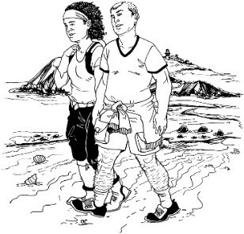
- te noho, me te kōrero ki tētahi wāhi hāneanea ana ki a koe

- te haere ki ngā wāhi taurikura ki a koe ki te kōrero ki reira

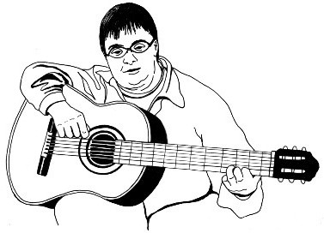
- te haere ki te hīkoi tahi, ki te kōrero tahi hoki

- te tohatoha i ngā taonga ōu hei mea tautoko i a koe e kōrero ana

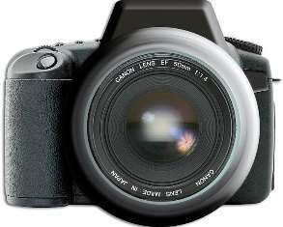
- te tohatoha i ngā whakaahua ki te tautoko i a koe ki te kōrero.

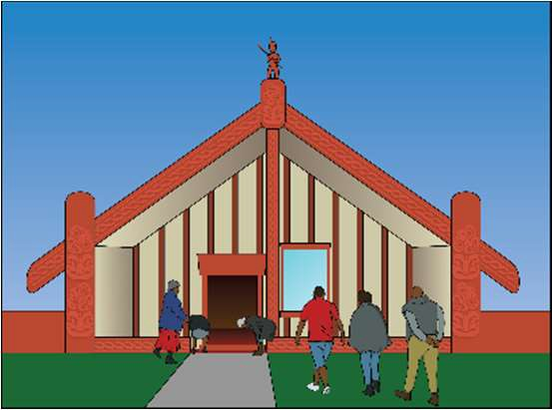
He ara auaha hoki ka taea ki te tuku mai tō kōrero:

- waiata

- pūrākau

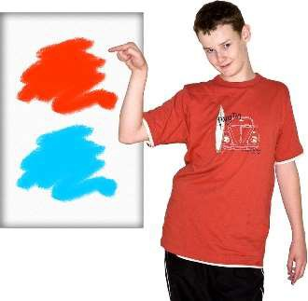
- mahi toi

- toikupu

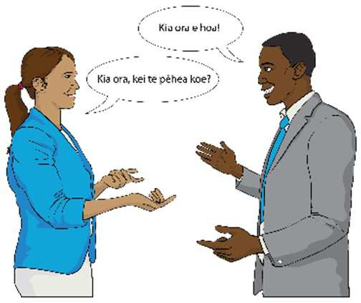
Mehemea he whakapapa Māori, ka noho ki tētahi hoa tuhi Māori ki te pīrangi koe

He kōrero Māori a Dr Kelly Tikao.

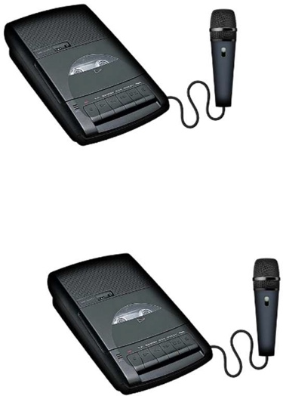
Ka uia koe e tō hoa tuhi mehemea e pai ana ki a koe te hopu i te oro o āu kōrero.

Māu anō, ki te wā e hiahia ana, tō hoa tuhi e tono ki te whakaweto i te hopuoro.

Kia hua tonu tō hoa tuhi, kua tuhia tō kōrero me ō kupu ake anake.

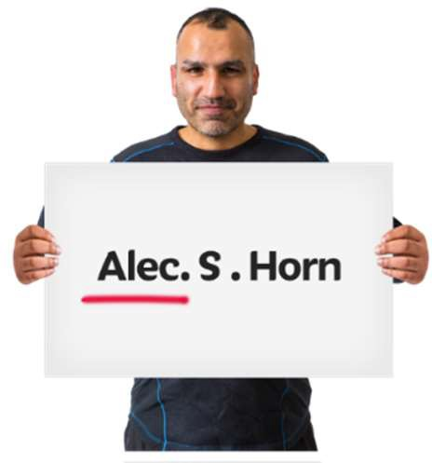
Māu anō e whakatau ki te hiahia rānei, ki te kore rānei e hiahia te tuku i tō ingoa ake.

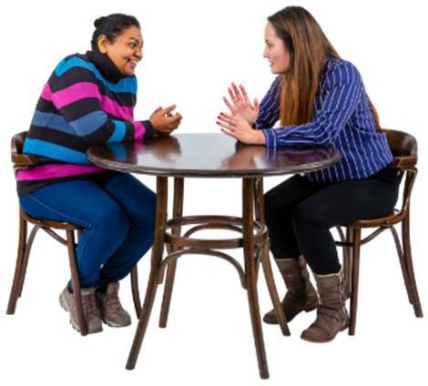
He kaupapa kōrero tēnei mō kōrua ko tō hoa tuhi.

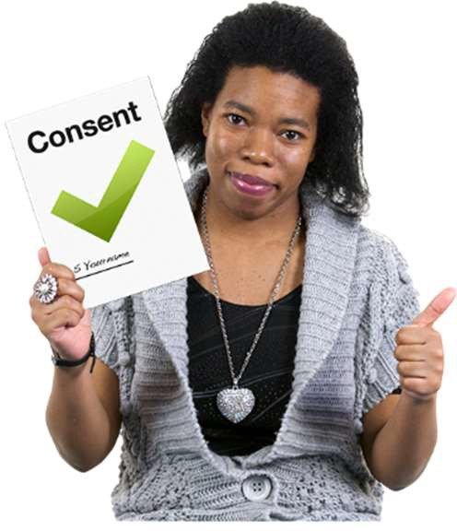
Ka uia koe ki te waitohu i tētahi puka whakaae, e kīia ana, kei te pai ki a koe ki te tuku tō kōrero ki te kohinga kōrero.

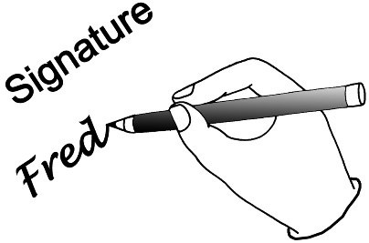
Ko te puka whakaae, tētahi mea ka waitohuhia e koe, ki te kī atu e whakaae ana koe ki te mahi e mahia ana

Ki te kore koe e waitohu i te puka whakaae, kāore ō kōrero e noho ki te kohinga kōrero ki te ipurangi.

I te otinga o te hinonga, ka whiwhi koe i ngā kape o:

- tō kōrero
- te pūrongo ka tuhia e mātou.

Ka 3 ki te 4 marama whai ake ai tō kōrero ki tō hoa tuhi.

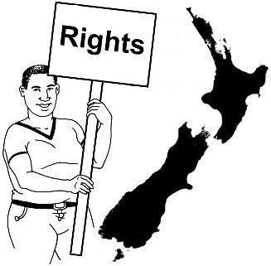
Ko tā mātou rongo mō te tūkino

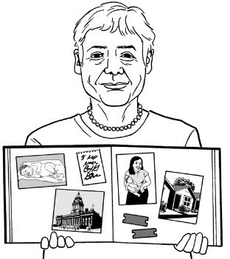
Hei wāhanga o te tukutuku mai o ngā kōrero o ngā tāngata, kei te mōhio mātou o te tira rangahau, ka rongo mātou mō:

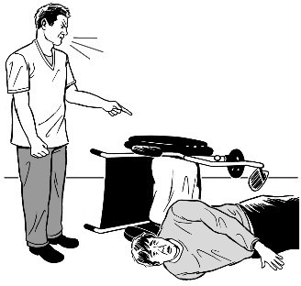
- te tūkino i pāhawa

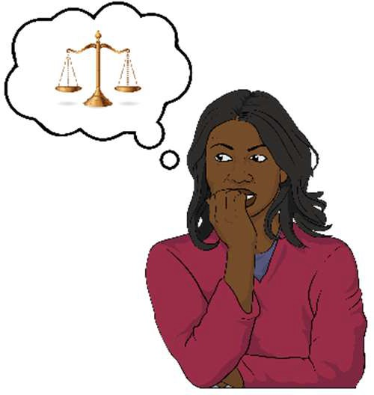
- ngā mōtika tangata tē aro atu.
Ko te tikanga o ngā mōtika tangata e ahu pēnei mai koe:

- matatika ana

- tōkeke ana

- kauanuanu ana.

Ka korowaihia te katoa o ngā tāngata e te mōtika tangata.

Nei ngā ture me whai e ngā kairanghau ki te rongo rātou kua pā ēnei āhuatanga e whai nei ki ngā reo kōrero:

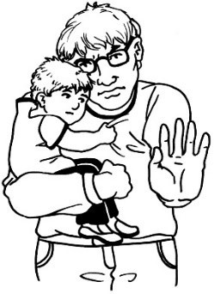
- ehara i te haumanu te noho

- i te rongo i te mamae

- kei te whakamamae i tētahi atu.

Ki te whakaaro te kairangahau ki te tuku i te kōrero mō te tūkino, ka tukuna i taua wā tonu ki tētahi rōpū pēnei i:

- te ratonga e whakahaere ana i tō maimoatanga

- tētahi wāhi tiaki tamariki pērā i a Oranga Tamariki

- ngā Pirihimana.

Tuatahi ka kōrero ngā kairangahau ki a koe i mua i tā rātou tuku i te kōrero kua kōrerotia ki a rātou.

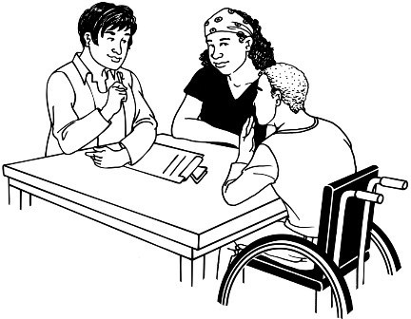
Ki te kī mai koe, kei te tūkinotia tētahi e koe, ka ākina koe e mātou kia kōrero ai koe ki tāngata e tika ana.

Ka ahatia au mēnā ka riri, ka rongo rānei au i te mamae?

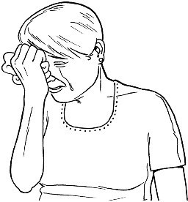
Kei te mōhio mātou mā ētahi o ngā kōrero āu ka rongo koe i te pōuri, i te mamae

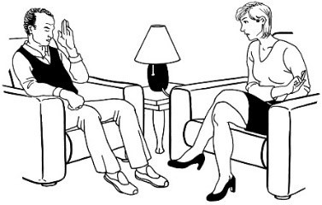
ki te pīrangi koe, ka taea e koe te kōrero ki tētahi kaitohutohu i te wā tonu e pīrangi ana.

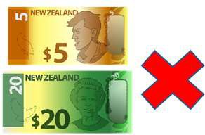
Ka kore koe e utu ki te kōrero koe ki tētahi kaitohutohu hei wāhanga o tēnei rangahau.

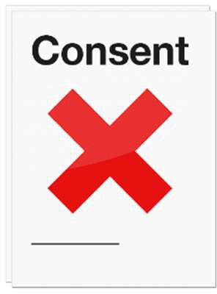
Ka taea rānei koe ki te unu atu i tēnei rangahau i te wā e pīrangi ana.

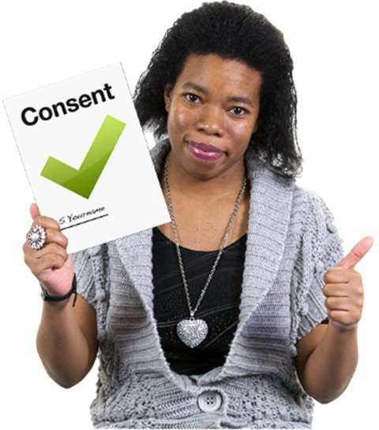
Ehara i te mea, ka uruhia koe ki te noho mai ki te rangahau nei.

Māu anō e whiri ki te hiahia ki te noho tonu ki te rangahau nei.

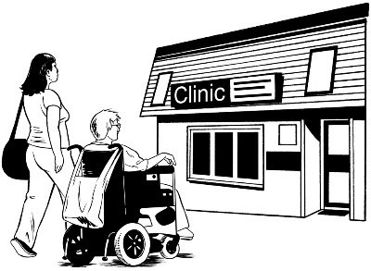
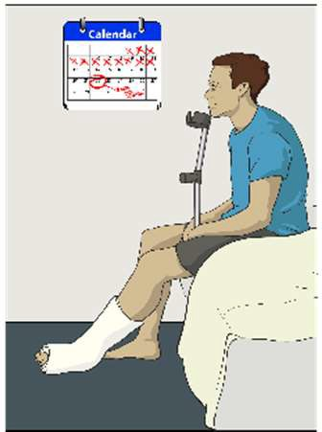
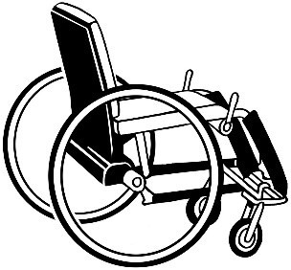
Ehara i te mea ka whara koe i tō noho mai ki te rangahau nei.

Ki te whara koe, ka kōrero koe ki ACC
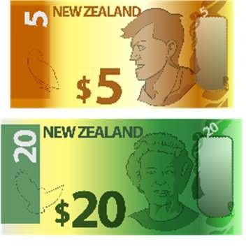
kia āwhina ai koe ki tō whara.
Ko te ACC ko te Kaporeihana Āwhina Hunga Whara (Accident Compensation Corporation).

Ka utua e te ACC ngā mea hei tautoko i a koe, ina whara ai koe:

- Taputapu whakaneke

- Ka utua koe ki te kore koe e taea te mahi nā te āhua o te whara

- te maimoatanga mō tō whara

Ka whakapā atu ki te ACC mā te:

Waea:

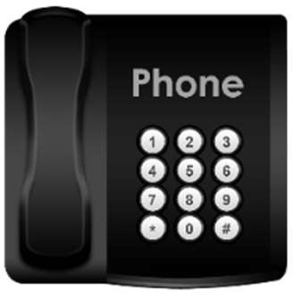
0800 101 996

He nama kore utu tēnei.

Ko te tikanga ia, ka kore e utua e koe.

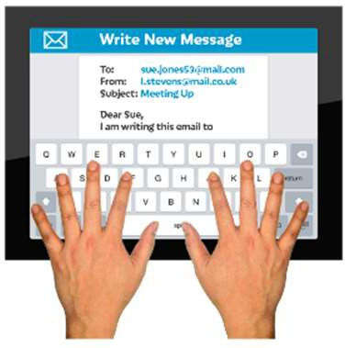
Ka īmēra ki te ACC ki

claims@acc.co.nz

Ka aha au mēnā kei te pīrangi au ki te uru ki te rangahau, ki te hiahia rānei au i ētahi atu kōrero?

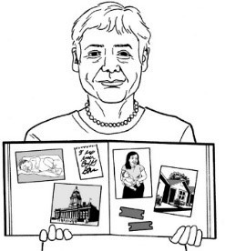
Ki te pīrangi koe ki te uru mai ki tēnei rangahau, me whakapā mai.

Ka uia koe ki te whakakī i te:

Puka Aronga Kaiuru

- Puka Whakaae Kaiuru

Ka tīkina ēnei pukapuka nā tō mātou

paetukutuku:

www.donaldbeasley.org.nz

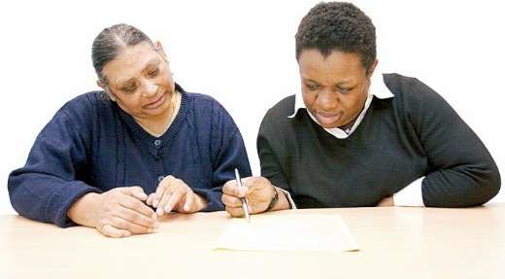
Kei te pai ki te ui atu ki tētahi atu ki āwhina ki a koe ki te whakakī i ngā pukapuka nei.

Ki ētahi kōrero anō mō te rangahau, mō ngā pukapuka rānei, tēnā:

Waea mai ki:

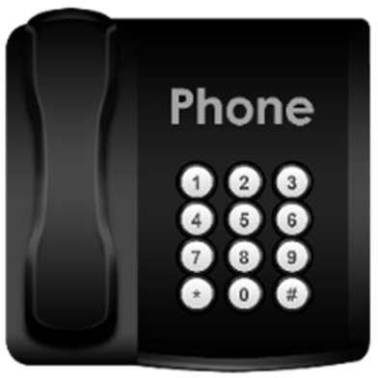
03 479 2162

0800 878 839

rānei

He mea kore utu te nama 0800

Īmēra mai ki:

admin@donaldbeasley.org.nz

Ka whakapā atu au ki a wai ki te hiahia au i ētahi atu kupu āwhina?

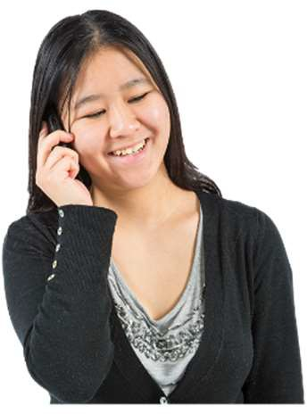
Ki te hiahia koe i ētahi atu kōrero mō ō mōtika ki tēnei rangahau, kōrero ki tētahi Kaitautoko Kiritaki Hauora me te Hauātanga (Health and Disability Consumer Advocate).

Ka whakapā atu ki a rātou mā te:

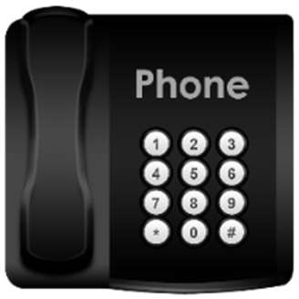
Waea:

0800 555 050

He nama kore utu tēnei

Ko te tikanga ia, ka kore e utua e koe.

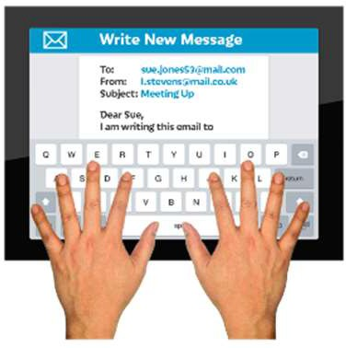
Ka īmēra rānei ki:

advocacy@advocacy.org.nz

Ka tukuna rānei he karere mā tō rātou paetukutuku:

https://advocacy.org.nz/contact/

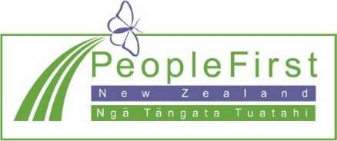
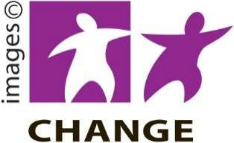
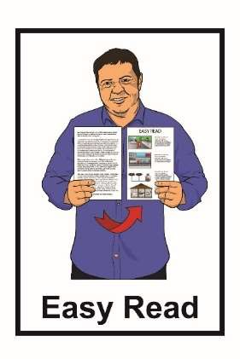

He mea tuhi tēnei nā te Donald Beasley Institute.

Kua whakamāmāhia te pānui nei nā te ratonga Make It Easy, nā, Ngā Tāngata Tuatahi.

Ehara ngā whakaaro ki roto i tēnei tuhinga i te whakaaro o Ngā Tāngata Tuatahi.

Kua tīpakohia e Make It Easy ngā whakaahua nā:

- Changepeople.org

- Photosymbols.com

- Sam Corliss

E noho ana ngā whakaahua o te tuhinga ‘Māmā te Pānui’ nei ki raro i te ture o te mana pupuri, ā, e kore e whakamahia ki te kore e whakaaetia.

