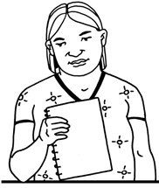
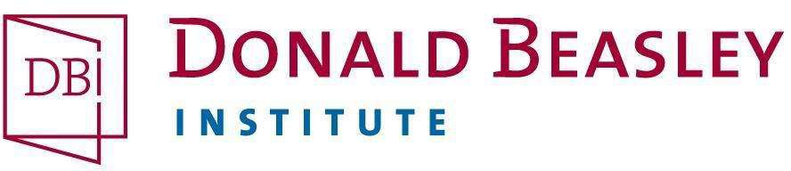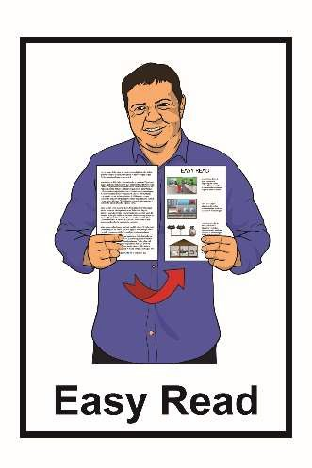

Hinonga rangahau:
Kōrerohia mai mōu
He tono kia uru ai koe ki tētahi hinonga rangahau

Mei 2021

He aha te tikanga o tēnei tono?

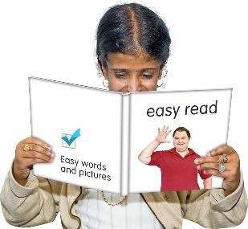
He tono ‘Māmā te Panui’ tēnei kia uru mai ai koe ki ēnei rangahau e kīia nei ko, Kōrerohia mai mōu e whāia ana e te Donald Beasley Institute.
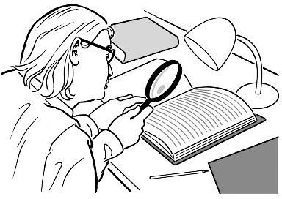
Ko tā te rangahau:

- Ka titiro ki te aha i pahawa
- Ka whāia i tētahi ara i pai ake ai te koke.

He nui te rangahau o te Donald Beasley Institute ki ngā kaupapa whakahirahira.

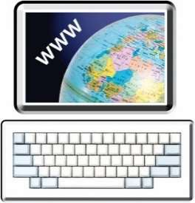
Whāia he kōrero anō mō te Donald Beasley Institute ki tō mātou paetukutuku:

www.donaldbeasley.org.nz

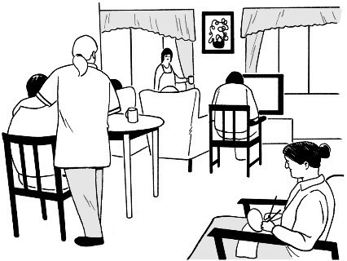
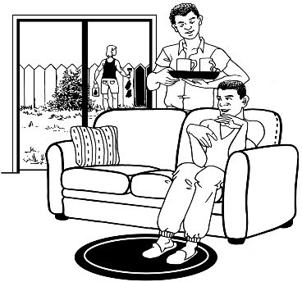
He aha te aha ki tēnei rangahau?

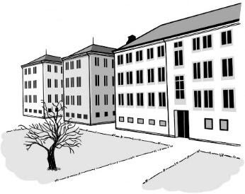
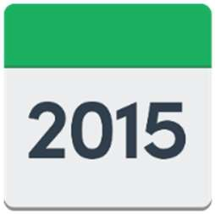
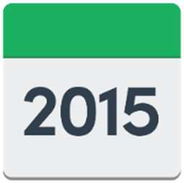
He mea rapu kōrero te rangahau nei mō te hunga hauā i te noho ki ngā whare taurima ki Aotearoa i waenga i ngā tau 1950-1999.
Ko te tikanga o te noho ki te whare taurima, ko tō noho ki raro i te tāwharautanga o te kāwana rānei o tētahi hāhi rānei.
1950
1999

Ko rātou i te noho taurima, i noho ki ngā momo wāhi pēnei i te:

- whakanōhanga

- ratonga hauā

- ratonga tānga manawa

- whakanōhanga hinengaro hauā, mate hinegaro rānei.

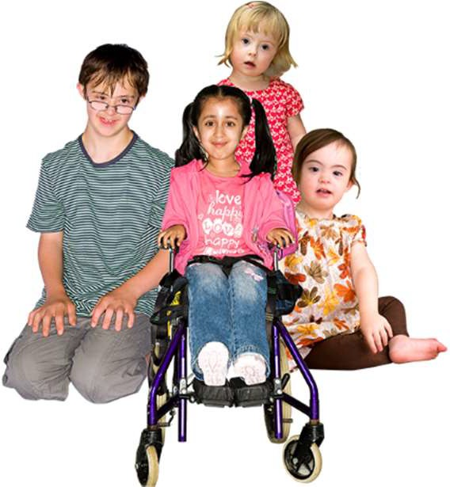
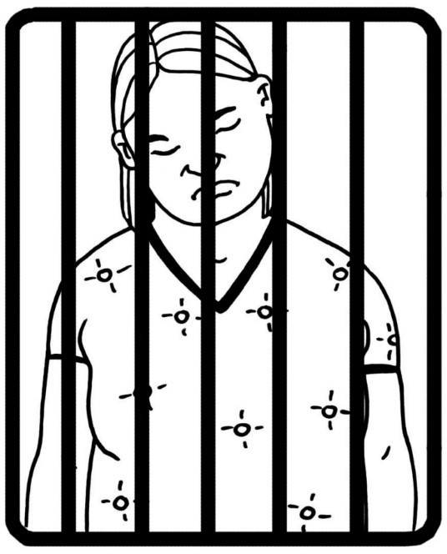
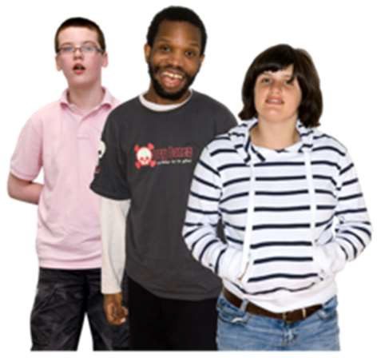
Ko rātou i te noho taurima, i noho hoki ki ngā momo wāhi pēnei i:

- Ngā ratonga tamariki pēnei nei:

  - whare whakatau tamariki

  - whare taurima

  - ratonga whāngai

  - kura, kura kōhungahunga rānei

- ratonga manatika taiohi pēnei nei:

  - whare manatika taiohi

  - nohopuni hauora

  - whare herehere Pirihimana

  - whare herehere Kōti

  - whare whakatau o te Pirihimana.

I noho hoki ēnei tāngata ki ngā wāhi i whakahaerehia e ngā hāhi, e ngā rōpū whakapono rānei.

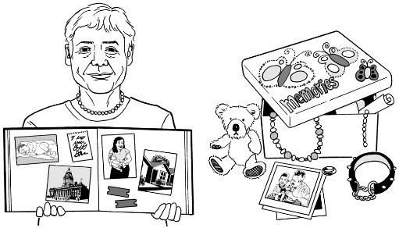
Kei te pīrangi mātou ki te rongo i ngā wheako o ngā tāngata i te noho ki ngā whare taurima ki Aotearoa.

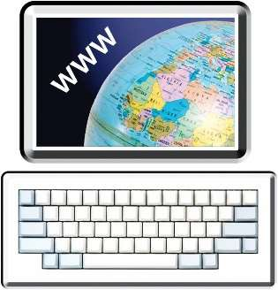
Whāia he kōrero anō mō te rangahau nei ki tō mātou paetukutuku:

www.donaldbeasley.org.nz/tell-me-about-you

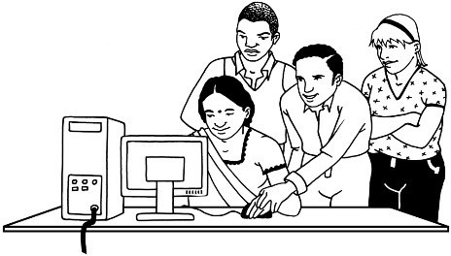
Mā wai te tono nei?

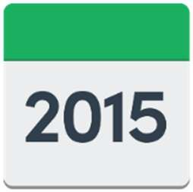
Ko te tono nei, kia uru mai ai ki te rangahau mā te momo:
1950
1999

- tangata he mate tōna ki te ako i noho ki tētahi whare taurima i waenga i ngā tau 1950-1999.

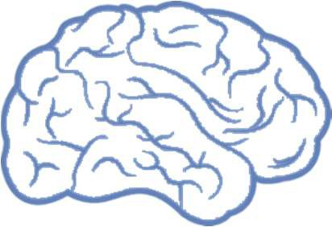
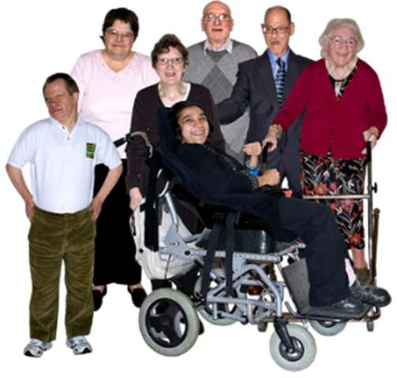
- tangata kanorau-io i noho ki tētahi whare taurima i waenga i ngā tau 1950-1999.
Ko te tikanga o te tangata kanorau-io:

- he rerekē te whakahaere o ō rātou roro

- he rerekē te ara ka whāia ki te ako.
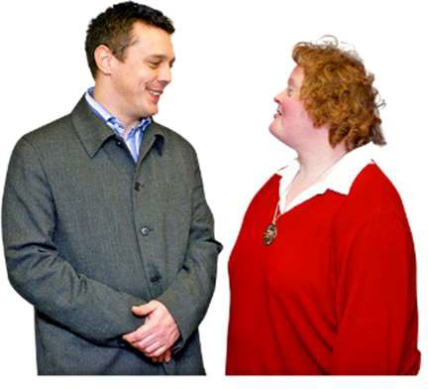
Ki te tēnei rangahau, ko te kanorau-io ko te:

- hunga takiwātanga

- hunga mate aro, mate hihiri (ADHD)

Ka whakaea te utu o tēnei rangahau i a wai?

Nā te Royal Commission Inquiry into Abuse in Care te pūtea i homai ki te Donald Beasley Institute ki te whakahaere i tēnei rangahau.

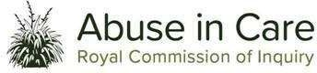
Ko te Royal Commission of Inquiry into Abuse in Care, ko te huinga mātanga e whai kōrero ana i te tangata kua rongo i te tūkino i ā rātou e noho ana ki ngā whare taurima.

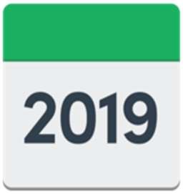
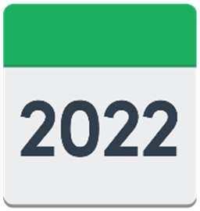
I timata i te Royal Commission of Inquiry into Abuse in Care i te tau 2019.

Ka mutu hei te 2022.

Ki te pīrangi au ki te uru, ka aha au?

Me kōrero mai ki a mātou mēnā:

- he pātai āu mō te rangahau

- kei te pīrangi koe ki te uru mai ki te rangahau.

Me kōrero tahi mātou ki a koe mō ngā kawenga, mō āu nā mahi ake kia uru mai ai koe ki te rangahau.

Waea mai ki a mātou:

- 03 479 2162

- 0800 878 839
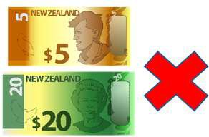 He mea kore utu te nama 0800.

Ka īmēra mai ki:

admin@donaldbeasley.org.nz

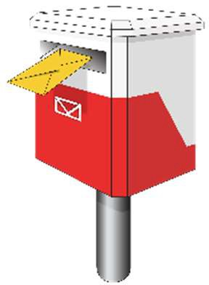
Ka tuku reta rānei ki:

Donald Beasley Institute Suite 4, Level 2
348 Cumberland Street

Dunedin 9016 New Zealand.

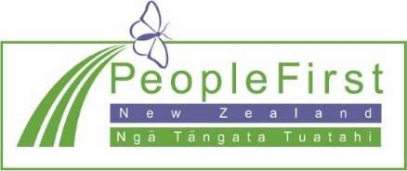
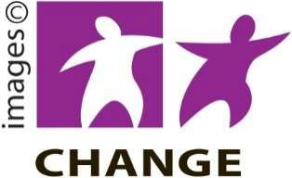
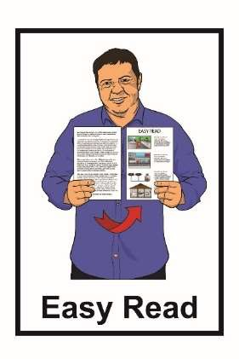

He mea tuhi tēnei nā te Donald Beasley Institute.

Kua whakamāmāhia te pānui nei nā te ratonga Make It Easy, nā, Ngā Tāngata Tuatahi.

Ehara ngā whakaaro ki roto i tēnei tuhinga i te whakaaro o Ngā Tāngata Tuatahi.

Kua tīpakohia e Make It Easy ngā whakaahua nā:

- Changepeople.org

- Photosymbols.com

- Sam Corliss
E noho ana ngā whakaahua o te tuhinga ‘Māmā te Pānui’ nei ki raro i te ture o te mana pupuri, ā, e kore e whakamahia ki te kore e whakaaetia.

