“One thing that I know Stand up for your rights”

by Graham P

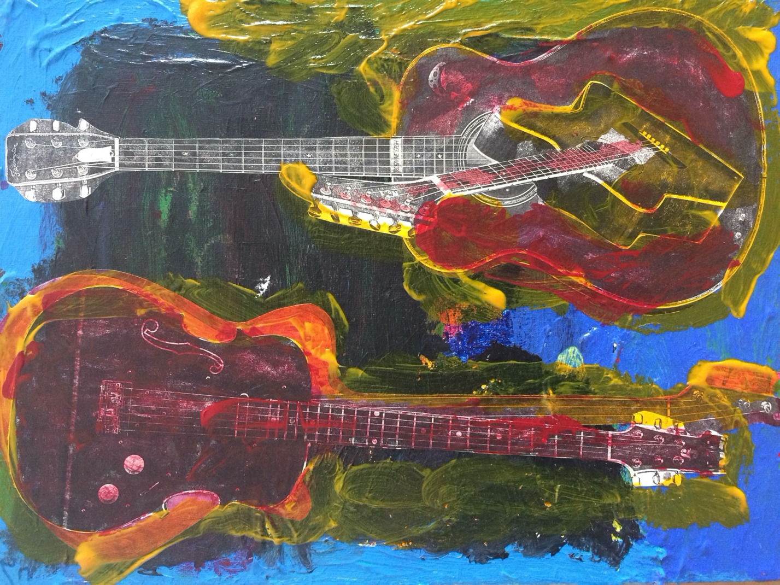

My name is Graham P. I was born in Alexandra. Growing up, I lived at home with my Mum and Dad, and my brother and two sisters.

When I was a little boy, I got bowled over by a train in Alexandra. I was trying to chase a kid off the railway track and the train came and bowled me over. I was scared.

I almost drowned in Alexandra. I was at the river with my Mum and Dad. The water went up to my neck. It was deep and I went under. Mum and Dad helped me get out. I was scared. I didn’t want to go back in after that.

I went to Dunedin after the train bowled me over. I went to Sarah Cohen School. I remember wearing a black helmet to protect my head from getting hurt because I had turns [seizures]. I spent some time at the IHC Workshop when I left school and then I moved into an IHC house.

I lived in Seacliff too. I was there right, I said to them I don’t like being locked up. But they did lock me up a lot and for long times. I had to take tablets so I didn’t have turns. I had a friend at Seacliff. Her name is Josie. We used to play Snakes and Ladders together. I was good at Snakes and Ladders and would win. I don’t play it anymore but I would like to. We sang songs at Seacliff but I didn’t like that because it made me bored and the songs were sad.

I moved to Cherry Farm from Seacliff. I can’t remember how old I was. When I got there, my arms were shaking. It was scary and frightening. The tablets for my turns made me all better. They made me feel calm and tired out. I didn’t like it there. They locked me up and I don’t like that. I don’t know why they locked me up. It was cold and made me sad. I was falling off the chair. Someone helped me up. She was nice to me. I would have turns and fall onto the floor. The staff didn’t help me.

I missed my family. It made me feel sad a bit. I used to dream about my Mum and Dad a lot. Mum and Dad are up in Heaven and I was sad about that. I liked them. I treated the staff like family. They didn’t treat me like family. Made me sad a bit. No one would comfort me when I was sad.

Some staff bossed me around and I don’t like that. Some staff were nice to me, like Ivan, he drove a yellow truck.During the day, I would watch TV and listen to music. I liked listening to music. I had a friend there too, his name was Robert. I miss him.

We recorded a Cherry Farm C.D, I sang on it, everyone did. I liked it a wee bit. The Cherry Farm songs were good. I rode a three-wheeler bike there. I went everywhere on it. There were lots of kids there, people around my age. I was in a Villa with nine other people. I had my own room but I didn’t like it. There was just a bed in it. I was happy to get away from Cherry Farm all together. I was in there, but I was sad there. Don’t talk about it. Let’s stop talking about it.

When I left Cherry Farm, I didn’t get to choose where I went. I was put into a house. I was scared. It was a strange place. The people weren’t nice. Shoved me in the corner. I used to walk everywhere. I used to walk around the block there but now I can’t. It’s not nice. I don’t remember what happened. I don’t remember how I stopped walking. I wish I could get that back again. So hard. Really hard. It will be good when I get back on my feet again, won’t it?

They put me in hospital too. I wanted to get out. The people were nice but I wanted out. I wanted to go for walks and listen to my music but I couldn’t do that there.

I don’t want to talk about it no more. Time to move on.

I like it here. I like to be in a big house. Saved my life it did. I like it here because it’s handy to the shops. Seacliff and Cherry Farm were far away. I live close to everything now. I like to be part of things. Part of the community. People take me for walks but I would like to go more. I feel bad when I can’t go. I wish I could go by myself but it’s hard. It’s so hard.

I like my room here, it’s comfortable. I have things in my room, I have a T.V set. I have more control and can be myself, look after myself. I do my dusting. It makes me happy. I can relax in my room. I don’t get shoved. If I fall and can’t get up, people help me. Things are better now. It’s all gone away.

A good life is going and looking around shops, getting coffee. I’ll tell you a good thing right, if I’m on a radio show, you might hear my voice everywhere. I was on a radio show and I can still be on it. There’s a song I like. “I’ll be home for Christmas, you can count on me”. It makes me a bit happy.

One thing that I know, stand up for your rights.
You get together with someone and stand up.
That means rights.
That means rights.

Graham chose to use his real first name in his story.
Artwork by Graham P himself – collage of two guiter with yellow, blue paints mixed to be green.

