“I don’t get locked up here”
by Graeme
2
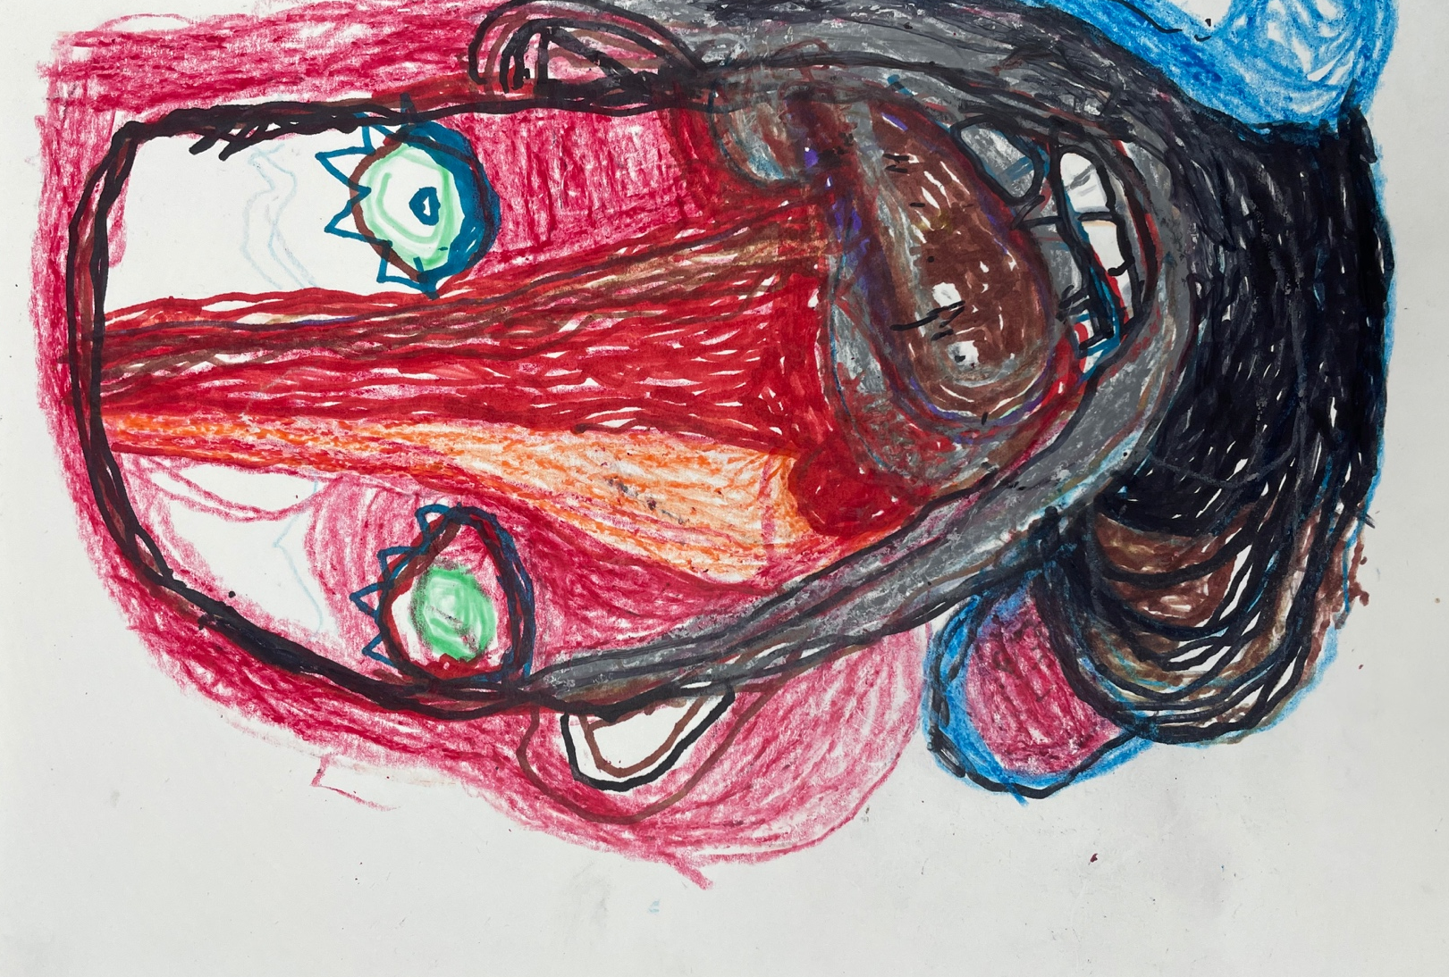

When I was a little kid I lived in Glen Road with Mum and Dad, my big sister, and my two brothers. My sister wore glasses, and she looked after me. We got on well.
I have lost all my family now. I am sad about that. I loved Mum and Dad and all my family.

Mum stayed at home and done the housework and cooking. She was a housewife. We got on well. Dad used to work on the railways. I think he was a train driver but I never got to ride on the train. Sometimes my Grandad would come around for a cup of coffee and morning tea.

I went to Tahuna Primary School. It was ok for me. I had friends but it is hard to remember their names. Sometimes my brothers and other kids bullied me. I was sad a lot. I liked playing football and rugby with the other boys at school. I remember one teacher. His name was Mr Watson. He used to tell me all about school. I liked him.

I liked the learning. I learned to read and write, but I don’t remember how to any more.

I never went to High school.

Then I was at Cherry Farm. I remember when I went, but I don’t remember how old I was or why I went there. I remember feeling angry when I got there, because I didn’t want to leave home. I was there for a long time. It was hard to be away from home. I missed all my family. Sometimes Mum and Dad and my sister would visit. My sister gave me a ring once.

Sometimes I would get angry and yell out and put holes in the walls. I find it a wee bit hard to talk about [being at Cherry Farm]. And I don’t like thinking about it. I don’t like Cherry Farm.

I lived in Villa 2 with three other people – all men.

The staff were no good to me at Cherry Farm. They used to give me a needle in the arse.
They would stab it into me. And give me lots of pills. I hadn’t done anything. I was scared of them. [They would] just knock me around because I used to play up and that. They used to ah, hit me.

I got locked up in Cherry Farm. The room was empty. Only floor boards and a big door. I was in that, room for a long time. Sometimes I used to hurt people too - I don’t know why I done that.

During the day I used to work in ah, Morris house, Morris house workshop. I used to make huts and that. Play Huts. We used to sell them. I enjoyed [making them]. Sometimes I got some money.

I started drawing at Cherry Farm because I got bored. I still do artwork. I go to community art studio every week now. I did look forward to going to Church on Sunday [at Cherry Farm]. God is important to me.

When I got to leave Cherry Farm, I was happy. I was very, I was, I was very happy to see um mum and my sister. Sometimes I got to go home for the holidays, and for my birthday. I was always happy to go home, and I was upset when I had to go back to Cherry Farm. I had a few friends there. I remember them but I can’t remember their names. I lived there for a long time didn’t I? It’s good that I don’t live there anymore.

I’ve got no family now, only this family. I like it here. I don’t get locked up here. I wouldn’t want to go back to Cherry Farm.

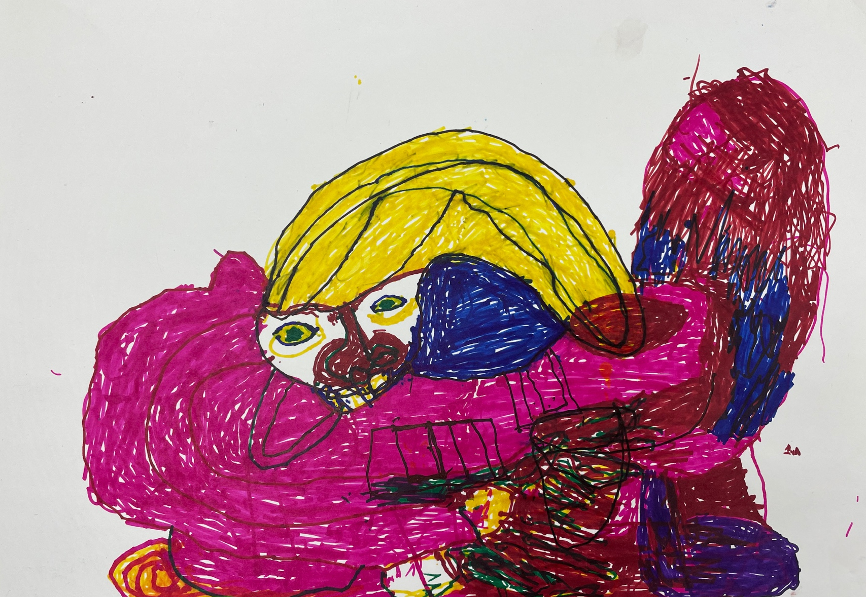

Graeme chose to use his real first name in his story. He chose not to refer to anyone else by name.
2 Artwork by Graeme

