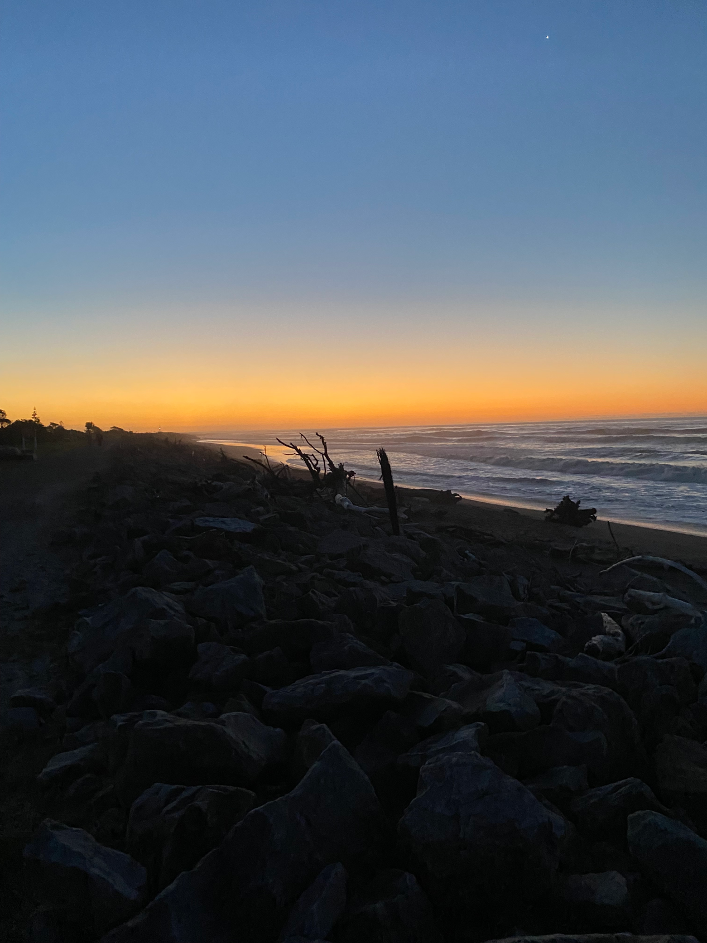
“Happy times”
By Rosie

I was born in the Bay of Island’s hospital, on the 6th of November 1957. I grew up in Kaikohe, Northland.

My Dad was a carpenter and my Mum was a housewife. My father passed away in 1975, and in 1994, my mother passed away too. That was a sad time for me.

I come from a really big family. There’s five sisters and two brothers. There’s eight of us. I’m the youngest. I am a twin – I have a twin brother Bill. I am close to my brother. Sometimes him and his wife sneak down to Hoki to see me. I write letters to keep in touch with my family. I am a good letter writer.

When I was five I went to Kaikohe East Primary School. It was a little school. I liked school, I had friends, and I found the work easy. I liked sport. I played netball. I wasn’t that good at it but I liked it. High school was good too - I loved going swimming.

When I was nineteen I left school to look after my mum. Well I tried to get a job in Kaikohe but it was hard because they already had someone employed at the supermarket, and it was a smallish place so not many jobs around.

Anyway, I looked after my mum because half of my sisters were married and got kids of their own and because I was the last one at home I got to look after Mum. Mum and I were quite close. She was grateful that I was helping her.

She was very, very sick at the end. [Her] friend come over and she asked me if she could ring the doctor, which she did and my mum went to the Bay of Islands hospital and they could do nothing for her. She died in hospital. It was hard on me.

I was still living in Northland when my mum passed away and I didn’t feel that there was much for me in Kaikohe. After Mum’s funeral I spent a month in Rotorua. I spent time with my sister in Rotorua, and then I rang my sister who lived in Hokitika, and I said to her “I made my decision and I’m coming”.

It was a big shift down to Hoki!

My family thought it would be a good idea for me to live at Seaview. One of my sisters’ worked there. Going from living with my mum in our own house in the community to living in Seaview was a big change. I was thirty-nine years old when I moved in!

I was a bit nervous for a start. I was most nervous about meeting people. There was a lot of people around. It was a bit nerve-wracking meeting staff too. I had never had staff. But I’m a people person so I introduced myself and everyone got to know me pretty well.

In my first months there I lived in House 6 with three other people; me, another woman, and two guys - we got on pretty good. One of them, a guy named Ewan, became my boyfriend!

He was older than me and it was good to have a boyfriend because my mother would not let me have one. No she wouldn’t let me, I was not allowed me to have a boyfriend. Sometimes I felt like walking away because of it.

When I lived in the house, I had nicknames for all the guys over at the hostel - at Pounamu. I had nicknames for the staff too. And they had a nickname for me – Hairy McLeary!

When I was in the house I sometimes cooked for myself and sometimes I went over to the hostel for meals.

I had my fortieth birthday at Pounamu soon after I moved into Seaview. Pounamu was the old nurses home. There might have been 16-20 people that lived in the hostel, but at the start I lived in the house over the road.

When Ewan passed away I had to move into Pounamu. I had my own room and my own things. I liked the staff there – they were a bit cheeky but so was I. I was a ratbag.

We had lots of adventures. Holidays in Christchurch all together - we used to do holiday swaps with Templeton hospital. It was fun because they have even got a hot swimming pool at Templeton. We had one at Seaview too, right outside Pounamu but it was open air and freezing cold! We also went to Nelson and stayed at the Tahuna Camp. We went out around town and went to Nature Land, which was a small zoo. We got on really well as a group. I have lots of photos of those times.

When I was at Seaview we used to have the Christmas party at the community hall. Grog involved, everyone was there. Everyone turned up at my 40th. I had that at Pounamu. There was no dancing but I had fizzy and two cakes.

I was friends with children that belonged to some of the staff. They were like my family too. I would take them off by the hand and find some goodies somewhere. They are all grown up with kids of their own now. I love kids.

We’d go around all of the villas and to the canteen. And I used to go to OT [occupational therapy]. The bus would pick us up to go back for lunch, then in the afternoon we’d go back to the OT again. Mostly I did knitting. My niece had a little baby girl and I knitted her a baby jersey and the lady put a brown teddy bear on there for me.

I met Phillip at Seaview and I picked up with him. He lived in Pounamu as well. It was love at first sight! He was a good looking guy and fun-loving. We were together for a short time, and then out-of-the-blue his family found him and took him back to the North Island. I never saw him again but I used to write to him. He stopped writing back because he passed away.

We heard that Seaview was going to close and I was a bit sad about it. I enjoyed being at Pounamu and would have been happy to stay there. When I lived with mum I had contact with other people, but when I lived at Seaview there were friends around all the time. I had good relationships there.

In the end, I spent 6 years at Seaview – from 1994 – 2000. I liked being in there. [I had] happy times up at Seaview.

We had a choice about who we got to live with, and I moved out with friends, and over the years I have lived in three different houses. I found it was great to be in the community and I didn’t look back.

One of the best things in my life was Andrew. We were introduced by someone else, and it was love at first sight for both of us. I was the older woman! I taught him how to cook. We went for drives in the weekend with friends of ours. Sometimes we even went to Christchurch.
We lived in the same house with two of our friends.

One day Andrew went to visit his grandad and didn’t come home. I was wondering where he was because he didn’t come home for tea. Andrew and his grandad were both shot by a neighbour. Andrew was just in the wrong place at the wrong time. I was in shock and couldn’t sleep. I felt very, very upset for a long time. This year it is 10 years since Andrew died. I haven’t had a boyfriend since Andrew – I don’t want to ever have another boyfriend. Never.

I am settled in this house. I like living with the other four women here. I knew them in Seaview. I get to see my family. I had my 64th birthday with my sister and nieces in Invercargill. We went to Queenstown and went on the Earnslaw. I hadn’t done that before. I sometimes call my sister that lives in Hokitika on my cellphone.

I’ve lived out here for ten years. I love it out here.
It’s beautiful. This was a good place for me to get over losing Andrew.
If I could stay out here or move into Hoki I would stay here but I go into Hoki most days. I go for drives, I go to the activity centre every morning, and I go to sunset point, but I like getting home.

I liked Seaview and I was sad when I heard it was closing down. But I like living out in the community more. I’ve got more choice living here than I did at Seaview.

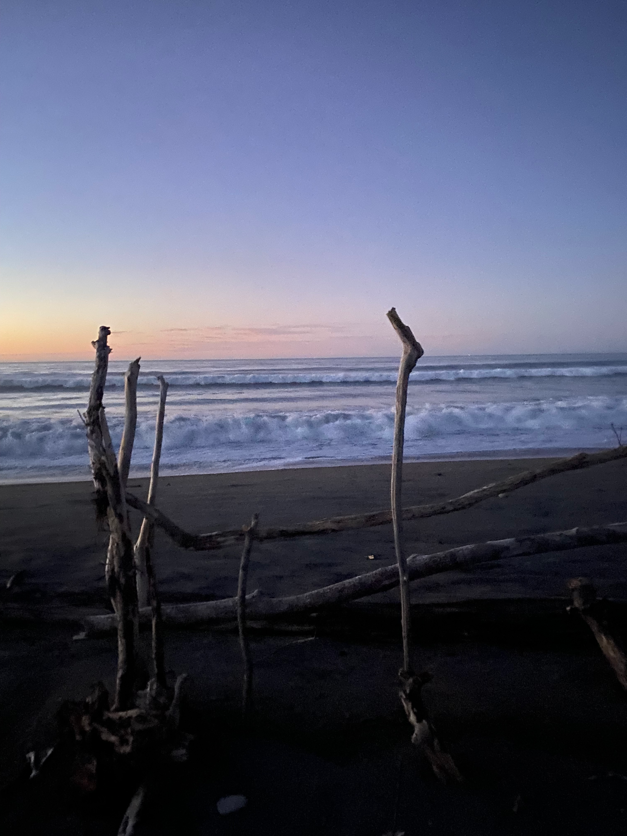

Rosie chose to use her first name in her story and not to name anyone else.

